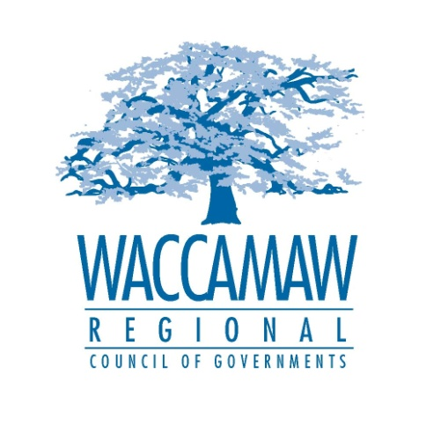

Waccamaw Air Quality Coalition
Thursday January 15 2015- 10:00am
WRCOG Conference Room
1230 Highmarket St.
Georgetown, SC 29440

- Welcome and Introductions Daniel Newquist, WRCOG

- National Radon Action Month Richelle Tolton, SCDHEC

- Horry County Monitoring Station Update SCDHEC

- SCDHEC Bureau of Air Quality Update SCDHEC

- Announcements from Coalition Members

- Future Meeting Dates and Topics Daniel Newquist

- Adjourn

