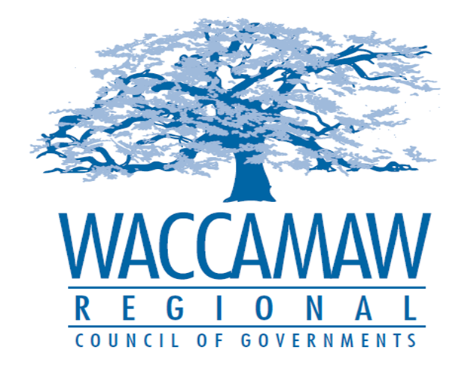
BOARD OF DIRECTORS MEETING
Monday, February 8, 2016 - 7:00 PM
1230 Highmarket Street, Georgetown, South Carolina 29440

- Call to Order…………………………………………………………………………………..……..Randal Wallace, Acting Chairman
- Invocation
- Introduction of Guests
- Determination Quorum
- Approval of the 2016 WRCOG Board of Directors’ Meeting Schedule
- Approval of the November 9, 2015 & December 14, 2015 Minutes
- Ratification Items:
- Budget Revision & Personnel Committee Recommendations
- RLF Committee Recommendation

- Nominating Committee Recommendation………………………………………………….…...Yancey McGill,
Action Item: YES Nominating Committee Chairman

3. Presentation of 2014-2015 Audit………………………….…………………….…… Alan W. Thompson, CPA
TPSA

- Audit Committee Report……………………………………………………………..……………..Murray Vernon
Action Item: YES Audit Committee Chairman

5. Finance Report…………………………………………………………………..……………….. Arnold Johnson,
Finance Director

- Andrews Bypass Phase II Update……………………………………………………………..….Mark Hoeweler
Assistant Executive Director

- Rural TIP Amendment ..........................................................................................................Edward Starks,
Action Item: YES Transportation Planner

- HOME Funding Amendment…………………….……………….………………………………...Courtney Kain,
Action Item: YES Planner/CDS

- Executive Director’s Report…………………………………..……….………………………....Sarah P. Smith,
Executive Director
10. Next Meeting: March 14, 2016

11. Other Business

12. Adjournment

