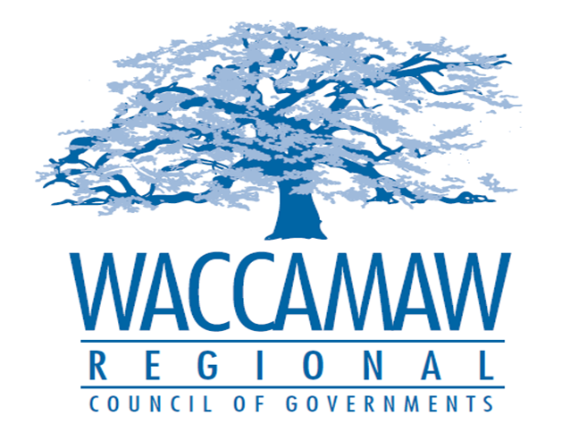
BOARD OF DIRECTORS’ MEETING
Monday, June 13, 2016 - 7:00 PM
1230 Highmarket Street, Georgetown, South Carolina 29440

- Call to Order……………………………………………………………………………....Randal Wallace, Chairman
- Invocation
- Introduction of Guests
- Determination Quorum
- Approval of the May 9, 2016 Minutes

- Finance Report ………………..…………………………………………….………..…Arnold Johnson,
Finance Director

- Audit & Finance Committee
2016/2017 Proposed Operating Budget………………………………………………Murray Vernon,
Committee Chairman
Board Action Required: Yes

- AAA/ Funded Meal Services RFP…………………………………………………...……Kim Harmon,
Aging Director
Board Action Required: Yes

- WIOA/WWDB Letter of Findings Cost Sharing……………………………………….Ayla Hemeon,
Director of Center Operations
Board Action Required: Yes

- Executive Director’s Report…………………………………..……….…………….....Mark Hoeweler,
Assistant Executive Director
7. Next Meeting: August 8, 2016

8. Other Business

9. Adjournment

