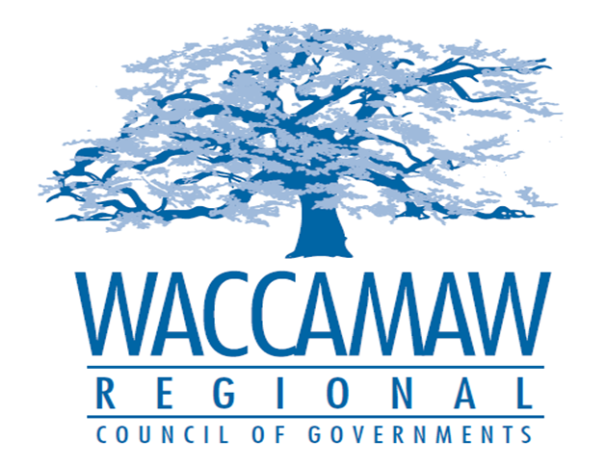

BOARD OF DIRECTORS’ MEETING
Monday, November 14, 2016 - 7:00 PM
1230 Highmarket Street, Georgetown, South Carolina 29440

A G E N D A

- Call to Order……………………………………………………………………………....Randal Wallace, Chairman
- Invocation
- Introduction of New Board Member
- Introduction of Guests
- Determination Quorum
- Approval of the September 12, 2016 Minutes

- Finance Report ………………..…………………………………………….………..…Arnold Johnson,
Finance Director

- Tri-County CHDO Board Appointments………………………………….…...………….Tom Britton, Planning Director
Board Action Required

- WIOA Update………………………………………….…………………………………..…Ayla Hemeon,
Workforce Development Director

- 208 Program Update………………………………………………………..….……….Daniel Newquist,
- Project Director

- Executive Director’s Report…………………………………..……….…….…….……....Sarah Smith,
Executive Director

7. Next Meeting: December 12, 2016

8. Other Business

9. Adjournment

