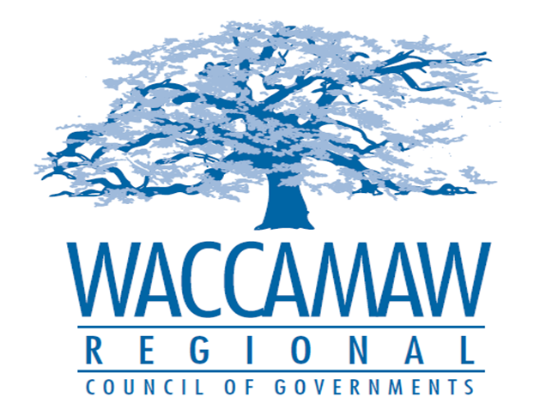

BOARD OF DIRECTORS’ MEETING
Monday, December 12, 2016 - 7:00 PM
1230 Highmarket Street, Georgetown, South Carolina 29440

A G E N D A

- Call to Order……………………………………………………………….………….... Randal Wallace, Chairman
- Invocation
- Introduction of Guests
- Determination Quorum
- Approval of the November 14, 2016 Minutes
- Approval of the 2017 WRCOG Board of Director Meeting Dates
- WRCOG’s SCARC Display

- 2016 Audit Presentation…………………………………….…...………..…Alan W. Thompson, CPA TPSA

- Audit Committee Report ………………………………………………………….…….Murray Vernon,
Audit Committee Chairman
Board Action Required

- Budget Revision FY2017…….…………………………………………..………..… Arnold Johnson,
Finance Director
Board Action Required

- GSATS/MPO/MTP Update………………….………………………………………….…Edward Starks,
Transportation Planner

- Executive Director’s Report…………………………………..……….…….…….……....Sarah Smith,
Executive Director
7. Next Meeting: January 9, 2017

8. Other Business

9. Adjournment

