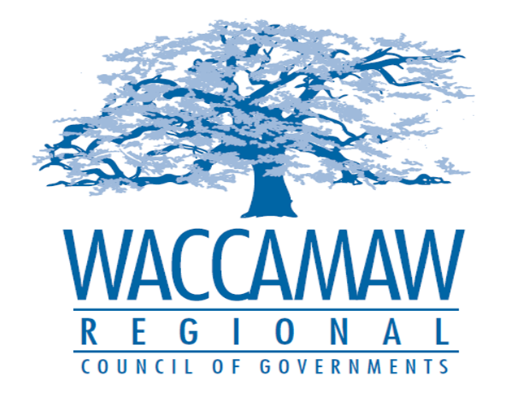

BOARD OF DIRECTORS’ MEETING
Monday, February 13, 2017 - 7:00 PM
1230 Highmarket Street, Georgetown, South Carolina 29440

- Call to Order……………………………………………………………………………....Randal Wallace, Chairman
- Invocation
- Introduction of Guests
- Determination Quorum
- Approval of the December 14, 2016 Minutes

- Finance Report ………………..…………………………………………….………..…Arnold Johnson,
Finance Director

- Finance Department Transition/Audit RFP Update…………………………………...Finance Staff

- Tri-County CHDO Board Appointment..……………………….……………...………….Tom Britton, Planning Director
Board Action Required

- State and Local Aid Discussion/HOME Program Update……………………………..Sarah Smith,
Executive Director

- Executive Director’s Report…………………………………..……….…….…….……....Sarah Smith,
Executive Director

- Next Meeting: March 13, 2017

- Other Business:

9. Adjournment

