Waccamaw Area Agency on Aging
2017-2021
Kimberly Harmon
5-8-2017

Contents
Verification of Intent 3
Executive Summary 4
Mission Statement 4
Vision Statement 5
Organizational Structure 5
Staff Experience and Qualifications 5
Regional Aging Advisory Committee 6
Client Assessments 7
Ten-Year Forecast for the Waccamaw Region 8
Focus Areas for the 2017-2021 Area Plan 10
Goals, Objectives and Performance Measures 10
Goal 1 10
Goal 2 11
Goal 3 12
Goal 4 12
Goal 5 14
Goal 6 15
Quality Management 17
Attachment A: Area Plan Assurances and Required Activities 18
Attachment B: Information Requirements Attachment B: Information Requirements 29
Section 305(a)(2)(E) 29
Section 306(a)(17) 29
Section 307(a)(10) 31
Section 307(a)(14) 31
Section 307(a)(29) 31
Attachment C: AAA Funding and Fiscal Oversight 32
Competitive Procurement 32
Fiscal Monitoring 36
Reimbursement for Services 38
Funding Formula 40
Current Funding Resources for AAA Operations 40
Match Requirements 41
Attachment D: General and Programmatic Information 41
Monitoring 41
Client Data Collection 47
Resource Development 47
Cost Sharing and Voluntary Contributions 48
High-Risk Providers and Corrective Action Plans 50
Providers Service Delivery Areas 50
2017 -2021 Area Plan Standard Assurances and Conditions 50
Training and Technical Assistance 51
Emergency Preparedness 51
Licensing Protocols 53
Outreach 53
Memorandums of Agreement (MOA) and Memorandums of Understanding (MOU) 53
I&R/A Funding 53
Regional Transportation Services 54
Nutrition Program 54
Family Caregiver Support Program 66
Ombudsman Services 72
Legal Assistance Program 74
Evidence Based and Wellness Programs 74
Reimbursement Request Accuracy 75
Assessment Process 76
Regional Successes 77
Attachment E: GIS Mapping 79
Attachment F: Strategic Planning, Workforce, Process Management and Client/Customer Satisfaction 92
Strategic Planning 92
Workforce Focus 92
Process Management 92
Client/Customer Satisfaction 93
Attachment G: Area Plan Public Hearings 94

Verification of Intent

The Area Agency on Aging hereby submits its Fiscal Year 2017-2021 Area Plan to the Lieutenant Governor’s Office on Aging. If approved, the plan is effective for the period of July 1, 2017 through June 30, 2021.

The Area Agency on Aging is granted the authority to develop and administer its Area Plan in accordance with all requirements of the Older Americans Act and the Lieutenant Governor’s Office on Aging. By signing this plan, the Planning and Service Area Director and the Area Agency on Aging Director assure that the written activities included in the plan will be completed during the effective period and annual updates will be given to the Lieutenant Governor’s Office on Aging when requested. Changes made to the approved plan will require and amendment submission to the Lieutenant Governor’s Office for approval.

This plan contains assurances that it will be implemented under provisions of the Older Americans Act of 1965 during the period identified, as well as the written requirements of the Lieutenant Governor’s Office on Aging and the South Carolina Aging Network’s Policies and Procedures Manual.

The Area Plan herewith submitted was developed in accordance with all federal and state statutory and regulatory requirements.

Waccamaw Regional Council of Governments
Area Agency on Aging

_____________________________________ _______________________
Planning Service Area Director Date

_____________________________________ _______________________
Area Agency on Aging Director Date

Executive Summary
In order to receive Older Americans Act (OAA) and state funding for 2017 through 2021, each Area Agency on Aging/Aging and Disability Resource Center (AAA/ADRC) is required to submit an Area Plan following the process stipulated by the LGOA. It is the responsibility of the AAA/ADRC to prepare an Area Plan document which accurately reflects the goals of the aging network within its planning and service area, while also taking into account the directives set by the Older Americans Act (OAA), the 2017 State Plan, the terms and conditions set by the Multigrant Notice of Grant Award (NGA), and the South Carolina Aging Network’s Policies and Procedures Manual. The Waccamaw 2017 – 2021 Area Plan is an innovative, forward-thinking document that provides a clear blueprint and guide for the AAA/ADRC over the next four (4) years.
In addition to being a blueprint for addressing the new paradigm set by the AoA and the LGOA, the Area Plan is a document which provides best practices for service delivery, accountability, and transparency, not only within the structure of the AAA/ADRC, but within the entire aging network. Through the Area Plan, the AAA/ADRC provides clear monitoring protocols, verification of services provided, and verification of service units earned, as well as the many assurances required by these instructions. The Area Plan demonstrates that the PSA and AAA/ADRC have a clear understanding and knowledge of all activities and services provided throughout its region.
The document addresses the AAA/ADRC Operational Functions and Needs of our region. These functions include the assessment of regional aging needs, program development, program coordination, long term care, advocacy, priority services, priority service contractors, transportation, nutrition services, training and technical assistance, monitoring, contract management, grievance procedures, performance outcome measures, resource development, cost-sharing and voluntary contributions, confidentiality and privacy.
The Area Plan also addresses direct service programs which are provided internally by the Council of Governments and includes staff qualifications, goals and objectives, strengths and weaknesses, and operational procedures for each of our internal programs. These internal programs include Long-Term Care Ombudsman, Information Referral and Assistance, Family Caregiver Program, and Insurance Counseling and Senior Medicare Patrol.

Finally, the plan addresses changing demographics and the impact on our service delivery system within the region. The plan will outline the use of intervention and prevention plans, senior center development plans, plans for families facing Alzheimer’s disease, and legal assistance programs to minimize impact on and maximize service options to the seniors and their families in our three counties.

Mission Statement
The Waccamaw AAA/ADRC is dedicated to improving the quality of life for seniors, adults with disabilities, and their family care partners, by helping them to achieve optimal health, independence and productivity in both the community and the long term care setting.

Vision Statement
The Waccamaw AAA/ADRC envisions adequate, just and equitable services for ALL. These services will honor and respect differences. They will be delivered with integrity; offer responsible choice; enable personal empowerment; and growth to area seniors, disabled individuals and their family care partners.

As we navigate our day-to-day work with seniors and their families we strive to ensure that each and every one is treated with the utmost respect and that the services they receive are the best that can be offered. We strive to provide as much choice in service options as possible and empower our clients to make as many decisions for themselves as they are comfortable making.

Organizational Structure
The Waccamaw AAA/ADRC is housed within the Waccamaw Regional Council of Governments (WRCOG).

Waccamaw Regional Council of Governments, a regional agency serving county governments, municipalities, and citizens of Georgetown, Horry and Williamsburg counties, offers a wide variety of planning, economic development and social services to aid in the orderly growth and development of the area.

Created in 1969, Waccamaw Regional is one of ten regional agencies in the state, together making up the SC Association of Regional Councils. The Council provides in-depth assistance to local governments serving as the technical planning staff for numerous planning and zoning commissions, assisting in securing and administering grant funds for local projects and services, as well as coordinating varied social services for the economically deprived.
Waccamaw Regional operates under the guidance of a twenty-five member Board of Directors comprised of elected officials and citizens-at-large from the tri-county area. Waccamaw Regional’s professional staff is engaged in five basic areas of activity: planning; economic and community development; aging; workforce and finance. The agency is organized into four separate departments according to those activities.

The AAA/ADRC is one of the five separate departments within the agency. The AAA Director supervises all direct service employees of the Aging department with oversight by the Executive Director of the Council.

Staff Experience and Qualifications

Kim Harmon, BA - AAA/ADRC Director – Kimberly Harmon acts as the Waccamaw aging director. She earned a Bachelor’s degree in Business Administration from Francis Marion University. She has been employed by the AAA for 16 years, and has work experience in the following areas: COA Finance Director; Interim COA Executive Director and as a municipal Finance director.

Tasia Stackhouse, LTC Ombudsman – Tasia has earned a Bachelor of Science Degree in Government and International Studies/Sociology. She has served for fifteen years in an advocacy role with the last eleven years as Waccamaw’s Long Term Care Ombudsman.

Valerie Gonzalez, Family Caregiver Advocate – Valerie has earned a Bachelor of Science Degree with a concentration in Gerontology. She has served for eighteen years in the aging field as Family Caregiver Advocate, Waiver Care Manager, CareManager II, Ombudsman, Protective Services worker, and Guardianship CareManager. She holds certificates in Family Dynamics and Social Work, Grief and Loss, Stress Management and ICARE.

Trina Cason, IR&A Specialist – Trina is currently enrolled in Horry Georgetown Technical College – Associate of Arts program in the Communications, Humanities, Behavioral and Social Sciences department. She has six years military service and is certified in the following areas: First Responder, and System Support. She has also worked as a licensed realtor. Trina has worked as Mobility Manager since 2012 and transitioned to the IR&A position in 2016.

Beulah Torbit, ICARE Specialist – Beulah earned her Bachelors of Social Work and minor in Business Administration from Limestone College. She has been employed by the AAA since December of 2015 as our Medicare Specialist. Prior to coming to our agency, Beulah served families in crisis through the Probation and Parole Board for Georgetown County.

Justin Blomdahl, Aging Programs Coordinator – Justin earned his Bachelors of Science in Physical Education and Leisure Services from Newberry College as well as a Masters of Business Administration from American Public University. Justin has been employed by the AAA since June of 2016 and serves as our services monitor and nutrition coordinator. Justin comes to us from the Georgetown County Recreation department where he serves as adult services coordinator and evidenced based program coordinator.

Regional Aging Advisory Committee
The purpose of the Advisory Council is to advise and assist the WRCOG AAA/ADRC in planning, developing, promoting and coordination aging services. The Advisory Council has Operational Guidelines which outline the terms of membership and frequency of meetings.
Although the Advisory Committee has no official governing power or policy making authority, the Waccamaw Regional Council of Governments AAA could not operate effectively without assistance from the Advisory Committee.
The Advisory Committee is the mechanism through which older persons and other community leaders can provide input regarding the interests and the needs of the Waccamaw region. The Advisory Committee members assist the Area Agency to understand and meet the interests and needs of the older persons in the Waccamaw region.

The Advisory Committee has the following basic responsibilities:
Advising the AAA in developing and implementing the area plan;
Identifying the needs and problems of older persons;
Advising the AAA in the area plan public hearing process;
Analyzing needs in light of available resources, programs, and services;
Identifying gaps in service system and recommending new services or changes in current services to meet identified needs;
Alerting AAA staff to emerging and critical issues related to older persons;
Reviewing and commenting on all federal, state, regional and community policies, programs, and actions which affect older persons;
Reacting to problems and issues raised by AAA staff
Representing the interests of older persons by acting as advocates;
Participating in program assessment/quality assurance activities; and
The active participation of its members in other aging organizations and serving on other community committees and boards in order to improve communication and ensure informed representation of the needs of older persons.

The Advisory Committee has bylaws which outline the terms of membership, frequency of meetings, election of officers, etc.

Client Assessments
The criteria for assessment is to use the assessment tool provided via the LGOA. The current assessment process will change as of July 1, 2017 as required by the Lieutenant Governor’s Office on Aging. All assessments for services will be conducted by staff of the AAA/ADRC. We have contracted with Ranny Saylor to create an assessment database that our staff will use to produce data concerning dates for reassessment planning as well as planning for ongoing new assessments for service. This system will pull data from AIM as well as input data from assessment staff to plan dates, times and proper routes for assessment completion.
We are currently in the process of hiring three additional staff members to conduct assessments for our region based on our preliminary data of assessments that will be needed on a monthly basis. We have also requested vehicles through the State Lease program to accommodate travel of these staff members. Our Aging Programs Coordinator will serve as the Assessment Coordinator and supervise new staff.
Clients who are currently receiving a services from our providers will be reassessed as per policies and procedures at least once a year of if there are significant changes to the client’s status.
New assessments for service will be conducted to determine a clients’ eligibility for our programs or other community services for which they may be eligible. Once an assessment has been made and scores have been determined by the AIM system, clients will be referred to the appropriate provider to begin service or placed on the appropriate waiting list until such time as services can begin. When a service slot becomes available, the client with the highest priority score will be selected from the service waitlist. This is the protocol for all services provided.

Waiting lists are sorted by priority score, thus ensuring that the client with the greatest need will be the next served when an opening occurs. Every effort is made to prevent curtailment of services to clients when they have not requested the termination. When it is clear, however, that another client critically needs the services and a service termination is unavoidable, the action will be documented in AIM and in the client’s record. A letter to the client on the curtailment of services is required to be sent prior to the service ending with the exception of service termination due to the death of a client. Immediate termination may be taken when the client or the client’s authorized representative requests service to stop, the client has moved out of the county and region or the client is deceased. Two-week notification should be provided in writing to the client, allowing them to make alternate arrangements, if the client’s reassessment indicates their condition has improved and he/she is no longer in critical need of the service. The client should be moved to the waitlist and offered other options, such as privately paying for service, using local funding or cost sharing with local funding and a sliding scale. Two week notification should also be provided if the client is not available to accept the service (i.e., low attendance at group dining facilities, frequently not a home to receive home delivered meals, etc.). The client should be contacted in writing and given the opportunity to provide a reason for poor attendance/availability. If there is no response from the client, he/she should be moved to inactive.

Ten-Year Forecast for the Waccamaw Region
The economy has improved since the last Waccamaw Area Plan was submitted. Our service constituency is forecast to grow considerably, especially along the coast in Georgetown and Horry counties, where seniors come from all over the nation to retire. Others have second homes here, or visit the area, regularly, for three to six months a year. As the average life span increases, and the population along coastal areas grow, the agency can expect to serve more individuals and families.
The historical and cultural differences that exist between the indigenous seniors of the Waccamaw region and in-migrating seniors will continue to exist in terms of personal finance, education levels and expectation with regard to the types and number of services to be offered. The agency will continue to strive to serve the diverse needs of our constituency via the increased development of a volunteer pool and partnerships with other service providers that demonstrate the intersection of shared mission.
Transportation – Continue to grow volunteer based transportation services across all three counties of the service area via: Waccamaw Assisted Rides Program and through partnership with GRACE Ministries’ Neighbor to Neighbor Program (N2N). Continue to meet with community coalitions to identify transportation “gaps” and devise plans to address those gaps in partnership with: area hospitals, SCDOT, Medicaid, COAST RTA, American Cancer Society, Veteran’s Administration, local medical clinics and other service providers.
Nutrition- Continue to work with providers to monitor, improve, and expand, congregate and home delivered meal programs. Continue to develop partnerships with community coalition members, with shared mission, to ameliorate hunger: Georgetown Community Coalition Partnership’s program: “What’s Cooking?”, Diabetes Association, Mended Hearts, local food banks, Soup Kitchens, Helping Hand, Friendship Place, homeless shelters and others.
I&R – Reorganize, update, and distribute the Regional Resource Directory to our constituents, volunteers and community service partners. Cross train all aging staff members to conduct effective interactions with callers and walk-in clients. Raise community awareness of the AAA/ADRC’s I&R services through community presentations; health fairs; and print articles.
Housing- Continue to work with the COG’s housing department, and community partners, to support programs and service related to the availability and rehabilitation of the area’s aging housing stock. Maintain and enhance working relationships with: churches – ramp programs, housing corporations, senior congregate housing projects, assisted living and long term care facilities.
Medical- Continue to maintain, and grow, relationships with local medical clinics, pharmacies, physician practices, disease related support agencies and hospitals such as: Health Coach, Family Caregiver Training/Support Groups, Alzheimer’s Association, Diabetes Association, Mended Hearts, expansion of dental services across the region, and coalition work groups for better mental health care.
Workforce Availability – Recent moves to cut Senior Employment Programs are disheartening for those who depend on this avenue to help them find gainful employment. The AAA/ADRC will continue to work with our in-house workforce development programs to ensure that the senior population is kept on the forefront of opportunities for training and employment. We understand that as the aging population grows the need for skilled staff will grow as well. Our staff will partner to bring training opportunities to our regions potential workforce as well as ensure that those entering higher education and the workforce know the opportunities found in the aging field through internships and paid work experience programs.
Distribution of Resources – Maintain, strengthen and extend the reach of the AAA/ADRC’s Family Caregiver Support Program and S.H.I.P. programs. Continue to train staff and maintain a working relationship with: The Benefits Bank, Farmer’s Market, local medical clinics, hospitals, pharmacy assistance programs, work force agencies, Social Security, Medicare and Medicaid to ensure long term successes of the external programs that can expand our internal reach to client populations.
Creation of New Resources - Through partnerships, and collaboration, continue to create new resources such as: Waccamaw Sports Classic, Care Transitions Community Collaborative, Health Coaches, Family Caregiver Training Educational Series, Family Caregiver Support Groups, Benefits Bank Workshops, What’s Cooking?, Assisted Rides Program, Neighbor to Neighbor Transportation services.
Policy Changes – As we see our populations increase, resources decrease, and expectations of younger seniors emerge we will review and update policies as needed to meet these challenges and opportunities.
Multi-Purpose Senior Centers – With the help of P.I.P. funding, Waccamaw providers have opened, maintained and or improved senior centers and meal sites throughout our region. We currently have nineteen centers that are centrally located to meet the need of seniors throughout our region. Horry County is currently planning for a new senior center in the growing area of Carolina Forest. The current facility does not have the capacity for the senior population in the area or the expected growth. These efforts are being funded through local dollars and fundraising efforts.
Cultural Diversity – Maintain a culturally diverse staff and seek volunteers to provide language translation, service access and to advise staff members regarding cultural customs, trends, expectations and appropriateness of services/programs.
Alzheimer’s Disease – Maintain and grow our partnership with the local and state chapter of the Alzheimer’s Association, continue to have A.A. literature on hand, speak at support groups, provide dementia-specific education professionals and families.
Legal Assistance – Maintain and grow relationships with area elder law attorneys, legal aid organizations, SC Bar Association, SC Legal Services, local law enforcement and victim’s advocate program thru I&R and joint educational programming.
Emergency Preparedness – Maintain and grow relationships with local VOADs in each county. We currently participate and meetings are coordinated through each county’s Emergency Management Division. Trainings and exercises attended by staff have been helpful in our most recent emergencies due to floods and hurricanes. Relationships with these agencies help us to ensure that senior needs and issues for emergency preparedness are not overlooked and continue to be a focus in our region.

Focus Areas for the 2017-2021 Area Plan
The Waccamaw Regional AAA/ADRC have set the following as our focus areas with planned goals and objectives that will propel the Waccamaw region forward in its planning and service for the populations we serve and hope to serve in the future.
Goal 1: Enable our older adults to remain active or become active. To live independent and healthy lifestyles for as long as possible.
Goal 2: Enable our older adults to age in place in their community through supports and community based services.
Goal 3: Combat senior isolation for those who are home bound.
Goal 4: To ensure that our most vulnerable adults, those who are in facilities, to have good quality of life and are free from abuse, neglect and exploitation.
Goal 5: To ensure that there are volunteer opportunities throughout our service constellation.
Goal 6: Ensure that our seniors, persons with disabilities and caregivers have the information that they need to make informed decisions about their health, healthcare, long term care needs, and service options.

Goals, Objectives and Performance Measures
Goal 1: Enable our older adults to remain active or become active and to live independent and healthy lifestyles for as long as possible.
Objective 1.1: Regional Senior Centers
- Increase enrollment by 10%
- Increase our active participation numbers each month
- Increase the number of meals served annually by 10%
Objective 1.2: HDM Clients
- Increase the level of client interaction by 10% each year
- Increase the number of meals delivered by 10%
- Increase the number of nutrition education sessions semi-annually
Objective 1.3: Youth Involvement
- Increase the level of interaction with school aged children and our older adults
- Develop one new project involving our older adults and children semi-annually
- Increase the number of youth volunteers annually
Objective 1.4: The Waccamaw Sports Classic
- Grow the registration numbers year-to-year by 10%
- Add two new events each year
- Add at least one new sponsor each year
Goal 2: Enable our older adults to age in place in their community through supports and community based services.
Objective 2.1: Regional Senior Centers
- Increase enrollment by 10%
- Increase our active participation numbers each month
- Increase the number of meals served annually by 10%
Objective 2.2: HDM Clients
- Increase the level of client interaction by 10% each year
- Increase the number of meals delivered by 10%
- Increase the number of nutrition education sessions semi-annually
Objective 2.3: Outreach to Caregivers
- Increase the number of new caregiving families by 5%
- Increase the number of quarterly outreach events by 4
- Add 3 new volunteers to the Seniors Raising Grandchildren
- Expand educational sessions by 1 each quarter
Strategies:
Community outreach will be the overarching theme to reach our goals for #2. Outreach to other community organizations, churches, senior groups, senior housing, etc.
To reach a greater number of caregivers who could be identified as benefiting from services the Waccamaw FCGSP has to offer. There will be an increased effort on identifying caregivers who care for individuals of any age that have been diagnosed with severe disabilities as well as locating caregivers who may not have English as their primary language. These are the caregivers who may not reach out for help as readily when they need to do so. As part of this effort the Waccamaw Caregiver Advocate will make a concerted effort to partner with other agencies or groups who may have access to potential caregivers. Included as places to look for access to caregivers will be local churches, civic groups, hospitals, health clinics, schools, and any other community organizations who may have access to caregivers in need of service assist the FCSGP can offer. Recently networking with others at a meeting of persons, agencies, facilities, and programs that focus on the elderly and disabled has opened up new contacts with a local hospital that is now under the Tidelands Health network. The Waccmamaw FCGSP CGA is hoping to develop a comprehensive referral pathway with this network of hospitals to reach caregivers who have gone unidentified in the past. Increased coordination and referral with programs like CLTC, Respite Coalition DSS, and DDSN, has also allowed the Wacamaw FCGSP to identify and provide service to a wider variety of caregivers who have varying needs. This will continue to be a focus of outreach for the Waccamaw FCGSP. Greater outreach and coordination with local Aging offices has been fruitful in assisting caregivers with finding services that meet needs the FCGSP cannot. Outreach efforts to schools and other programs that serve SRC will be targeted in the near future as well. Although we have experienced an increase in SRC caregivers more efforts need to be applied to reach those not yet identified as possibly benefiting from FCGSP services.

Goal 3: Combat senior isolation for those who are home bound.
Objective 3.1: Assisted Rides
- Identify resources for public/assisted transportation for each zip code in our region and which zip codes have no resources for transportation
- Identify new funding sources, included social media to help fund local rides.
- Research methods of social media funding and how to turn those funds into rides.
- Identify and utilize a volunteer meeting space conducive to volunteerism.
Strategies:
- Develop database identifying transportation resources by zip code.
- Research methods of social media funding and how to turn those funds into rides.
- Develop new partnerships that include meeting spaces in each county to hold volunteer meetings and organize volunteers that offer a volunteer friendly environment.
Objective 3.2 In-home services
- Increase the level of client interaction by 10% each year
- Increase the number of meals delivered by 10%
- Increase the level of interaction with school aged children and our older adults
Strategies:
- Community outreach
- Projects with schools
Goal 4: To ensure that our most vulnerable adults, those who are in facilities, to have good quality of life and are free from abuse, neglect and exploitation.
Objective 4.1 Volunteers
- Recruit and train at least 2 volunteers by FY 2018.

Objective 4.2 Outreach
- Expand community outreach activities.
- Conduct 1 community outreach activity quarterly.

Objective 4.3 In-service training

- Increase facility In-service trainings and expand subject matter presented.
- Conduct an in-service training in each of the regions facilities annually.

Strategies:
Attend additional trainings and webinars to have a better comprehension and understanding of the new Ombudsman regulations issued by ACL.

Update and distribute literature about long term care, rights, benefits and resources.

Distribute consumer friendly information to area partners as well as online providing consumers with information on how to reach the Ombudsman program and/or make a complaint.

The program is also moving toward empowering resident and their families to resolve concerns through self-advocacy, while creating a broader awareness of the Ombudsman program. The program will work toward improving community outreach activities to raise awareness of the program. The local ombudsman will work with social services in each of the respective senior communities to establish or expand Resident and Family Councils. The Ombudsman will also conduct educational trainings for resident/families on long term care services and/or developing advocacy skills. Also engage and assist residents and family members in the development of Resident and Family councils. Family councils normally meet after business hours therefore the Ombudsman would be required to be available to conduct after hour sessions. Continue to conduct facility in-service training to staff.

The Ombudsman program works specially with residents in Long Term Care facility. It provides an outlet to determine if processes and actions by providers follow OAPA guidelines. It works directly as representation for residents, through advocacy of quality of living standards. Information provided and the observation of care, procedures used and processes while in the facilities is normally how the Ombudsman ascertain information. The Ombudsman specifically:
- Investigates and works to resolve problems or complaints affecting long term residents.
- Identifies problems areas in long term care facilities and advocates for change.
- Provides information about long term care related services
- Promotes resident, family and community in long term care.
- Educates the community about needs of long term care residents
- Coordinates efforts with other agencies concerned with long term care
- Visits long term care facilities to talk residents and monitor conditions.
- Educates residents and facility staff about residents’ rights and other issues.

Objective 4.4 Partnerships
- Increase new partnerships, foster closer more cohesive relationships with current partners

Strategies:
The Long Term Care Ombudsman along with the below listed partners engage in activities to minimize are alleviate all types of abuse and neglect of resident in long term care facilities through education, advocacy and justice.

- Waccamaw Region Aging Advisory Council
- Williamsburg County interagency Council
- Horry County Department of Social Services
- Horry County Council on Aging
- Horry County Sheriff Department
- City Of Georgetown Police Department
- Williamsburg County Disability Board
- National Association of Local Long Term Care Ombudsman (NALLTCO) Board Member
- Consumer Voice
- South Carolina Department of Health and Environmental Control

Goal 5: To ensure that there are volunteer opportunities throughout our service constellation.
Objective 5.1 – Volunteers
- Increase volunteers for Friendly Visitor program by 1 per year
- Increase volunteers for ICARE program by 3 per year
- Increase volunteers for Assisted Rides program by 10 per year
Strategies:
Community outreach efforts for volunteerism are on-going. We will use our Aging Advisory Council, community partners, Councils on Aging, Board of Directors, etc. to encourage volunteerism
Providing proper and on-going training and engagement activities will be paramount to successfully recruiting, engaging and retaining volunteers.
Volunteer recognitions will be planned for all volunteers once programs are up and running.
Our ICARE program will recruit and train volunteers to provide coverage for Williamsburg, Georgetown and Horry Counties. Specific activities are to assist in dissemination of outreach and also assist in inputting data into SC ACESS and SIRS. The plan for recruiting volunteers will be done by:
  - Information tables at community outreach events
  - Flyers, posters, and brochures
  - Word of mouth
  - Religious institutions – having information about volunteer recruitment in church bulletin, announcements etc.
  - Send letters to companies for re-employee ability
  - Send letters to Active Adult retirement communities
  - Send letters to local colleges for Social worker interns

Goal 6: Ensure that our seniors, persons with disabilities and caregivers have the information that they need to make informed decisions about their health, healthcare, long term care needs, and service options.
Objective 6.1: Develop internal process to randomly follow up with consumers to find out if their needs were met after contact.
Objective 6.2: Maintain AGING AND DISABILITY RESOURCE GUIDE annually. Task staff with updating guide to insure it is 100% updated at the end of each calendar year.
Objective 6.3: Increase number of outreach events in the region to include scheduling face-to-face sessions, either in a community members’ home, partnering office or in one of our offices.
Objective 6.4: Increase awareness of our MIPPA, SHIP and “Hard to Reach Contacts”
Strategies:
The IR&A Specialist has numerous collaborations with other leaders and innovators in the aging sphere who specialize in effective service delivery and professional training designed to help older adults plan for and age in place.
As an active member in the Williamsburg County Interagency Council, resources and challenges are discussed monthly to strengthen the systems that provide services to the citizens of Williamsburg County. This includes communication, collaboration and community development in all demographics. The goals of the Williamsburg County Interagency Council are to promote partnering, sharing information, decreasing duplication of services and to identify gaps and develop services to fill gaps.
As an active member in the National Aging in Place Council, resources are established by a network of professionals from the private, public and non-profit sectors who can help plan for housing and care needs. This includes reaching out to seniors, participate in establishing local Aging in Place Councils among businesses, public agencies, non-profit organizations, the aging in place professional network, and the health care system.
As an active participant in the Alliance for a Healthier South Carolina, SC Population Health Summit and other conferences throughout the year, resources are gathered to improve meeting the needs and coordinating services for the aging and disabled population in our region’s health care.
As an active participant in the Palmetto Guild of the Grand Strand, monthly meetings bring together community education and networking that focuses on senior citizens. New resources are gathered and updated to help provide accurate referral information and assistance.
As an active partner with the TRANSITION2WORK by ReEmployability, we utilize employees in temporary volunteer positions in the office while they are transitioning back to work. By volunteering the injured worker remains acclimated to their normal work schedule and return to work programs are proven to help injured employees recover and get back to work faster.
We have partnered with the Socastee, Waccamaw Branch, Conway and Surfside Beach libraries to host a total of 15 Medicare 101 and Medicare Part D classes. Having these partners allow us to utilize their training facilities, access to their computer lab and most importantly creates an atmosphere for a diverse population.
We’ve also partnered with Council on Ageing Senior Centers, Georgetown County Bureau of Aging and Williamsburg Vital Aging to sponsor 12 Medicare Fraud and Awareness classes. These classes are designed to educate and empower our seniors to fight back against Medicare fraud so they would not become a victim.
Community Events
Event Name | Region | Location
Vendor Booth | Horry | Grand Strand Health Fair
 | Horry | The Church of Resurrection New Beginning Food Distribution
 | Horry | BlueChoice Health Plan of SC Back-to-School Fest
 | Horry/Florence | United Pentecostal Apostolic Church Conference
 | Georgetown | Blue Ridge Nursing Home Grand Re-opening
 | Williamsburg | Seniors Farmer’s Market
 | Williamsburg | Williamsburg Interagency Meeting
Information Outreach | Horry | Veteran Housing Benefit, James R Frazier Community Center
 | Horry | Tideland Health Hospital Diabetes Support Group
 | Horry | Alzheimer’s Caregivers Support Group North Myrtle Beach
 | Georgetown | Choppee Head Start Community Health & Wellness Fair
 | Georgetown | St Elizabeth Place Affordable Housing for the Elderly
 | Williamsburg | Greater St Peter Apostolic Faith Church Women’s Conference
 | Williamsburg | Kingstree Local AARP Chapter

New Partners
- Non Counseling of Ageing Seniors Centers within our region
- Adult Day Care Facilities
- Local Colleges
- Georgetown County Parks and Recreation
- Community Restaurant/ Diners. In every county, there are seniors and retirees who meet for breakfast and/or morning coffee. These community eateries can become one of our potential new partners. We can utilize this opportunity to disseminate flyers and information about ICARE, the Medicare Savings Program and Low Income Subsidy. To accomplish this, we would have to contact the managers for approval. We can create a session called, “Coffee and Medicare” or provide a coffee station and give a 5 to 10 minutes presentation about our programs.

Quality Management
The Waccamaw Area Agency on Aging ensures quality of services and programs through our monitoring processes discussed in detail throughout the area plan. We will continue our current methods and will implement new processes for all new programs added to our roster.
A yearly reporting of all quality management activities will be submitted to the LGOA by June 3rd of each year as required in the State Policy and Procedures Manual.

Attachment A: Area Plan Assurances and Required Activities
The Older Americans Act (OAA) requires the Lieutenant Governor’s Office on Aging (LGOA) to make assurances in its State Plan that the conditions of the OAA are strictly followed and executed in the State of South Carolina.

As an Area Agency on Aging in South Carolina, your organization is responsible for implementing the requirements of the OAA as stipulated in these assurances. The AAA also commits to supporting the LGOA in the delivery of aging services based on the stipulations set forth by the South Carolina Aging Network’s Policies and Procedures Manual.

Sec. 305(a) - (c), ORGANIZATION

(a)(2)(A) The State agency shall, except as provided in subsection (b)(5), designate for each such area (planning and service area) after consideration of the views offered by the unit or units of general purpose local government in such area, a public or private nonprofit agency or organization as the area agency on aging for such area.

(a)(2)(B) The State agency shall provide assurances, satisfactory to the Assistant Secretary, that the State agency will take into account, in connection with matters of general policy arising in the development and administration of the State Plan for any fiscal year, the views of recipients of supportive services or nutrition services, or individuals using multipurpose senior centers provided under such plan.

(a)(2)(E) The State agency shall provide assurance that preference will be given to providing services to older individuals with greatest economic need and older individuals with greatest social need, (with particular attention to low-income older individuals, including low-income minority older individuals, older individuals with limited English proficiency, and older individuals residing in rural areas) and include proposed methods of carrying out the preference in the State plan;

(a)(2)(F) The State agency shall provide assurances that the State agency will require use of outreach efforts described in section 307(a)(16).

(a)(2)(G)(ii) The State agency shall provide an assurance that the State agency will undertake specific program development, advocacy, and outreach efforts focused on the needs of
low-income minority older individuals and older individuals residing in rural areas.

(c)(5) In the case of a State specified in subsection (b)(5), the State agency and area agencies shall provide assurance, determined adequate by the State agency, that the area agency on aging will have the ability to develop an area plan and to carry out, directly or through contractual or other arrangements, a program in accordance with the plan within the planning and service area.

States must assure that the following assurances (Section 306) will be met by its designated area agencies on agencies, or by the State in the case of single planning and service area states.

Sec. 306(a), AREA PLANS

(2) Each area agency on aging shall provide assurances that an adequate proportion, as required under section 307(a)(2), of the amount allotted for part B to the planning and service area will be expended for the delivery of each of the following categories of services-
services associated with access to services (transportation, health services (including mental health services), outreach, information and assistance (which may include information and assistance to consumers on availability of services under part B and how to receive benefits under and participate in publicly supported programs for which the consumer may be eligible), and case management services);
in-home services, including supportive services for families of older individuals who are victims of Alzheimer's disease and related disorders with neurological and organic brain dysfunction; and legal assistance; and assurances that the area agency on aging will report annually to the State agency in detail the amount of funds expended for each such category during the fiscal year most recently concluded.

(4)(A)(i)(I) provide assurances that the area agency on aging will—
(aa) set specific objectives, consistent with State policy, for providing services to older individuals with greatest economic need, older individuals with greatest social need, and older individuals at risk for institutional placement;
(bb) include specific objectives for providing services to low-income minority older individuals, older individuals with limited English proficiency, and older individuals residing in rural areas; and
(II) include proposed methods to achieve the objectives described in items (aa) and (bb) of subclause (I);
(ii) provide assurances that the area agency on aging will include in each agreement made with a provider of any service under this title, a requirement that such provider will—
- specify how the provider intends to satisfy the service needs of low-income minority individuals, older individuals with limited English proficiency, and older individuals residing in rural areas in the area served by the provider;
- to the maximum extent feasible, provide services to low-income minority individuals, older individuals with limited English proficiency, and older individuals residing in rural areas in accordance with their need for such services; and
- meet specific objectives established by the area agency on aging, for providing services to low-income minority individuals, older individuals with limited English proficiency, and older individuals residing in rural areas within the planning and service area; and
(4)(A)(iii) With respect to the fiscal year preceding the fiscal year for which such plan is prepared, each area agency on aging shall--
- identify the number of low-income minority older individuals and older individuals residing in rural areas in the planning and service area;
- describe the methods used to satisfy the service needs of such minority older individuals; and
- provide information on the extent to which the area agency on aging met the objectives described in clause (a)(4)(A)(i).
(4)(B)(i) Each area agency on aging shall provide assurances that the area agency on aging will use outreach efforts that will identify individuals eligible for assistance under this Act, with special emphasis on--
- older individuals residing in rural areas;
- older individuals with greatest economic need (with particular attention to low-income minority individuals and older individuals residing in rural areas);
- older individuals with greatest social need (with particular attention to low-income minority individuals and older individuals residing in rural areas);
- older individuals with severe disabilities;
- older individuals with limited English proficiency;
- older individuals with Alzheimer’s disease and related disorders with neurological and organic brain dysfunction (and the caretakers of such individuals); and
- older individuals at risk for institutional placement; and
(4)(C) Each area agency on agency shall provide assurance that the area agency on aging will ensure that each activity undertaken by the agency, including planning, advocacy, and systems development, will include a focus on the needs of low-income minority older individuals and older individuals residing in rural areas.

(5) Each area agency on aging shall provide assurances that the area agency on aging will coordinate planning, identification, assessment of needs, and provision of services for older individuals with disabilities, with particular attention to individuals with severe disabilities, and individuals at risk for institutional placement, with agencies that develop or provide services for individuals with disabilities.

(6)(F) Each area agency will:
in coordination with the State agency and with the State agency responsible for mental health services, increase public awareness of mental health disorders, remove barriers to diagnosis and treatment, and coordinate mental health services (including mental health screenings) provided with funds expended by the area agency on aging with mental health services provided by community health centers and by other public agencies and nonprofit private organizations;

(9) Each area agency on aging shall provide assurances that the area agency on aging, in carrying out the State Long-Term Care Ombudsman program under section 307(a)(9), will expend not less than the total amount of funds appropriated under this Act and expended by the agency in fiscal year 2000 in carrying out such a program under this title.

(11) Each area agency on aging shall provide information and assurances concerning services to older individuals who are Native Americans (referred to in this paragraph as "older Native Americans"), including-
- information concerning whether there is a significant population of older Native Americans in the planning and service area and if so, an assurance that the area agency on aging will pursue activities, including outreach, to increase access of those older Native Americans to programs and benefits provided under this title;
- an assurance that the area agency on aging will, to the maximum extent practicable, coordinate the services the agency provides under this title with services provided under title VI; and
- an assurance that the area agency on aging will make services under the area plan available, to the same extent as such services are available to older individuals within the planning and service area, to older Native Americans.

(13)(A) Each area agency on aging shall provide assurances that the area agency on aging will maintain the integrity and public purpose of services provided, and service providers, under this title in all contractual and commercial relationships.

(13)(B) Each area agency on aging shall provide assurances that the area agency on aging will disclose to the Assistant Secretary and the State agency--
- the identity of each nongovernmental entity with which such agency has a contract or commercial relationship relating to providing any service to older individuals; and
- the nature of such contract or such relationship.

(13)(C) Each area agency on aging shall provide assurances that the area agency will demonstrate that a loss or diminution in the quantity or quality of the services provided, or to be provided, under this title by such agency has not resulted and will not result from such non-governmental contracts or such commercial relationships.

(13)(D) Each area agency on aging shall provide assurances that the area agency will demonstrate that the quantity or quality of the services to be provided under this title by such agency will be enhanced as a result of such non-governmental contracts or commercial relationships.

(13)(E) Each area agency on aging shall provide assurances that the area agency will, on the request of the Assistant Secretary or the State, for the purpose of monitoring compliance with this Act (including conducting an audit), disclose all sources and expenditures of funds such agency receives or expends to provide services to older individuals.

- Each area agency on aging shall provide assurances that funds received under this title will not be used to pay any part of a cost (including an administrative cost) incurred by the area agency on aging to carry out a contract or commercial relationship that is not carried out to implement this title.

- provide assurances that funds received under this title will be used-

  - to provide benefits and services to older individuals, giving priority to older individuals identified in paragraph (4)(A)(i); and
  - in compliance with the assurances specified in paragraph (13) and the limitations specified in section 212;
(17)Each Area Plan will include information detailing how the Area Agency will coordinate activities and develop long-range emergency preparedness plans with local and State emergency response agencies, relief organizations, local and State governments and other institutions that have responsibility for disaster relief service delivery.

Sec. 307, STATE PLANS

(7)(A) The plan shall provide satisfactory assurance that such fiscal control and fund accounting procedures will be adopted as may be necessary to assure proper disbursement of, and accounting for, Federal funds paid under this title to the State, including any such funds paid to the recipients of a grant or contract.

(7)(B) The plan shall provide assurances that--
- no individual (appointed or otherwise) involved in the designation of the State agency or an area agency on aging, or in the designation of the head of any subdivision of the State agency or of an area agency on aging, is subject to a conflict of interest prohibited under this Act;
- no officer, employee, or other representative of the State agency or an area agency on aging is subject to a conflict of interest prohibited under this Act; and
- mechanisms are in place to identify and remove conflicts of interest prohibited under this Act.

- The plan shall provide assurances that the State agency will carry out, through the Office of the State Long-Term Care Ombudsman, a State Long-Term Care Ombudsman program in accordance with section 712 and this title, and will expend for such purpose an amount that is not less than an amount expended by the State agency with funds received under this title for fiscal year 2000, and an amount that is not less than the amount expended by the State agency with funds received under title VII for fiscal year 2000.

- The plan shall provide assurance that the special needs of older individuals residing in rural areas will be taken into consideration and shall describe how those needs have been met and describe how funds have been allocated to meet those needs.

(11)(A) The plan shall provide assurances that area agencies on aging will--
- enter into contracts with providers of legal assistance which can demonstrate the experience or capacity to deliver legal assistance;
- include in any such contract provisions to assure that any recipient of funds under division
  - will be subject to specific restrictions and regulations promulgated under the Legal Services Corporation Act (other than restrictions and regulations governing eligibility for legal assistance under such Act and governing membership of local governing boards) as determined appropriate by the Assistant Secretary; and
- attempt to involve the private bar in legal assistance activities authorized under this title, including groups within the private bar furnishing services to older individuals on a pro bono and reduced fee basis.

(11)(B) The plan contains assurances that no legal assistance will be furnished unless the grantee administers a program designed to provide legal assistance to older individuals with social or economic need and has agreed, if the grantee is not a Legal Services Corporation project grantee, to coordinate its services with existing Legal Services Corporation projects in the planning and service area in order to concentrate the use of funds provided under this title on individuals with the greatest such need; and the area agency on aging makes a finding, after assessment, pursuant to standards for service promulgated by the Assistant Secretary, that any grantee selected is the entity best able to provide the particular services.

(11)(D) The plan contains assurances, to the extent practicable, that legal assistance furnished under the plan will be in addition to any legal assistance for older individuals being furnished with funds from sources other than this Act and that reasonable efforts will be made to maintain existing levels of legal assistance for older individuals;

(11)(E) The plan contains assurances that area agencies on aging will give priority to legal assistance related to income, health care, long-term care, nutrition, housing, utilities, protective services, defense of guardianship, abuse, neglect, and age discrimination.

- The plan shall provide, whenever the State desires to provide for a fiscal year for services for the prevention of abuse of older individuals, the plan contains assurances that any area agency on aging carrying out such services will conduct a program consistent with relevant State law and coordinated with existing State adult protective service activities for--
  - public education to identify and prevent abuse of older individuals;
  - receipt of reports of abuse of older individuals;
  - active participation of older individuals participating in programs under this Act through outreach, conferences, and referral of such individuals to other social service agencies or sources of assistance where appropriate and consented to by the parties to be referred; and
  - referral of complaints to law enforcement or public protective service agencies where appropriate.

- The plan shall provide assurances that each State will assign personnel (one of whom shall be known as a legal assistance developer) to provide State leadership in developing legal assistance programs for older individuals throughout the State.

- The plan shall provide assurances that, if a substantial number of the older individuals residing in any planning and service area in the State are of limited English-speaking ability, then the State will require the area agency on aging for each such planning and service area—
  - to utilize in the delivery of outreach services under section 306(a)(2)(A), the services of workers who are fluent in the language spoken by a predominant number of such older individuals who are of limited English-speaking ability; and
  - to designate an individual employed by the area agency on aging, or available to such area agency on aging on a full-time basis, whose responsibilities will include--
- taking such action as may be appropriate to assure that counseling assistance is made available to such older individuals who are of limited English-speaking ability in order to assist such older individuals in participating in programs and receiving assistance under this Act; and
- providing guidance to individuals engaged in the delivery of supportive services under the area plan involved to enable such individuals to be aware of cultural sensitivities and to take into account effectively linguistic and cultural differences.

- The plan shall provide assurances that the State agency will require outreach efforts that will— identify individuals eligible for assistance under this Act, with special emphasis on—
- older individuals residing in rural areas;
- older individuals with greatest economic need (with particular attention to low-income older individuals, including low-income minority older individuals, older individuals with limited English proficiency, and older individuals residing in rural areas;
- older individuals with greatest social need (with particular attention to low-income older individuals, including low-income minority older individuals, older individuals with limited English proficiency, and older individuals residing in rural areas;
- older individuals with severe disabilities;
- older individuals with limited English-speaking ability; and
- older individuals with Alzheimer’s disease and related disorders with neurological and organic brain dysfunction (and the caretakers of such individuals); and
- inform the older individuals referred to in clauses (i) through (vi) of subparagraph (A), and the caretakers of such individuals, of the availability of such assistance.

- The plan shall provide, with respect to the needs of older individuals with severe disabilities, assurances that the State will coordinate planning, identification, assessment of needs, and service for older individuals with disabilities with particular attention to individuals with severe disabilities with the State agencies with primary responsibility for individuals with disabilities, including severe disabilities, to enhance services and develop collaborative programs, where appropriate, to meet the needs of older individuals with disabilities.

- The plan shall provide assurances that area agencies on aging will conduct efforts to facilitate the coordination of community-based, long-term care services, pursuant to section 306(a)(7), for older individuals who--
- reside at home and are at risk of institutionalization because of limitations on their ability to function independently;
- are patients in hospitals and are at risk of prolonged institutionalization; or
- are patients in long-term care facilities, but who can return to their homes if community-based services are provided to them.

- The plan shall include the assurances and description required by section 705(a).

- The plan shall provide assurances that special efforts will be made to provide technical assistance to minority providers of services.

- The plan shall
- provide an assurance that the State agency will coordinate programs under this title and programs under title VI, if applicable; and
- provide an assurance that the State agency will pursue activities to increase access by older individuals who are Native Americans to all aging programs and benefits provided by the agency, including programs and benefits provided under this title, if applicable, and specify the ways in which the State agency intends to implement the activities.

- If case management services are offered to provide access to supportive services, the plan shall provide that the State agency shall ensure compliance with the requirements specified in section 306(a)(8).

- The plan shall provide assurances that demonstrable efforts will be made--
  - to coordinate services provided under this Act with other State services that benefit older individuals; and
  - to provide multigenerational activities, such as opportunities for older individuals to serve as mentors or advisers in child care, youth day care, educational assistance, at-risk youth intervention, juvenile delinquency treatment, and family support programs.

- The plan shall provide assurances that the State will coordinate public services within the State to assist older individuals to obtain transportation services associated with access to services provided under this title, to services under title VI, to comprehensive counseling services, and to legal assistance.

- The plan shall include assurances that the State has in effect a mechanism to provide for quality in the provision of in-home services under this title.

- The plan shall provide assurances that funds received under this title will not be used to pay any part of a cost (including an administrative cost) incurred by the State agency or an area agency on aging to carry out a contract or commercial relationship that is not carried out to implement this title.

The plan shall provide assurances that area agencies on aging will provide, to the extent feasible, for the furnishing of services under this Act, consistent with self-directed care.

Sec. 308, PLANNING, COORDINATION, EVALUATION, AND ADMINISTRATION OF STATE PLANS

(b)(3)(E) No application by a State under subparagraph (b)(3)(A) shall be approved unless it contains assurances that no amounts received by the State under this paragraph will be used to hire any individual to fill a job opening created by the action of the State in laying off or terminating the employment of any regular employee not supported under this Act in anticipation of filling the vacancy so created by hiring an employee to be supported through use of amounts received under this paragraph.

Sec. 705, ADDITIONAL STATE PLAN REQUIREMENTS (as numbered in statute)

- The State plan shall provide an assurance that the State, in carrying out any chapter of this subtitle for which the State receives funding under this subtitle, will establish programs in accordance with the requirements of the chapter and this chapter.

- The State plan shall provide an assurance that the State will hold public hearings, and use other means, to obtain the views of older individuals, area agencies on aging, recipients of grants under title VI, and other interested persons and entities regarding programs carried out under this subtitle.

- The State plan shall provide an assurance that the State, in consultation with area agencies on aging, will identify and prioritize statewide activities aimed at ensuring that older individuals have access to, and assistance in securing and maintaining, benefits and rights.

- The State plan shall provide an assurance that the State will use funds made available under this subtitle for a chapter in addition to, and will not supplant, any funds that are expended under any Federal or State law in existence on the day before the date of the enactment of this subtitle, to carry out each of the vulnerable elder rights protection activities described in the chapter.

- The State plan shall provide an assurance that the State will place no restrictions, other than the requirements referred to in clauses (i) through (iv) of section 712(a)(5)(C), on the eligibility of entities for designation as local Ombudsman entities under section 712(a)(5).

- The State plan shall provide an assurance that, with respect to programs for the prevention of elder abuse, neglect, and exploitation under chapter 3—
  - in carrying out such programs the State agency will conduct a program of services consistent with relevant State law and coordinated with existing State adult protective service activities for--
- public education to identify and prevent elder abuse;
- receipt of reports of elder abuse;
- active participation of older individuals participating in programs under this Act through outreach, conferences, and referral of such individuals to other social service agencies or sources of assistance if appropriate and if the individuals to be referred consent; and
- referral of complaints to law enforcement or public protective service agencies if appropriate;
  - the State will not permit involuntary or coerced participation in the program of services described in subparagraph (A) by alleged victims, abusers, or their households; and
  - all information gathered in the course of receiving reports and making referrals shall remain confidential except--
- if all parties to such complaint consent in writing to the release of such information;
- if the release of such information is to a law enforcement agency, public protective service agency, licensing or certification agency, ombudsman program, or protection or advocacy system; or
- upon court order

Verification of Older Americans Act Assurances
By signing this document, the authorized officials commit the Area Agency on Aging to performing all listed assurances and activities as stipulated in the Older Americans Act, as amended in 2006 (2016). In addition, the AAA provides assurance that it will adhere to all components of the South Carolina Aging Network’s Policies and Procedures Manual, the Lieutenant Governor’s Office on Aging’s (LGOA’s) Multigrant Notification of Award Terms and Conditions, and to individual LGOA programmatic policies and procedures.

Waccamaw Regional Council of Governments
Area Agency on Aging

___________________________________ ___________________
Planning Service Area Director Date

____________________________________ ___________________
Area Agency on Aging Director Date

Attachment B: Information Requirements Attachment B: Information Requirements

Section 305(a)(2)(E)

Waccamaw Area Agency on Aging is committed to ensuring that preference will be given to providing services to older individuals with greatest economic need and older individuals with greatest social need. As you will see in our GIS mapping section, we currently serve aging populations who are in the highest percentages of the Low to Moderate Income as well as minority populations throughout our three county region. This will continue to be accomplished through community outreach as well as assessment tools. AAA staff will take over the assessments of all potential and current service recipients and we will ensure that priority scores derived through the AIM system will be used to decide continuation and/or start of services as well as waitlist for services for all those who are assessed.

Section 306(a)(17)

Area Agency on Aging staff actively participates in the Winyah Bay Volunteers Active in Disaster and Local Emergency Planning Committee which meets at varying times throughout the year, with more times during an active disaster. The meetings are coordinated through the Georgetown County Emergency Services, Tracey L. Howle. The IR&A Specialist has completed the required NIMS/ICS training through the FEMA Emergency Management Institute to participate in the group. Some recent presentations include Fire Prevention and Safety, “Get to Know” all about the South Carolina Emergency Management Division’s Regional Emergency Management Program, Georgetown 911 overview, and Long Term Recovery resources. The most recent training offered was by the National Weather Service which included certification as a Weather Spotter. As part of a special collaboration, access has been provided to Cindy Grace, Georgetown Emergency Management the Ridesheduler database containing information for community members that may have trouble evacuating in a disaster.
Area Agency staff actively participates in the Williamsburg County Community Organization Active in Disaster, coordinated by Dr. Tiffany Cooks, Director for the Williamsburg County Emergency Management Division/E911. The meetings are quarterly with more time during an active disaster. The mission is to coordinate effective, efficient, and streamlined service delivery to people affected by disaster, while eliminating unnecessary duplication of effort, through the four phases of disaster: preparation, response, recovery and mitigation. Some recent presentations include, GIS Addressing/Mapping, Survival Challenge, and operation “RED”. As part of a special collaboration, access has been provided to Kendrick Huggins, Recovery Coordinator the Ridescheduler database containing information for community members that may have trouble evacuation in a disaster.
Area Agency staff actively participated in the Waccamaw River Team South Carolina Day November 2016 in Horry County. This was a one-stop shop to provide services and information to Hurricane Matthew and flood victims in the area. Resource information was shared with the public and other resource providers and new resources were obtained to help with future inquiries.
Staff is scheduled to participate at the next Horry County Volunteer Active in Disaster scheduled for April 24, 2017 in Conway, South Carolina. This is coordinated by the VOAD president, Angie Repass. The goal for staff is to actively participate in the group moving forward and learn what other resources are available for Emergency Management in Horry County.
All of the collaborations above, ensure that our seniors are not forgotten in emergency preparedness planning and that we have a seat at the table for emergency management endeavors in our region.
Protocol for services delivery during a disaster: This section is pulled from Waccamaw AAAs Emergency Preparedness handbook:
Following an office closure, the Executive Director or other staff shall, as soon as possible, reactivate the office to provide the following priority services:
• Information and Assistance for homebound adults/service providers/EOC requests
• Friendly reassurance to participants (providers will be in charge of this function)
• Assistance to EOCs, shelters, or other affected areas
• Access to participant information (via AIM or SCACCESS)

The WRCOG/ADRC Aging Program Coordinator shall respond to the emergency as follows:
a. Notify other Emergency Coordinators of the activation.
b. Determine a 12-hour schedule of staff that will actively manage the emergency throughout the duration.
- Contact all the service providers who may be impacted by the emergency (i.e., nutrition providers).
- Notify contractors/provider to contact the participants/caregivers who may be impacted by the emergency (if possible)
e. Respond and document EOC requests for:
i. Information: On local and community-based services and resources, with state and local EOC staff.
ii. Food: Work with nutrition providers to ensure all HDM participants have food. Coordinate efforts for other communities or individuals who may be in need of food. Nutrition providers maintain approximately three (3) days of food on their kitchen shelves at all times which could be used to assist others who need food in the event of an emergency.
iii. Water: Work with nutrition providers and resource advocates to ensure that HDM participants have water. Coordinate efforts for other communities or individuals who may be in need of water. (The local/county EOC is a good resource to obtain donated bottled water.)
iv. Volunteers: Deploy staff, Resource Advocates, Chore providers, or others (depending on the needs) to obtain volunteers as needed.
v. Friendly Reassurance: Deploy staff, Resource Advocates, or others to check on vulnerable elderly. This includes participants or other elderly participating in congregate nutrition programs. Seniors will be assisted by providing food/water, offering information, contacting caregivers, calling 911, and directing to local hospitals or shelters for further assistance.
vi. Other: During an emergency, a variety of requests may come through. This may include contacting other agencies in the network for assistance. Utilize the resources in the SC ACCESS to address the emergencies as they arise.

Section 307(a)(10)

The Waccamaw Area Agency on Aging understands well the needs of the rural elderly as much or most of our region is considered rural. Transportation tends to be the number one barrier to receiving and accessing services of all kinds, not just senior services as defined by the Older Americans Act. We are actively pursuing volunteer transportation options in our region and currently run an Assisted Rides Volunteer Transportation program to help combat the transportation issues of the rural elderly as well as the isolation that occurs from living far from others with no means of transport. Funding for these types of programs has been difficult and we have partnered with local businesses, hospitals, community organizations, local and regional foundations etc. to keep these efforts alive. In fiscal year 2016-2017 we have provided 4,094 one-way trips to seniors totaling 82,507 miles with 37 volunteers to doctor’s visits, grocery runs, pharmacy, etc.

Section 307(a)(14)

Waccamaw Area Agency on Aging is committed to serve those individuals with limited English proficiency by training staff in conversational and service access languages for the most prevalent languages occurring in our region such as Spanish. We also have access to translation services through our Workforce Development department through contracts held for workers seeking employment. Staff will be trained in cultural sensitivities and cultural differences to assist those seeking services to feel comfortable in their service access and delivery.

Section 307(a)(29)

Please see Section 306(a)(17) above for assurances detailing emergency preparedness plans as well as local collaborations.

Attachment C: AAA Funding and Fiscal Oversight

Competitive Procurement
Excerpt from Waccamaw Regional Council of Government’s Policies and Procedures Manual

SECTION IX. – PURCHASING AND PROCUREMENT PROCEDURE

A. Purpose

The purpose of this policy is to establish uniform standards for the purchase and procurement of goods and services utilized by the Council. This policy is intended to promote accountability, transparency, and competiveness and to ensure the wise stewardship of public monies.

B. Policy to be Construed as Minimum Standards; Authority of Executive Director

The procedures outlined in this policy are to be considered the minimum standards. The Finance Director or Executive Director may, in addition to the standards outlined herein, require additional documentation or institute supplemental procedures and safeguards when determined to be in the best interest of the Council. All disputes arising under this policy shall be referred to the Executive Director for resolution.

Notwithstanding any other provision to the contrary, the Executive Director reserves the right to review, approve, or disapprove any expenditure/purchase request. All requests, irrespective of the amount, shall be referred to the Executive Director for approval (or denial) in cases where the purchase or expenditure would 1) require the Council to enter into a written contract, 2) involve a purchase that is not budgeted or that would exceed a budgeted amount, or 3) obligate the Council to an installment or monthly payment (excluding normal operating expenses).

C. Purchase Types and Procedures

No employee may incur indebtedness of any form in the name of the Council or make or obligate any expenditure of the Council’s funds except in conformity with this policy. Purchases include the procurement of goods and services by way of a purchase order, request for direct payment, check, credit card, contract, understanding or established account. For the purposes of this policy, purchases are classified as : 1. Routine or Recurrent or 2. Non-Routine, Capital, or Non-recurrent.

1. Routine or Recurrent Purchases

Routine or recurrent purchases are the Council’s most common form of expenditure. Although these purchases require documentation and the responsibility of the staff to exercise thrift and judgment, the completion of a purchase requisition request and competitive procurement are typically not required. Routine or recurrent purchases include a) petty cash purchases, b) office supply purchases, and c) operating expenses:

a) Petty Cash Purchases: Petty cash purchases are generally less than $200 and are for emergent needs. Emergent needs can include the provision of meals for a required meeting, the recording of a deed or other official document, or similar occurrences where the normal procurement process would, in the opinion of the Finance Director, be deemed impractical. Petty cash purchases require the following:

(1) Staff receives verbal authorization from Department Head;
(2) Staff submits verbal request to the Finance Department;
(3) Finance Director approves or denies. If approved, disbursement is made to the staff member and is documented; and
(4) Staff provides a receipt to the Finance Department immediately upon return to the office.

b) Office Supply Purchases. In general, purchasing across the organization will be a centralized function. Each department head shall submit monthly a listing of needed supplies to the Office Manager. Special request items should be submitted in writing and include specific information in order to ensure accuracy. The Office Manager will assess inventory and, pending approval of the Finance Director or Executive Director, shall order and replenish general office supplies. Supply requests for the SC Work Centers shall be submitted directly to the Finance Department, delineated by center to ensure proper costing and delivery. Departmental staff should make every effort to plan in advance to avoid non-scheduled or emergency orders involving special runs, the use of credit cards, or petty cash. Special order requests equal to or greater than $2,500 shall follow the procedures outlined in Procurement Table 1.

c) Operating Expenses. These expenses include, but are not limited to, payments for utilities, telephone, office rent, office cleaning, lawn & landscape maintenance, equipment lease or rental, postage, retirement contributions, insurance deductions, payroll taxes, and other mandated or elective payroll deductions. Payment for such expenses, when budgeted, shall be approved and administered by the Finance Director.

2. Non-routine, Capital, or Non-recurrent Purchases

Non-routine, capital, or non-recurrent purchases require a more formalized process. The Council’s standard procurement process is outlined in Procurement Table 1. When procurement involves the expenditure of federal assistance or contract funds, such procurement shall comply with all applicable federal and state laws and regulations that are mandated under the respective program’s requirements (e.g. our Aging programs, Workforce programs, HOME Consortium, etc). Procurement may also involve other governing boards or committees, whose oversight or approval is required, or may involve contractual appeal or grievance procedures. Department heads are responsible for ensuring that these supplemental standards and requirements are adhered to in the procurement process.

D. Authorization for Sole Source Purchases

The Finance Director will determine if and when a sole source purchase is necessary and acceptable. Sole source procurement may be permitted when the item or service is available from only one supplier (e.g. compatibility of equipment, trial or test basis, public utility services or the item is one of a kind). Sole source purchases must be preauthorized by the Finance Director on a Purchase Requisition. The department head shall provide written justification/explanation for the sole source purchase request. If there is uncertainty and/or disagreement with respect to the permissibility of a sole source selection, the Finance Director will refer the matter to the Executive Director for further review and a final determination.

Procurement Table 1
Non-routine, Capital, or Non-Recurrent Purchase Approval Process
Amount of Purchase | STEP | STAFF ACTION
< $2,500 | 1. | Staff obtains three oral or on-line quotes (optional but recommended);
 | 2. | Staff completes Purchase Requisition and/or Purchase Order;
 | 3. | Department Head reviews and approves/denies;
 | 4. | Approved requisition is forwarded to Finance Department;
 | 5. | Finance Director reviews for completeness and budgetary compliance; if approved, payment is authorized;
 | 6. | Payment by check or electronic transfer is initiated by the Finance Department; if staff initiates an authorized payment using an agency credit card, a receipt of the transaction shall be provided to the card holder on the same business day or upon return to the office (see credit card policy); and
 | 7. | Upon receipt of purchased item(s), staff notifies the Finance Department to ensure the tagging of purchased inventory.
$2,500 to $10,000 | 1. | Staff obtains preclearance from the Department Head prior to soliciting written quotations;
 | 2. | Staff solicits written quotations from three (3) qualified sources; (see note)
 | 3. | Staff completes Purchase Requisition or Purchase Order with attached quotations. If the recommended vendor’s quotation is higher than the lowest received, an attachment outlining the reason(s) for the vendor’s selection shall be provided;
 | 4. | Department Head reviews and approves/denies;
 | 5. | Approved requisition is forwarded to the Finance Department;
 | 6. | Finance Director reviews for completeness and budgetary compliance. All purchases greater than $5,000 are referred to the Executive Director for approval/denial. If approved, payment is authorized;
 | 7. | Except for offsite events (conferences, in-store purchases, etc) payment is initiated by the Finance Department; and
 | 8. | Upon receipt of purchased item(s), staff notifies the Finance Department to ensure the tagging of purchased inventory.
> $10,000 | 1. | Staff obtains preclearance from the Department Head prior to soliciting competitive bids;
 | 2. | Staff prepares advertisement for completive bids which must be formally advertised at least once in the South Carolina Business Opportunities (SCBO) publication and/or a local newspaper as deemed appropriate; (see note)
 | 3. | Staff completes Purchase Requisition or Purchase Order with attached bids. If the recommended vendor’s bid is higher than the lowest received, justification outlining the reasons for the vendor’s selection shall be provided;
 | 4. | Department Head reviews and approves/denies;
 | 5. | Approved requisition is forwarded to the Finance Department;
 | 6. | Finance Director reviews for completeness and budgetary compliance; request is forwarded to the Executive Director for review;
 | 7. | Executive Director approves/denies;
 | 8. | If approved, staff coordinates award notice with the Finance Department. The Finance Department initiates payment upon award acceptance; and
 | 9. | Upon receipt of a purchased item, staff notifies the Finance Department to ensure the tagging of purchased inventory.
Note: In lieu of the competitive solicitation as outline herein, the Council may use State Term Contract pricing as defined by the MMO, as necessary and applicable, when it is deemed more cost effective. Sole source purchases may be authorized in accordance with Subsection D.

Current contracts were executed on July 1, 2014 and will end on June 30, 2018 for all services.

Fiscal Monitoring

Financial Reporting Protocols
Action: | Responsibility:
- Provider submits the Monthly MUSR, LG45d, LG97c by the 10th day of each month | Provider/Contractor
- LG97c reports are reviewed for current assessment date, status, risk scores | AAA Director
- LG45d reports are reviewed for status and reported number of units | AAA Director
- If any discrepancies are found in the above reports, the provider is notified for clarification or correction. | AAA Director
- When reports are satisfactorily reviewed, the MUSR data is transferred to in-house excel reimbursement reports. (Reimbursement Sheets and Reconciliation of Catering)These reports account for all local match and reconciliation of the catering bills. | AAA Director
- From these in-house reports, a payment request is compiled for each contractor as well as our caterer. This payment request is submitted to the COG Finance Department. | AAA Director
- The payment request is entered into AccuFund, the COG’s internal accounting system. | Financial Assistant
- A AAA Revenue and Expense analysis is prepared and provided to the AAA Director, this report includes internal expenditures as well as pass through expenditures | Financial Assistant
- PRFs are completed using the revenue and expenditure reports for each area proscribed by the LGOA: Internal, HCBS, ICARE, Assisted Rides | AAA Director
- MUSRs for IIIE, Alzheimers, Respite, IIIB-IIID, and HCBS/Bingo are run from the AIM system for comparison and reconciliation prior to the PRFs submission to the LGOA | AAA Director
- When all reports are reconciled, the PRFs and the MUSRs are given to the Executive Director for signature | AAA Director
- When signatures are complete, the requests for payment and MUSRs are scanned, saved, and emailed to FinanceHelp@aging.sc.gov for processing by the 21st of each month | AAA Director
- When payment is received from the LGOA, payments are entered into the AccuFund accounting system and reconciled. Checks are cut to our provider/contractors based on the reimbursement sheets. | Financial Assistant

AIM data reports are reviewed closely by COA staff as well as AAA staff to ensure accuracy. Also, the AAA requests two separate months of source documentation to support units served for each service for which we contract as a part of our monitoring procedures. These source documents are inspected and reconciled. Each contractor submits year end audits to our office for inspection and review.

Any non-compliance issues that are discovered in any one of the steps above will be addressed in writing with dates for completion and all fiscal records would be updated once resolution between both parties are satisfactory.

Each contractor is required to keep all source documentation such as logs, sign-in sheets, etc. on site for review by the AAA. The AAA requests at random, source documentation for two separate months for each service provided as a monitoring tool to evaluate proper accounting of service units.

- Unit costs for providers are assessed before the beginning of each fiscal year during the years when procurement of services is not in effect. Our provider/contractors have proposed and continue to propose unit costs which are median to below the state averages.

- The Waccamaw PSA provides the breakdown of unit costs for each service provider in each year’s area plan update and unit costs are evaluated during fiscal monitoring of each provider on a yearly basis.

- The chart below shows an example of the form we ask to be submitted for unit cost from each provider.

Reimbursement for Services

Budget and Unit Cost Calculations
Offeror: |  |  | Geographic Area: |  |  | RFP#:
Item # | SERVICE Delivery Costs: (Enter data in Green Cells Only) | 100% Budget (All Svcs) | Group Dining Meals | Health Promotions | Home Delivered Meals | Home Living Support | Transport
1 | Personnel Salaries | 0.00
2 | Fringe Benefits | 0.00
3 | Travel (for service delivery) | 0.00
4 | Training (include training related staff travel) | 0.00
5 | Facility/Building cost | 0.00
6 | Utilities | 0.00
7 | Equipment | 0.00
8 | Insurance | 0.00
9 | Supplies | 0.00
10 | Raw Food/Meal Cost (Nutrition Svcs only) | 0.00
11 | Other: (specify) | 0.00
12 | Other: (specify) | 0.00
13 | Other: (specify) | 0.00
14 | Other: (specify) | 0.00
15 | Other: (specify) | 0.00
16 | Other: (specify) | 0.00
17 | Subtotal - Service Provision Costs | 0.00 | 0.00 | 0.00 | 0.00 | 0.00 | 0.00
 | Management (Indirect/Overhead) Costs
18 | Personnel Salaries | 0.00
19 | Fringe Benefits | 0.00
20 | Other Overhead/Indirect Costs (Include all) | 0.00
21 | Other: (specify) | 0.00
22 | Other: (specify) | 0.00
23 | Subtotal - Mgmt (Indirect/Overhead) Costs | 0.00 | 0.00 | 0.00 | 0.00 | 0.00 | 0.00
 | Case Management/Assessment Costs
24 | Personnel Salaries | 0.00
25 | Fringe Benefits | 0.00
26 | Contractual (Case Mgmt/Assessment only) | 0.00
27 | Other: (specify) | 0.00
28 | Other: (specify) | 0.00
29 | Other: (specify) | 0.00
30 | Subtotal - Case MGMT/Assessment Costs | 0.00 | 0.00 | 0.00 | 0.00 | 0.00 | 0.00
31 | Other Contractual | 0.00
32 | Profit | 0.00
33 | TOTAL OPERATING BUDGET | 0.00 | 0.00 | 0.00 | 0.00 | 0.00 | 0.00
34 |  | Fringe Rate as % Of Salaries | #DIV/0! | #DIV/0! | #DIV/0! | #DIV/0! | #DIV/0!
35 |  | Projected Total # of Units
36 |  | Actual Unit Cost | #DIV/0! | #DIV/0! | #DIV/0! | #DIV/0! | #DIV/0!
 | Matching Requirements
37 | Minimum Required Match (10 %) is: | 0.00 | 0.00 | 0.00 | 0.00 | 0.00 | 0.00
38 | Total Cash Match (provide detail) | 0.00
39 | Total In-Kind Cash Equivalent (provide detail) | 0.00
40 | Subtotal - Available Match | 0.00 | 0.00 | 0.00 | 0.00 | 0.00 | 0.00
41 | Minimum Match Requirement Met? | NO | NO | NO | NO | NO | NO
 |  | Net Unit Cost (Actual - Applied Match) | #DIV/0! | #DIV/0! | #DIV/0! | #DIV/0! | #DIV/0!

- The Waccamaw PSA monitors on site to ensure that LG-94 sign in sheets are used. Also, as a part of our on-going monitoring process, the contractors/providers are asked to supply source documents (LG94) to the AAA for comparison to LG45d service unit reports. We ask for a least two months documentation which are then compared to submitted reports for those months of reimbursements.

Funding Formula
The Waccamaw Regional Council of Governments AAA/ADRC utilizes the following configuration as well as the needs assessment in allocating Older Americans Act and State Funding:
- Fifty percent (50%) of available amount to be divided equally among the three counties of Horry, Georgetown and Williamsburg. This amount allows each county an equal base amount of support.

- Twenty percent (20%) funding distributed to each county based on their applicable most current 10-year census 60+ general population in relation to percentage of Waccamaw regional totals.

- Ten percent (10%) of funding distributed to each county based on their applicable most current 10-year census 60+ minority population in relation to percentage of Waccamaw regional totals.

- Ten percent (10%) of funding distributed to each county based on their applicable most current 10-year census 60+ population in relation to percentage of Waccamaw regional totals.

- Five percent (5%) of funding distributed to each county based on their applicable most current 10-year census 60+ rural population in relation to percentage of Waccamaw regional totals.

- Five (5%) of funding distributed to each county based on their applicable 2000 85+ frail population in relation to percentage of Waccamaw’s regional totals.

Current Funding Resources for AAA Operations
All contractors are paid 90% of their contracted unit rate, therefore, they are providing their own match. Waccamaw currently records this match as third party match for each service for each contractor through the AccuFund system. Each county is provided matching funds through the county governments that they serve and these amounts are reported each year. Currently, Waccamaw AAA has an FTA grant for Mobility Management that is used for our Assisted Rides program. Waccamaw receives both local governmental funding as well as local aide to subdivisions to provide internal match for Aging programs.

Match Requirements
The Waccamaw regional contractual agencies shall maintain an adequate accounting system and procedures to control and support all of its operations.

The Waccamaw Regional Council of Governments AAA/ADRC requires that all contract agencies receiving grant funds maintain proper accounts, with necessary supporting documents. Such accounts must be in a form that will provide for an accurate status of all funds at any time. Also included will be the disposition of funds received and the nature and amount of all expenditures and obligations claimed. Detailed procedures are specified in the State Unit on Aging and the Waccamaw Regional Council of Governments AAA/ADRC Policy and Procedures Manual.

Waccamaw regional contractual agencies are required to assure that funds awarded in the area plan process are not used to replace funds from non-federal organizational sources. Contract agencies must agree to continue to initiate efforts to obtain private and other public organizational support for services funded by the Waccamaw Regional Council of Governments AAA/ADRC.

Each Waccamaw regional contractual agency must meet all of the matching and percentage allocation requirements of the federal regulations as applied to its service area in the Area Plan.

All contractors are paid 90% of their contracted unit rate, therefore, they are providing their own match. Waccamaw currently records this match as third party match for each service for each contractor through the AccuFund system. Each county is provided matching funds through the county governments that they serve and these amounts are reported each year.

The portion on non-federal expenditures under the area plan shall be accounted for by the Waccamaw regional contractual agencies. This portion of the non-federal share may be cash and/or in-kind contributions. Contract agencies receiving funds through the Waccamaw Regional Council of Governments AAA/ADRC shall accurately report to the Waccamaw Regional Council of Governments AAA/ADRC the amount and source of funds/resources used as the non-federal share.

Attachment D: General and Programmatic Information

Monitoring
Congregate Meal Program Inspection Form

- The monitoring of a congregate program takes place annually at designated meal site. Monitoring consists of six sections; Management Section, Observation of Meal Program, Interview Site Manager, Client Record Review, Checklist of Nutrition, and finally a Comments and/or Suggestions page.

- Management Section
  - This section is to be filled out prior to the arrival of both the Site Manager and Inspector.
  - Within this section there are questions such as; number of clients enrolled, has this decreased/increased since the last fiscal year, average daily attendance, certifications, years of experience, hours of operation, etc.

- Observation of Meal Program
  - This section looks at multiple aspects of the meal program; appearance, required documentation, what’s being served, etc.
  - This section serves as a checklist for the site alone. To help the inspector note any issues that could be potentially harmful to the enrollment of the program.
  - Questions such as is there a; choking poster, grievance information, food menus, evacuation plan, activity calendars, fire inspections, sign in sheet, separate storage rooms, etc.
  - All of these and more play a vital role in the effective operation of a meal site.

- Interview Site Manager
  - During this section the inspector will get the opportunity to get to know the site manager and his/her experience.
  - This process will begin by stating all those who are under the site manager, their names and titles.
  - The inspector will then go into asking about; nutrition education, social activities, recreational activities, types of training, proper temperatures, certifications, reporting changes, meal delivery, storing of food/cleaning supplies.
  - These questions and more serve as the guide for the inspector to ensure the site manager is experienced to be running this program.

- Client Record Review
  - In this section the inspector reviews the assessment forms for a random group of clients enrolled in the program.
  - In this form the inspector is checking for justifications for why he/she is enrolled in the program.
  - The inspector is also checking for proper documentation of; consent forms, service plans, termination forms, nutritional forms, prior assessments, etc.

Congregate Inspections
Date | Center | Enrolled | Increase/Decrease
September 7th, 2016 | Kingstree Wellness Center  Vital Aging Williamsburg County | 45 | Decrease
September 14th, 2016 | Greeleyville Wellness Center  Vital Aging Williamsburg County | 41 | The Same
September 20th, 2016 | Hemingway Wellness Center  Vital Aging Williamsburg County | 64 | Increase
September 26th, 2016 | Aynor Senior Center HCCOA | 49 | The Same
October 3rd, 2016 | Conway Senior Center HCCOA | 82 | Increased
October 17th, 2016 | Carolina Forest Senior Center HCCOA | 38 | Increased
October 24th, 2016 | Loris Senior Center HCCOA | 52 | Increased
October 26th, 2016 | Green Sea Floyd HCCOA | 40 | Increased
November2nd, 2016 | North Strand Senior Center HCCOA | 39 | Increased
November 10th, 2016 | Grand Strand Senior Center HCCOA | 29 | Increased
November 16th, 2016 | South Strand Senior Center HCCOA | 37 | Increased
November 18th, 2016 | Burgess Senior Center HCCOA | 25 | The Same
November 22nd, 2016 | Andrews Senior center  Georgetown County Bureau of Aging Services | 28 | Increased
November 29th, 2016 | Georgetown Senior Center BOAS | 34 | Increase
December 1st, 2016 | North Santee Senior Center  Georgetown County BOAS | 24 | Decrease
December 7th, 2016 | Plantersville Senior Center  Georgetown County BOAS | 30 | Increase
December 12th, 2016 | Bucksport Senior Center HCCOA | 42 | Increased
December 15th, 2016 | St. Luke Senior Center  Georgetown County BOAS | 24 | Increased
December 29th, 2016 | Waccamaw Senior Center  Georgetown County BOAS | 24 | Decreased

Site | Corrective Actions Requested
Kingstree Wellness Center | Need to have proper handwashing posters posted up.  Jewelry is not to be worn while prepping or serving food.  Must have hooks for mops to be hung up to dry.
Greeleyville Wellness Center | Reminder about CPR certifications expiring soon.  Jewelry needs to be removed while serving food.  Need updated copies of all inspections; fire, extinguishers, and alarm.
Hemingway Wellness Center | Revisit the heating process of cornbread is handled to prevent contamination.  Need a handwashing & choking poster to be posted.  Need hooks for mops for hanging up to dry.
Aynor Senior Center | Trash cans need to have lids to prevent contamination.  Mops need to be hung up to dry.  Proper handwashing poster needs to be displayed.
Conway Senior Center | Having a sign displayed out in front of the building.  Trash cans need to have lids to prevent contamination.  Need an updated fire inspection.  Ceiling tiles in the main room appeared to be damaged.  Needed an updated Hood System inspection.
Carolina Forest Senior Center | No corrective action needed.
Loris Senior Center | Please post a fire inspection.  Signs of water damage that were noticed.  Requested to replace the broken window along the back wall.
Green Sea Floyd Senior Center | Potential trip hazard as you enter the center.  Be careful to not add to much bleach to cleaning solutions.  To prevent contamination only allow those who wear gloves and hair nets deliver food.
North Strand Senior Center | Negative marks on the Fire Inspection.  Recommended a sign out front if possible.
Grand Strand Senior Center | No corrective action needed.
South Strand Senior Center | No corrective action needed.
Burgess Senior Center | No corrective action needed.
Bucksport Senior Center | A fire inspection must be posted.
Andrews Senior Center | Recommended a certified pest inspector for the ants found in kitchen.  Needed to have a proper handwashing technique form.  One of the fire alarms cover was off.
Georgetown Senior Center | Need to have a menu of the week posted.  Mops need to be hung up after usage.  Trash cans must have lids to prevent contamination.
North Santee Senior Center | Need to have a proper handwashing poster posted.  Mops need to be hung up after usage to prevent contamination.  Need to check drain in the Men’s restroom, potential trip hazard.
Plantersville Senior Center | Mops need to be hung up to dry, and buckets dumped and cleaned.
St. Luck Senior Center | Gloves and Hair nets must be warn while serving.
Waccamaw Senior Center | Need to have an up to date fire inspection posted.  Trash cans need to have lids.  Mrs. Johnson needs to update her expired CPR Certification.

Site | COA Follow-Up Responses
Kingstree Wellness Center | Staff has been instructed to not wear jewelry when handling food.  Proper handwashing posters have been posted.  Racks and hooks were ordered for mops and brooms.
Greeleyville Wellness Center | CPR classes scheduled for 11/15/16.  Fire inspections are the City’s responsibility. Charlene Bradley has coordinated with the city to update those.  Coordinators have been instructed to remove all jewelry before serving.
Hemingway Wellness Center | The Site manager has been instructed on proper ways to reheat cornbread.  Handwashing and choking posters have been posted.  Racks for mops have been ordered.
Aynor Senior Center | Site manager has been reminded of garbage cans.  Mary Case will be covering proper cleaning techniques.  Handwashing poster was posted.
Conway Senior Center | Not allowed to post a sign due to not owning the building.  Instructions have been made to cover trash cans.  The City of Conway conducted the fire inspection on January 2016.  City of Conway handles all updates to structural damage.  City of Conway conducted a hood system check on September 2016
Carolina Forest Senior Center | N/A
Loris Senior Center | Ms. Merritt called up to the Loris Fire Department about inspection.  Water damages have been repaired.  Window is under warranty and being processed for repair.
Green Sea Floyd Senior Center | Ms. Wright has requested the repair of potential trip hazard.  Mary Case will be review proper safety serving techniques.
North Strand Senior Center | HCCOA notified building owners about negative marks on fire inspection.  The church won’t allow a sign to be put out front of their building.
Grand Strand Senior Center | N/A
South Strand Senior Center | N/A
Burgess Senior Center | N/A
Bucksport Senior Center | Ms. Alston will post the fire inspection on bulletin board.
Andrews Senior Center | ProTek Certified Pest inspection treated all sites for ants.  Posters for handwashing have been displayed.  Fire alarm covers have been replaced.
Georgetown Senior Center | Menus have been posted on bulletin boards.  Ordered hooks for mops to be hung up to dry.  New trash cans with lids have been purchased to replace old.
North Santee Senior Center | Handwashing poster have been posted.  Hooks for mops have been ordered.  Work order has been place for the
Plantersville Senior Center | Hooks for mops have been received.  Instructed staff to clean out buckets after every usage.
St. Luck Senior Center | Managers have been instructed to wear gloves and hair nets while serving
Waccamaw Senior Center | Fire Inspection has been posted.  Trash cans now have lids.  Ms. Johnson completed her CPR on February 14th, 2017.

HDM Meal Route Inspections
Date | Meal Route | Enrolled | Increased/Decreased
January 25th, 2017 | Andrews Meal Route 1  Georgetown County BOAS | 44 | Decreased
February 1st, 2017 | Plantersville Meal Route  Georgetown County BOAS | 19 | Decreased
February 8th, 2017 | North Santee Meal Route  Georgetown County BOAS | 19 | Decreased
February 15th, 2017 | St. Luke Meal Route  Georgetown County BOAS | 57 | Decreased
February 21st, 2017 | Lanes/Salters Area Meal Route  Williamsburg County Vital Aging | 297 | Increased
February 28th, 2017 | Kingstree/Nesmith Area Meal Route  Williamsburg County Vital Aging | 297 | Increased
March 7th, 2017 | Kingstree/White Oakes Meal Route  Williamsburg County Vital Aging | 297 | Increased
March 14th, 2017 | Salters/Greeleyville Meal Route  Williamsburg County Vital Aging | 297 | Increased
March 22nd, 2017 | HCCOA Ann Holden Meal Route | 330 | Decreased
March 29th, 2017 | HCCOA Monica Powers Meal Route | 330 | Decreased
April 5th, 2017 | HCCOA Bob Robinson Meal Route | 330 | Decreased
April 12th, 2017 | HCCOA ? Meal Route | 330 | Decreased

Route | Corrective Action
Andrews Meal Route 1 | No corrective actions needed
Plantersville Meal Route | Please make sure a heating pad is always used.
North Santee Meal Route | Make sure seniors are signed off if they receive or not.
St. Luke Meal Route | Document whether seniors their home to receive or not.  Meals must not be left if seniors are not home.
Lanes/Salters Meal Route | No corrective actions needed
Kingstree/Nesmith Meal Route | No corrective actions needed.
Kingstree/White Oakes Meal Route | No corrective actions needed.
Salters/Greeleyville Meal Route | No corrective actions needed.
HCCOA Ann Holden Meal Route | No corrective actions needed.
HCCOA Monica Powers Meal Route | Mrs. Powers is in need of her CPR Certification.
HCCOA Bob Robinson Meal Route | Requested the usage of thermal blankets to cover food.
HCCOA Ethan Hecker Meal Route | Needs to update CPR Certification

Route | COA – Follow up Responses
Plantersville Meal Route | Instructed managers to use heating pads.
North Santee Meal Route | Instructed driver on record keeping procedures
St. Luke Meal Route | Meal delivery is now being documented.  Driver was reinstructed to not leave any meals unattended.
Monica Powers Meal Route HCCOA | CPR certifications are being scheduled.
Bob Robinson Meal Route HCCOA | Blankets were lost in the flood. They have been ordered.
Ethan Hecker Meal Route HCCOA | CPR certifications are being scheduled.

Client Data Collection
AIM data is checked by AAA staff on a monthly basis. The PSA uses AIM reports to ensure data is entered correctly.

Providers: The Waccamaw AAA/ADRC is currently using the AIM report LG97c to review assessment dates and ensure they are current for all clients served. This report is then cross-referenced with AIM report LG45d to ensure that any client who received a service without a current assessment will not be reimbursed. If a service was received without a current assessment the agency is notified and the units are disallowed prior to request for payments to the state office. In the coming year, as prescribed by the changes to the Policy and Procedure Manual, our staff will make monthly visits to observe the service delivery of our contractors as well as continuing to monitor the AIM reports. This process ensures that all clients are entered into the AIM system prior to seeking reimbursement from the AAA. All reports with certifications from the Executive Directors of the provider agencies are due to the AAA office by the 10th of each month.

Internal: All client calls and/or walk-ins for the IR&A and SHIP programs are entered into the OLSA system either by the staff member taking the information or by our data entry specialist. Each month the IR&A Specialist provides to the AAA Director reports chronicling each call by employee with specifics as to the call taken. We are able to monitor types of calls, resolution, and improvement needed.

The Ombudsman provides reports to the state office when requested and also copies the AAA Director at that time. The Ombudsman reports are in aggregate data as to not divulge confidential information. These reports help us to gauge the number of open cases and assist in showing what types of topics should be covered in trainings for Long Term Care (LTC) staff and families.

Resource Development
The Waccamaw Regional Council of Governments AAA/ADRC is always looking for resources to maintain, enhance and develop services or if the service can be more effectively or efficiently provided by the AAA/ADRC. The AAA seeks funds from local governments, foundations, United Way, federal grants and other sources.

Grant Related Income Units Collected from July 1, 2015 through June 30, 2016
Contractor | Group Dining | Transportation | Home Delivered | Health Promotion
Georgetown County Bureau of Aging Services | 356.9 units | 0 | 0 | 0
Horry County Council on Aging | 231.76 units | 3055.32 units | 213.28 units | 124.60 units
Vital Aging of Williamsburg County | 404 units | 342.38 units | 102.08 units
Total | 992.66 units | 3,397.70 units | 315.36 units | 124.60 units

Cost Sharing and Voluntary Contributions
Each Waccamaw regional contractor is required to meet the contribution requirements. A voluntary contribution is a gift or donation, freely given, without persuasion, coercion or legal obligation.
Each contractor shall be sure to:
- Provide each program beneficiary with an opportunity to voluntarily contribute to the cost of the service;
- Protect the privacy and confidentiality of each program beneficiary with respect to their contribution or lack of contribution;
- Clearly inform each program beneficiary that he/she is not obligated to contribute and that any contribution is purely voluntary;
- Establish appropriate and professional finance and accounting procedures to safeguard and account for all contributions; and
- Use all collected contributions to expand the service for which the contributions were given and to supplement (not supplant) funds received under the OAA. (OAA 315(b)(4)(A through)
- Record all Voluntary Contributions accurately in AIM.
Voluntary Contributions are also called Grant Related Income (GRI). Voluntary Contributions are applied against the service unit cost and are used to purchase additional units of service. These funds shall be used in the State Fiscal Year in which they are collected.

The Older Americans Act amendments provide for cost sharing for limited services delivered with OAA funds. Cost sharing is allowed with State Funded Services. Cost sharing is sharing the full cost of the service between the contractor and the program beneficiary. The following OAA programs cannot be cost shared: information and assistance, outreach, benefits counseling and/or case management services; ombudsman, abuse prevention, legal assistance or other consumer protection services; congregate and home delivered meals funded under the OAA; or any service delivered through tribal organizations (OAA 315 (a)(2)(A through D).
The State Unit on Aging does not allow cost sharing for services by older individuals whose income is at or below the Federal Poverty guidelines. The State Unit on Aging may exclude from cost sharing low-income individuals whose incomes are above the Federal Poverty level if other factors warrant partial or full exemption. The State Unit on Aging shall not consider any assets, savings or other property owned by older persons when defining low-income individuals who are exempt from cost sharing when creating or explaining a sliding scale for the cost sharing or when seeking contributions.
The following suggested sliding donation schedule is to be used for contributions and fees for services in the Waccamaw region.
 | Monthly Income |  |  | % of
 | Category |  |  | Unit Cost
 | $-0- | - | 500
 | $551 | - | 750 | 5%
 | $951 | - | 1,150 | 15%
 | $1,151 | - | 1,350 | 20%
 | $1,351 | - | 1,550 | 30%
 | $1,551 | - | 1,750 | 40%
 | $1,751 | - | 1,950 | 50%
Above | $1,950 | - |  | Full Cost

The maximum total fees a client can be charged, regardless of the number of services, shall not exceed ten percent of the client’s total annual income.

High-Risk Providers and Corrective Action Plans
AAA/ADRC maintains an on-going, professional working relationship with all contractual service providers. Orientation, training, refresher courses, technical assistance services, written manuals, standard form utilization, frequent contact, scheduled monitoring visits, voucher audits and an open door policy for unannounced visits to program sites all play a part in assuring contractor compliance with OAA legislative parameters and LGOA’s mandatory procedures and policies that are based on legislation.

The Waccamaw Program Coordinator maintains and shares the findings/ outcomes of detailed program monitoring reports with staff members of the contracting service agency. A verbal discussion of strengths and weaknesses takes place, at the close of each monitoring visit, first, with front–line staff and then with agency administrative staff/supervisors. A written summary of findings are provided, if requested.

When corrective action is necessary, a plan is developed with the contractor to improve the program parameters that are found to be out of compliance. The plan includes: specific steps for correction; a timeline for accomplishment; who is responsible to take action; and an appointment date for a re-check of compliance. Technical assistance is offered to address: staff re-education; revisions to procedures; and review of expectation, etc.

De-Designation – Contractors will be de-designated for: no attempt to take corrective action; a pattern of non-compliance, over time, that designates a disregard for the terms of the agreement and/or corrective action; willful abuse, neglect or exploitation of clients/volunteers/staff; and willful misappropriation of funds.

The Programs Coordinator will report documented, egregious non-compliance, or dangerous practices, to the Aging Department Director and COG Executive Director. These administrators will inform LGOA of the issues. LGOA will inform federal officials.

Providers Service Delivery Areas
The Waccamaw Regional Council of Governments AAA/ADRC is not expected to deliver services directly unless there is no viable alternative. The AAA/ADRC insures efficient and effective service delivery through its contracts. Currently, all three of our service providers make all services available to the entire county for which they serve. In our 2014 procurement, we made this a condition of application. As we move into conducting assessments in 2017, we will have even more control of the clients we will authorize services for in the region and will ensure that all areas are served appropriately.

2017 -2021 Area Plan Standard Assurances and Conditions
Waccamaw Regional Area Agency on Aging is always committed to ensuring that our programs are in compliance with all applicable laws, regulations, assurances and conditions of any agreement for which we take part. We understand the importance of ensuring that targets are met, correct populations are served, and overall compliances are in order for both are internal operations as well as those of our providers. Staff are fully aware of the regulations for their particular departments and goals are set to meet all requirements.

Training and Technical Assistance
A standardized training and orientation curriculum based on legislation and LGOA Service Manuals has been developed and implemented across the service territory. Regional training and refresher courses are offered throughout the year, and upon request of sub-contractors, as new employees are hired. Included in training are: Scope of Service requirements; client intake and prioritization; job safety and expectations; emergency procedures; DETERMINE score forms and training; and reporting procedures.
Technical assistance will continue to be offered in terms of planning for new service centers, improving client health and nutrition educational programming, offering of regional health and wellness activities, and regional social activities.

Emergency Preparedness
Area Agency on Aging staff actively participates in the Winyah Bay Volunteers Active in Disaster and Local Emergency Planning Committee which meets at varying times throughout the year, with more times during an active disaster. The meetings are coordinated through the Georgetown County Emergency Services, Tracey L. Howle. The IR&A Specialist has completed the required NIMS/ICS training through the FEMA Emergency Management Institute to participate in the group. Some recent presentations include Fire Prevention and Safety, “Get to Know” all about the South Carolina Emergency Management Division’s Regional Emergency Management Program, Georgetown 911 overview, and Long Term Recovery resources. The most recent training offered was by the National Weather Service which included certification as a Weather Spotter. As part of a special collaboration, access has been provided to Cindy Grace, Georgetown Emergency Management the Ridesheduler database containing information for community members that may have trouble evacuating in a disaster.
Area Agency staff actively participates in the Williamsburg County Community Organization Active in Disaster, coordinated by Dr. Tiffany Cooks, Director for the Williamsburg County Emergency Management Division/E911. The meetings are quarterly with more time during an active disaster. The mission is to coordinate effective, efficient, and streamlined service delivery to people affected by disaster, while eliminating unnecessary duplication of effort, through the four phases of disaster: preparation, response, recovery and mitigation. Some recent presentations include, GIS Addressing/Mapping, Survival Challenge, and operation “RED”. As part of a special collaboration, access has been provided to Kendrick Huggins, Recovery Coordinator the Ridescheduler database containing information for community members that may have trouble evacuation in a disaster.
Area Agency staff actively participated in the Waccamaw River Team South Carolina Day November 2016 in Horry County. This was a one-stop shop to provide services and information to Hurricane Matthew and flood victims in the area. Resource information was shared with the public and other resource providers and new resources were obtained to help with future inquiries.
Staff is scheduled to participate at the next Horry County Volunteer Active in Disaster scheduled for April 24, 2017 in Conway, South Carolina. This is coordinated by the VOAD president, Angie Repass. The goal for staff is to actively participate in the group moving forward and learn what other resources are available for Emergency Management in Horry County.
All of the collaborations above, ensure that our seniors are not forgotten in emergency preparedness planning and that we have a seat at the table for emergency management endeavors in our region.
Protocol for services delivery during a disaster: This section is pulled from Waccamaw AAAs Emergency Preparedness handbook:
Following an office closure, the Executive Director or other staff shall, as soon as possible, reactivate the office to provide the following priority services:
• Information and Assistance for homebound adults/service providers/EOC requests
• Friendly reassurance to participants (providers will be in charge of this function)
• Assistance to EOCs, shelters, or other affected areas
• Access to participant information (via AIM or SCACCESS)

The WRCOG/ADRC Aging Program Coordinator shall respond to the emergency as follows:
a. Notify other Emergency Coordinators of the activation.
b. Determine a 12-hour schedule of staff that will actively manage the emergency throughout the duration.
  - Contact all the service providers who may be impacted by the emergency (i.e., nutrition providers).
  - Notify contractors/provider to contact the participants/caregivers who may be impacted by the emergency (if possible)
e. Respond and document EOC requests for:
i. Information: On local and community-based services and resources, with state and local EOC staff.
ii. Food: Work with nutrition providers to ensure all HDM participants have food. Coordinate efforts for other communities or individuals who may be in need of food. Nutrition providers maintain approximately three (3) days of food on their kitchen shelves at all times which could be used to assist others who need food in the event of an emergency.
iii. Water: Work with nutrition providers and resource advocates to ensure that HDM participants have water. Coordinate efforts for other communities or individuals who may be in need of water. (The local/county EOC is a good resource to obtain donated bottled water.)
iv. Volunteers: Deploy staff, Resource Advocates, Chore providers, or others (depending on the needs) to obtain volunteers as needed.
v. Friendly Reassurance: Deploy staff, Resource Advocates, or others to check on vulnerable elderly. This includes participants or other elderly participating in congregate nutrition programs. Seniors will be assisted by providing food/water, offering information, contacting caregivers, calling 911, and directing to local hospitals or shelters for further assistance.
vi. Other: During an emergency, a variety of requests may come through. This may include contacting other agencies in the network for assistance. Utilize the resources in the SC ACCESS to address the emergencies as they arise.

Licensing Protocols
All contract agencies receiving funds from the Waccamaw Regional Council of Governments AAA/ADRC shall assure that when federal, state or local public jurisdictions require licensure for the provision of services, the contract agency will meet such licensure requirements.

Outreach
The Waccamaw Aging Programs Coordinator has implemented a standard process for contractor administrators and staff members including: orientation, training, refresher education, monitoring and follow up services. Consultation and technical assistance are offered as needed and when requested. The goal has been and continues to be to standardize the of quality services/programs across the region.
AAA/ADRC staff members offer their services through the senior center system. Examples include: S.H.I.P. counseling and Part D re-enrollment workshops, The Benefits Bank workshops, special educational presentations on: dental care, diabetes, stroke, dementia, regional social activities such as fashion shows and talent contests. Another example is having County Parks and Recreation employees organize health and wellness programming – Waccamaw Sports Classic and County Parks and Recreation workers provide practice sessions to prepare senior center participants to prepare for optimal performance at the WSC event.
Partnerships have been developed with community service providers to extend service outreach and expand programming for clients. Examples include: Coastal Carolina University faculty, staff and students; Georgetown Hospital System, home care agencies, hospice agencies, disease-related service agencies, advocacy agencies, AARP, elder care attorneys, physicians, dentists, Helping Hands, Department of Social Services, nursing homes, assisted living facilities, adult day service agencies, transportation providers, and more.
Partnership focus areas include: health and wellness, transportation, meeting medical needs, meeting dental needs, meeting mental health needs, disaster preparedness, dealing with chronic health conditions, nutrition, family care giving education and support, insurance needs, financial and long term care, planning, information and referral. The collaborative community processes that aim to identify needs, engage active service partners, assess current resources, make plans to address “gaps” in resources, assign responsibility, and develop pilot programs will continue into the future.

Memorandums of Agreement (MOA) and Memorandums of Understanding (MOU)
All aging services with the exception of legal services are issued under contract. We hold a Memorandum of Understanding with our legal services contractor – South Carolina Legal Services that has been approved by the legal services program staff at the LGOA.

I&R/A Funding
As required, the Waccamaw Regional Council of Governments uses Information and Referral funding for its allocated purposes and it is not being used to fund programs or activities outside of the Information and Referral Program.

Regional Transportation Services
Transportation is critical for seniors and persons with disabilities to access goods, services, social activities, medical appointments and other places to stay independent and engaged in the community. There is a direct correlation between lack of transportation and poverty level, poor nutrition, diminished mental and physical health and a general disengagement from the community. This population group has increased by an average of 19.03 percent in our PSA and is projected to continue as the baby-boomer generation ages. Currently there are very limited human service agencies/organizations to meet the transportation needs for this population group.

The WRCOG-ADRC Assisted Rides Program is a volunteer transportation system that has been helping to meet the transportation needs in this PSA. Volunteer drivers are recruited to provide rides which are coordinated through the Mobility Manager located at the ADRC. The volunteer drivers sign up to provide rides based on their availability, they are provided mileage reimbursement if requested, quarterly incentives and volunteer insurance coverage. The passengers request their rides at least three days in advance and their rides are confirmed within 24 hours of the appointment time. There is no fee for the service, however, donations are accepted. Currently this program provides on average, 500 rides a month, totaling an average of 35,000 miles a month.
A low-cost web-based software was obtained and through collaboration is shared with other stakeholders in the community. Currently there are 15 partners helping to promote the program that includes having the ability to enroll passengers. The web-based software has also been shared with emergency management to quickly identify individuals in the community that may need assistance during an evacuation or other emergency situations. Steering committees are being utilized to continually monitor the transportation needs for the PSA as well as available resources to meet those needs.

Nutrition Program
Protocols for Addressing Food Temperatures
  - According to ServSafe food can be held without temperature control for up to four hours. If these conditions below are met;
    - Hot food held at 135 degrees or higher before removing from temperature control.
    - Cold food held at 41 degrees or lower before removing from refrigerator.
  - ServSafe allows the opportunity to check temperatures more frequently. This allows a site manager time to heat food up to a safe temperature if the temperature begins to drop.
  - Food under no circumstance can be served below the minimum safe; hot temperature 135 degrees or cold temperature 41 degrees.
  - Our regional Meal Provider is Senior Catering. All hot and cold meals are delivered in clean insulated containers.
    - Williamsburg County Vital Aging utilized Tradition Meal Solutions for their Frozen HDM Meals.
    - Horry County Council on Aging utilizes Golden Gourmet Meals for their Frozen Meal Provider.
  - Site managers are trained to check temperatures of meals to ensure they are at a safe
Meal Voucher Forms
A. These forms are submitted each month to the AAA.
B. On these forms you will find; meal ratings, comments/complaints, food temperatures, and any corrective action take.
C. These forms provide the AAA with the needed information of our client preferences.
D. These preferences are then taken to our menu reviews to develop a menu that suits the needs of our clients.

HCCOA Meal Vouchers
Site | Date | Complaint | Corrective Action
Aynor |  | No complaints
 | August 9th, 2016 | Pears/Apricots temperatures low | Food discarded
 | August 10th, 2016 | Turkey/Spinach salad temperatures high | Food discarded
 | August 11th, 2016 | Tropical fruit mix temperature high | Food discarded
 | August 12th, 2016 | Pudding temperature high | Food discarded
 | August 18th, 2016 | Chicken to bland
 | September 2016 | No complaints
 | October 4th, 2016 | Bad reviews on white chicken chili
 | October 24th, 2016 | Chicken below safe temperature | Discarded
 | November 2016 | No complaints
 | December 2016 | No complaints
 | January 25th, 2017 | Cauliflower overcooked
 | February 2017 | No complaints

Site | Date | Complaint | Corrective Action
Bucksport | July 28th, 2016 | No enough chicken provided
 | August 1st, 2016 | Meal over cooked
 | august 3rd, 2016 | Short on sweet potato patties
 | August 4th, 2016 | Don’t like fish
 | August 5th, 2016 | Chicken salad bland
 | August 8th, 2016 | Veggies overcooked
 | August 15th, 2016 | Veggies/Chicken overcooked
 | August 17th, 2016 | Potatoes were bland
 | August 18th, 2016 | Broccoli with cheese overcooked
 | August 19th, 2016 | Quiche over cooked
 | August 20th, 2016 | Carrots over cooked
 | August 24th, 2016 | Tuna salad to salty
 | August 25th, 2016 | Beans undercooked
 | August 29th, 2016 | Ham, beets, spinach overcooked
 | August 30th, 2016 | Sprouts bland
 | September 1st, 2016 | Chicken overcooked
 | September 2nd, 2016 | No crust on cobbler
 | September 7th, 2016 | No Italian dressing for salad
 | September 14th, 2016 | Desert was really hard
 | September 16th, 2016 | Quiche dry and stuck to pan
 | September 19th, 2016 | Potatoes overcooked
 | September 20th, 2016 | Not enough greens
 | September 27th, 2016 | Cookies bland
 | October 3rd, 2016 | Sprouts overcooked
 | November 2nd, 2016 | Some buns had mold | Discarded
 | November 8th, 2016 | Pork was bland
 | November 21st, 2016 | Chicken overcooked
 | November 29th, 2016 | Desert was burnt
 | December 2nd, 2016 | Meat overcooked
 | December 9th, 2016 | Fish soggy
 | December 14th, 2016 | Short broccoli
 | December 30th, 2016 | Hoppin john really bad
 | January 10th, 2017 | Dessert temperature to high | Discarded
 | January 26th, 2017 | Peas were bland
 | February 2017 | No complaints

Site | Date | Complaint | Corrective Action
Burgess | July 2016 | No complaints
 | Augusts 18th, 2016 | No raisins
 | September 2016 | No complaints
 | October 2016 | No complaints
 | November 4th, 2016 | Temperatures unsafe | Discarded
 | November 18th, 2016 | Temperatures unsafe | Discarded
 | November 21st, 2016 | Temperatures unsafe | Discarded
 | November 23rd, 2016 | Temperatures unsafe | Discarded
 | November 28th, 2016 | Temperatures unsafe | Discarded
 | December 1st, 2016 | Temperatures unsafe | Discarded
 | December 9th, 2016 | Temperatures unsafe | Discarded
 | December 12th, 2016 | Temperatures unsafe | Discarded
 | December 14th, 2016 | Temperatures unsafe | Discarded
 | December 16th, 2016 | Temperatures unsafe | Discarded
 | December 19th, 2016 | Temperatures unsafe | Discarded
 | December 28th, 2016 | Temperatures unsafe | Discarded
 | December 30th, 2016 | Temperatures unsafe | Discarded
 | January 6th, 2017 | Temperatures unsafe | Discarded
 | January 9th, 2017 | Temperatures unsafe | Discarded
 | January 18th, 2017 | Temperatures unsafe | Discarded
 | January 13th, 2017 | Temperatures unsafe | Discarded
 | January 23rd, 2017 | Temperatures unsafe | Discarded
 | January 27th, 2017 | Temperatures unsafe | Discarded
 | January 30th, 2017 | Temperatures unsafe | Discarded
 | February 3rd, 2017 | Temperatures unsafe | Discarded

Site | Date | Complaint | Corrective Action
Conway | July 5th, 2016 | Wrong food item delivered.
 | July 14th, 2016 | No raisin packets
 | July 21st, 2016 | No raisin packets
 | July 22nd, 2016 | Milk was sour | Discarded
 | July 26th, 2016 | No beans in Beans & Ham.
 | August 11th, 2016 | No raisins
 | August 22nd, 2016 | 2 bad oranges sent | Oranges discarded
 | September 7th, 2016 | Milk was sour | Discarded
 | September 19th, 2016 | 2 oranges rotten | Oranges discarded
 | September 20th, 2016 | Desert over safe temperature | Discarded
 | October 2016 | No complaints
 | November 10th, 2016 | Short on the fish
 | December 14th, 2016 | Food dropped in temperature | Proper procedures to reheat were used.
 | December 16th, 2016 | Not enough food was sent
 | December 30th, 2016 | No bananas sent
 | January 10th, 2017 | Found a hair in food. | Food was discarded
 | February 2017 | No complaints

Site | Date | Complaint | Corrective Action
Green Sea Floyd | July 11th, 2016 | Sloppy Joe to greasy
 | July 15th, 2016 | Cabbage was bland
 | July 22nd, 2016 | Bananas over ripe | Discarded
 | August 2016 | No complaints
 | September 2016 | No complaints
 | October 2016 | No complaints
 | November 2016 | No complaints
 | December 2016 | No complaints
 | January 2017 | No complaints
 | February 3rd, 2017 | No more fish

Site | Date | Complaint | Corrective Action
Loris | July 14th, 2016 | No raisin packets
 | July 20th, 2016 | Temperatures unsafe | Discarded
 | July 21st, 2016 | No raisin packets
 | July 22nd, 2016 | Bananas rotten | Discarded
 | August 2nd, 2016 | Rice temperature to low | Discarded
 | August 11th, 2016 | No raisins
 | August 17th 2016 | Potatoes temperature to low | Discarded
 | August 18th, 2016 | No raisins
 | August 22nd, 2016 | Meal temperatures to low | All discarded replaced meal
 | September 15th, 2016 | Chicken under safe temperature | Discarded
 | September 26th, 2016 | No bread
 | September 29th, 2016 | Short on the fish
 | October 17th, 2016 | Milk was sour | Discarded
 | October 24th, 2016 | Milk was sour | Discarded
 | October 27th, 2016 | Vegetables below temperature | Discarded
 | November 2016 | No complaints
 | December 2016 | No complaints
 | January 6th, 2017 | Potato temperature to low | Discarded
 | January 9th, 2017 | Not enough chicken
 | January 10th, 2017 | Temperature began to drop | Proper action was taken to reheat
 | February 2nd., 2017 | Temperatures unsafe | Discarded
 | February 13th, 2017 | Milk sour | discarded

Site | Date | Complaint | Corrective Action
North Strand | July 6th, 2016 | Seniors didn’t like the sausage
 | August 11th, 2016 | Steak below temperature | Discarded
 | September 6th, 2016 | Rice below safe temperature | Discarded
 | September 14th, 2016 | Tomatoes under temperature | discarded
 | October 2016 | No complaints
 | November 11th, 2016 | No more fish
 | December 2016 | No complaints
 | January 3rd, 2017 | Steak temperature low | discarded
 | February 3rd, 2017 | No more fish
Site | Date | Complaint | Corrective Action
South Strand | July 5th, 2016 | Spinach over cooked
 | July 6th, 2016 | Seniors didn’t like the sausage
 | July 7th, 2016 | Cabbage & Beans bland
 | July 12th, 2016 | Okra + Tomato overcooked
 | July 14th, 2016 | Greens overcooked
 | July 21st, 2016 | Short on number of meals
 | July 22nd & 26th, 2016 | Greens overcooked
 | August 1st, 2016 | Spinach overcooked
 | August 4th, 2016 | Cabbage overcooked
 | August 19th & 23rd, 2016 | Greens overcooked
 | August 26th, 2016 | Rice temperature to low | Discarded
 | Augusts 29th, 2016 | Spinach overcooked
 | August 30th, 2016 | Sprouts to bland
 | September 8th, 2016 | Greens overcooked
 | September 12th, 2016 | Chicken bland
 | September 16th & 20th, 2016 | Greens overcooked
 | September 26th, 2016 | Ham overcooked
 | October 4th, 2016 | Did not like the white chicken chili
 | October 27th, 2016 | Greens overcooked
 | November 3rd, 2016 | Spinach overcooked
 | November 4th, 2016 | Greens overcooked
 | November 11th, 2016 | No more fish
 | December 1st, 2016 | Potatoes were bad
 | December 2nd, 2016 | Greens over cooked
 | December 30th, 2016 | Greens overcooked
 | January 27th, 2017 | Spinach overcooked
 | February 21st, 2017 | No more red or green peppers

Site | Date | Complaint | Corrective Action
Grand Strand | July 12th, 2016 | No raisin packets
 | July 21st, 2016 | Potatoes bland
 | July 28th, 2016 | Chicken overcooked
 | August 9th, 2016 | Riblet overcooked
 | August 11th, 2016 | Mixed greens bland
 | August 30th, 2016 | Rice/sprouts undercooked
 | September 6th, 2016 | Pork overcooked
 | September 8th, 2016 | Chicken patty overcooked
 | September 29th, 2016 | No more fish
 | October 4th, 2016 | Refused to eat white chicken chili
 | October 18th, 2016 | Ordered 18 meals only got 13.
 | October 25th, 2016 | Corn overcooked
 | November 8th, 2016 | Didn’t like the meal
 | December 2016 | No complaints
 | January 2017 | No complaints

Georgetown County Bureau of Aging Services Meal Vouchers

Site | Date | Complaint | Corrective Action
Andrews | July 2016 | No complaint
 | August 22nd, 2016 | Pork steak raw | Discarded
 | September 29th, 2016 | Chicken was dry
 | October 2016 | No complaint
 | November 22nd, 2016 | Hamburger meat had an unsafe temperature | Discarded and replaced
 | December 16th, 2016 | Didn’t like cornbread
 | December 30th, 2016 | Hopping John was not liked
 | January 2016 | No complaints
 | January 2016 | No complaints
Georgetown | January 5th, 2016 | The meal was bad this day
 | August 2016 | No complaints
 | September 14th, 2016 | Food temperatures dropped | Proper corrective action taken to reheat
 | September 16th, 2016 | Food temperatures dropped | Proper corrective action taken to reheat
 | September 20th, 2016 | Food temperatures dropped | Proper corrective action taken to reheat
 | September 27th, 2016 | Food temperatures dropped | Proper corrective action taken to reheat
 | October 4th, 2016 | Disliked the white chicken chili
 | October 11the, 2016 | Peas & greens were disliked
 | October 31st, 2016 | rice temperature dropped | Proper corrective action taken to reheat
 | November 4th, 2016 | Cornbread tasted bad
 | December 27th, 2016 | Rice dropped in temperature | Proper corrective action taken to reheat
 | January 4th, 2016 | Temperatures dropped | Proper corrective action taken to reheat
 | January 5th, 2016 | Temperatures dropped | Proper corrective action taken to reheat
 | January 9th, 2016 | Temperatures dropped | Proper corrective action taken to reheat
 | January 11th, 2016 | Temperatures dropped | Proper corrective action taken to reheat
 | January 13th, 2016 | Temperatures dropped | Proper corrective action taken to reheat
 | January 17th, 2016 | Temperatures dropped | Proper corrective action taken to reheat
 | January 20th, 2016 | Temperatures dropped | Proper corrective action taken to reheat
 | January 23rd, 2016 | Temperatures dropped | Proper corrective action taken to reheat
 | January 31st, 2016 | Temperatures dropped | Proper corrective action taken to reheat
 | February 3rd, 2017 | Temperatures dropped | Proper corrective action taken to reheat
 | February 6th, 2017 | Temperatures dropped | Proper corrective action taken to reheat
 | February 10th, 2017 | Temperatures dropped | Proper corrective action taken to reheat
 | February 13th, 2017 | Temperatures dropped | Proper corrective action taken to reheat
 | February 14th, 2017 | Dessert temperatures to high | discarded
 | February 28th, 2017 | Rice temperature dropped | Proper corrective action taken to reheat
Waccamaw | July 2016 | No complaints
 | August 19th, 2016 | Mac and cheese bland
 | September 14th, 2016 | Food temperatures dropped | Proper corrective action taken to reheat
 | October 17th, 2016 | Chicken patty was bland
 | October 19th, 2016 | Temperatures dropped | Proper corrective action taken to reheat
 | October 24th, 2016 | Chicken tenders were bland
 | November 17th, 2016 | Potatoes were bland
 | November 29th, 2016 | Temperatures were low | Discarded dropped to far
 | December 19th, 2016 | Chicken was bad
 | December 27th, 2016 | Rice was bad
 | December 30th, 2016 | Hoppin John bland
 | January 23rd, 2017 | Broccoli with cheese had no cheese
 | February 6th, 2016 | Chicken was bad
Plantersville | July 14th, 2016 | Food to salty
 | August 3rd, 2016 | Milk spoiled | Discarded
 | September 6th, 2016 | Breaded chicken was dry
 | October 3rd, 2016 | Sprouts were bad
 | October 4th, 2016 | W. chicken chili was bad
 | November 1st, 2016 | W. chicken chili was bad
 | November 15th, 2016 | Ham was really bad
 | November 21st, 2016 | Chicken was undercooked | Discarded
 | November 23rd, 2016 | Stuffing was runny
 | December 2016 | No complaints
 | January 11th, 2017 | Pork tasted old
 | January 12th, 2017 | Some oranges spoiled | Discarded
 | February 2017 | No complaints
St. Luke | July 18th, 2016 | Chicken patty overcooked
 | July 22nd, 2016 | Mac and cheese overcooked
 | August 2016 | No complaints
 | October 4th, 2016 | Temperatures dropped | Proper corrective action taken to reheat
 | November 29th, 2016 | Nothing was good
 | December 2016 | No complaints
 | January 2017 | No complaints
 | February 24th, 2017 | Mac and cheese tasted bad
North Santee | July 2016 | No complaints
 | August 9th, 2016 | Breaded chicken was bad
 | September 27th, 2016 | Meatloaf real bad
 | October 3rd, 2016 | Meatloaf had no gravy
 | October 4th, 2016 | W. chicken chili was bad
 | November 8th, 2016 | Dessert was to sweet
 | December 2016 | No complaints
 | January 2017 | No complaints
 | February 22nd, 2017 | Carrots were bland

Vital Aging Meal Vouchers
Site | Date | Complaint | Corrective Action
Greeleyville | July 7th, 2016 | Carrots & Peas were bland
 | July 19th, 2016 | Pear crisp tasted bad
 | July 21st, 2016 | Potatoes were too salty
 | August 8th, 2016 | June peas tasted bad
 | August 15th, 2016 | Chicken patty tasted bad
 | August 25th, 2016 | Beans overcooked
 | August 29th, 2016 | Potatoes not cooked | Discarded
 | September 2016 | No complaints
 | October 4th, 2016 | Didn’t like the W. chicken chili
 | October 19th, 2016 | Potatoes to salty
 | November 18th, 2016 | Temperatures to low | Discarded
 | November 23rd, 2016 | Temperatures to low | Discarded
 | November 29th, 2016 | Didn’t like W. chicken chili
 | December 19th, 2016 | Sweet potatoes to sweet
 | December 20th, 2016 | Don’t like the fish
 | January 12th, 2017 | Peas were overcooked
 | February 8th, 2017 | Didn’t like the pork cutlet
 | February 9th, 2017 | Peas were to hard
 | February 21st, 2017 | Beef noodles overcooked
 | February 24th, 2017 | Don’t want fish again
Hemingway | July 2016 | No complaints
 | August 2016 | No complaints
 | September 2016 | No complaints
 | October 4th, 2016 | 5 milks were sour | Discarded
 | November 2016 | No complaints
 | December 30th, 2016 | Entrée temperature low | Proper corrective action take to reheat
 | January 10th, 2017 | Citrus cup temperature to high | Discarded
 | January 23rd, 2017 | Beets/onions cold mixture temperature to high | Discarded
Kingstree | July 2016 | No complaints
 | August 31st, 2016 | Buns and dessert didn’t taste good
 | September 2016 | No complaints
 | October 4th, 2016 | Didn’t like W. chicken chili
 | November 1st, 2016 | Didn’t eat W. chicken chili | Food was discarded
 | November 8th, 2016 | Don’t want catfish again
 | November 9th, 2016 | Sweet potatoes were like soup
 | November 29th, 2016 | Chicken chili came out bad
 | December 2016 | No complaints
 | January 2017 | No complaints
 | February 2017 | No complaints

Nutrition Program Training
- Our COA’s are responsible for obtaining special food safe certification to better serve our clients.
- These certifications give the; directors, site managers, or volunteers to needed training to provide quality service.
- Those certified are also required to instruct those who are not so that they too can better their knowledge and skills.

Name | Organization | Certification | Date Certified | Date Expired
Justin Blomdahl | Waccamaw AAA | ServSafe | July 14th, 2016 | July 14th, 2021
Mary Case | Horry County Council on Aging | ServSafe | November 10th, 2015 | November 10th, 2020
Jacqueline Elliott | Georgetown County Bureau of Aging Services | ServSafe | October 19th, 2016 | October 19th, 2021
Charlene Bradley | Williamsburg County Vital Aging | ServSafe | September 12th, 2016 | September 12th, 2021
Erin Strickland | Williamsburg County Vital Aging | ServSafe | October 24th, 2016 | October 24th, 2021
Lorene Wright | Horry County Council on Aging | Food Safety Basics | September 22nd, 2015
Mary Case | Horry County Council on Aging | Food Safety Basics | September 22nd, 2015
Jackie Willis | Horry County Council on Aging | Food Safety Basics | September 22nd, 2015

Evidenced Based Nutrition Education
Each of our contractors submits monthly nutrition education materials to the Aging Program Coordinator for review and approval prior to executing the training with clients. The AAA monitors AIM data and Nutrition Education evaluations to ascertain the levels of completion and understanding of the materials used.
Waiting Lists, Justifications, and Registered Dietitian
Currently the providers maintain waiting lists for services in the AIM system. As of July 1st when the AAA assumes the role of assessor, we will begin to maintain all waiting lists for services we provide and to ascertain unmet service needs in our region. Justifications will also be handled at the AAA level and provided in AIM by staff assessors for those who may have scores below the norm and for those who may need additional services beyond the five meals per week boundary. The Waccamaw AAA currently only uses the registered dietitian employed by our meal vendor.

Family Caregiver Support Program
The Waccamaw Family Caregiver Support Program (FCGSP) is a person centered program focusing on providing information, education, counseling, and support to caregivers residing in the Waccamaw Region which covers the counties of Georgetown, Horry, and Williamsburg. The goal is to assist caregivers in reducing the stress, isolation, and fear that many caregivers who take on the responsibility of another person’s care often experience. In order to reach this goal it is important the caregiver feels empowered and secure about their role as a caregiver and in control of their situation. The Waccamaw Caregiver Advocate (CGA) works with the caregiver to first help them self-identify as a caregiver and to encourage caregivers to believe in themselves and their ability to successfully manage their care giving experience. Self-identification is stressed and considered to be vital as it lends to caregivers more readily seeking and accepting the help that is often times so desperately needed. Failure to identify can be a major block for caregivers. Assisting caregivers in developing an initial plan of action is the next step. The Waccamaw CGA guides caregivers in identifying their needs, exploring the strengths and weaknesses they possess so they better understand what they themselves can manage and what assist will be needed from others to meet those needs, followed by researching and accessing service options that are available to best meet those needs. Taken in to account at this time is a backup plan of action needed to prevent crisis situations presently and in the future. Caregivers are encouraged to be proactive instead of reactive in their planning. The caregiver can then be directed in taking on a team approach to care planning/care managing their situation and in determining who or what they need to bring on the team to help them meet those needs. An empowered, well informed, and confident caregiver is one who gains control and choice over their lives. By taking a team approach the caregiver’s feelings of isolation are reduced and hopefully the caregiver’s experience is a more joyful and less stressful one with feelings of Depression and Anxiety allayed. Once a plan is developed caregivers can reassess to determine what was successful and what needs to be changed of added to the plan.
Identifying, informing, educating and supporting caregivers in need, as well as others interested in the process throughout the region, are main objectives of the Waccamaw FCGSP and various resources and avenues are employed to reach those objectives and include the following:
- Providing Information/Education/Outreach to Groups through face to face presentation to various organizations (churches, AARP, local county governing bodies, senior centers), agencies (in-service education to better inform workers of challenges caregivers face), and groups (including physicians’ practice groups and disease specific support groups); advertising in local newspapers and other media; providing educational opportunities/curricula often through partnering with other service organizations or institutions (including the Osher Lifelong Learning Institute at Coastal Carolina University and the local Alzheimer’s Association ); informational booths with FCGSP and Aging Program materials at fairs and other such community gatherings; and providing caregiver and disease specific informational pamphlets, as well as, a lending library where material can be borrowed by caregivers to increase knowledge and provide assistance with care giving.
- Assisting Caregivers to Access Needed Services through an application or assessment process either in person or by telephone if it is the Waccamaw Family Caregiver or Alzheimer’s Respite Program to determine eligibility criteria for Respite or Supplemental services; through sharing of information as allowed by the caregiver with other programs to assist in determining and meeting eligibility criteria and processes for other program services or supports (including Alzheimer’s Support Group funding, SC Respite Coalition services, the Community Long Term Care Program; the Veterans Administration Aid and Attendance Program, and hospice and palliative programs). Working with caregivers to guide them on how to research, identify, and access valuable and needed information/programs/services that may be useful to them is a very important part of the process towards ensuring caregivers needs are being met.
- Individual Counseling, Support Groups & Caregiver Training is very important in ensuring caregivers have a successful caregiver experience. The Waccamaw FCGSP not only provides support group services under the FCGSP but also links caregivers to other support groups (Alzheimer’s, Diabetes, Parkinson’s, Stroke, COPD, Heart Disease, Grief, Autism, Cancer)to allow the caregiver choice in determining what they feel best meets their needs. Providing education to caregivers and those who assist caregivers has been a priority. This has been undertaken in the Waccamaw Region by conducting caregiver education workshops either alone or in tandem with other organizations/ groups including the local Alzheimer’s Association and the local university, that are tailored around areas of concern that have been identified by caregivers and those who provide assistance to them, These educational workshops include such topics such as, how to build a care team, how to properly plan for you or your loved one’s successful discharge and recovery following a hospital or other facility stay ( presented by the CGA in tandem with Alzheimer’s Association and as part of a local university OSHER class on “End of Life Preparedness”), how to manage the holidays, healthy living for your brain and body, and caring for the caregiver. A well informed and more knowledgeable caregiver is one who feels more confident, empowered and in control of their situation, all of which lend to ensuring a successful care giving experience. There are also visits to caregivers’ homes as often as is possible to complete program eligibility processes as well as to counsel and educate caregivers on concerns that are specific their situations.
- Respite Service funding is provided under the FCGSP to allow caregivers to renew and receive a temporary reprieve from their care giving responsibilities. Depending on the program (Alzheimer’s, FCGSP, and Seniors Raising Children SRC) needed or requested an application or assessment process is initiated to determine eligibility. Caregivers found eligible for respite services are offered a choice between accessing respite provided by a private caregiver they know, an approved in-home care agency, adult day facility, or overnight facility. Caregivers are also afforded the choice of using more than one respite service option if they so choose and funding is available. For caregivers who indicate the ability to finance their own respite care but are in need of information on available resources the Waccamaw CGA provides a listing of licensed, insured, bonded, back ground check, and drug tested worker, agencies or facilities.
- Supplemental Service assist is offered to Waccamaw FCGSP Region caregivers who are in need of reimbursement or assist to cover the cost of care giving supplies (for instance adult briefs, wipes, latex gloves, barrier creams not covered under insurance, equipment (including ramps, handicap assistive aids, emergency response systems), SRC needs (Summer camps, after school programs, school related fees, school clothing), any other products or services deemed needed and eligible under regulations.
The Waccamaw Region FCGSP uses three main sources of funding received from either the State and/or Federal Level. Sources of funding include Alzheimer’s, Title III E, and Respite Non-Recurring (RNR). Alzheimer funding is accessed first for care givers with care receivers dx with a Dementia, followed by FCGSP Title III E funding for SRC caregivers and caregivers of those dx with a severe disability, and last by caregivers of any of the categories named who are in need of respite but where there is no funding remaining under the FCGSP or Alzheimer respite program funding to meet their respite need. If a waiting list exist the Waccamaw CGA can use priority scores received following the assessment process to determine who receives funding assistance next. Following is a breakdown of the procedures and processes utilized by the Waccamaw FCGSP to determine eligibility and provide services for each source of program funding.
Alzheimer’s funding process begins with a completion of a three page application completed by the caregiver and a diagnosing physician. This programs serves only those caregivers caring for someone with a physician diagnosed dementia. Completed applications that are received by the CGA are dated and initialed. Caregivers are contacted the day of the receipt of a completed application to report such and, if funding and time that day is available, and if the caregiver has decided what provider they want to use to provide respite, are authorized to begin receiving service. Vouchers with caregiver information, allotted amount, and eligibility time periods are mailed to the caregiver and faxed to the agency or facility with a request to contact the caregiver as soon as possible to conduct the intake and begin service. The Alzheimer’s Program provides a $500 respite per caregiver to be used within a six month period. Payment and follow-up procedures are the same for Alzheimer’s as they are for FCGSP.
Family Caregiver Support Program Title III E funding requires an assessment to determine eligibility for Respite or Supplement funding. The Waccamaw CGA conducts an assessment in person or by phone with the caregiver after receiving information from a physician or nurse about the care receivers health and level of disability. Referrals for this service come from a wide variety of sources including hospices, hospitals, medical and non-medical care agencies, caregivers themselves, physicians, churches, schools, counseling centers, CLTC, DSSN, DSS, Humana, 211, local law enforcement, nursing and assisted living facilities who are discharging, neighbors, friends, family, and others many other sources. When a referral is received the CGA contacts the caregiver to do an initial intake to determine any program services within Alzheimer, FCGSP, other ADRC, and the community that may benefit the caregiver. Once all necessary referral information is received Assessments to determine eligibility are scheduled at the caregiver’s convenience and a time slot is available in the advocate’s schedule. Caregivers are sent either via mail, email, fax, or verbally, an extensive list of agencies and facilities who are licensed, insured, bonded, conduct worker background checks and drug testing, to choose from to allow sufficient time for them to explore each option and have a choice at time of assessment. Normal turnaround time for all paper work is within a seven business day period at most unless there is some unusual circumstance like hospitalization of the care receiver or something of that nature that delays the process however, often times it is within three business days or less if possible. Caregivers are authorized immediately after the assessments are conducted. Caregivers who have selected a private worker of their own are sent a Worker Information form to complete and return along with a letter of authorization indicating eligibility beginning and end dates, amount authorized, instructions on time period for submission and payment of receipts/ invoices/ or billing, where to have billing sent, and CGA contact information. Caregiver are given an initial $500 in respite to be used within a three month period. If however, they are in need of more before the 3 month period is up and funding is available, caregivers can be allotted additional respite for a total of $1500-$2,000 depending on need. Some caregivers are allotted the total yearly allotment amount if they will be using respite that will require it as is the case with an overnight facility stay of several days. For caregivers choosing an in-home care agency or facility respite providers are faxed a copy of the letter of authorization and asked to contact the caregiver as soon as is possible to conduct their intake process and begin serving the caregiver. Caregivers are instructed by the CGA to notify the advocate if a call from the provider is not received within two business days. SRC are assessed for service following receipt of proof of their responsibility either formally (courts, DSS) or informally (children’s school) and are sent an authorization letter along with Supplemental or Respite forms and instructed on how and where to forward appropriate billing or receipt items or services purchased and submitted for reimbursement. Caregivers using the Supplemental Service alone or in tandem with any other program are sent an eligibility letter along with information and guidance on what supplies, items, products, or equipment are eligible for reimbursement. Follow-up phone calls to caregivers by the Waccamaw Caregiver Program are placed upon receipt of the first invoice or billing to determine caregiver satisfaction with respite care received and accuracy of billing. Caregivers are instructed to report any care concerns they have at any time during the respite authorization period. Caregivers are given the choice to resolve issues themselves or have the CGA handle any concerns. The advocate follows-up with a call to the agency cited to resolve care issues reported as the same issue may be affecting other caregivers. In follow-up complaint/concern issue calls to agencies it is the caregiver’s decision about whether or not they want the agency to know their information otherwise, the Waccamaw CGA without revealing her source requests an agency send a general message to all workers addressing the concern issue.
RNR program funding is the last accessed and follows the same protocol as the FCGSP in regards to the FCGSP assessment and follow-up process however, this program limits funding to caregivers who are in need of respite only.
Information about, referrals to, and assist to access other agencies or programs as is appropriated are made for and with caregivers as permitted and requested by the caregiver to aid in meeting all need identified. Referrals to programs like CLTC, Veterans Aid and Attendance, hospice/ palliative programs, and other possible assistance programs.
The goals for the Waccamaw FCGSP include the following:
- Increase the amount and range of Outreach to reach a greater number of caregivers who could be identified as benefiting from services the Waccamaw FCGSP has to offer. There will be an increased effort on identifying caregivers who care for individuals of any age that have been diagnosed with severe disabilities as well as locating caregivers who may not have English as their primary language. These are the caregivers who may not reach out for help as readily when they need to do so. As part of this effort the Waccamaw Caregiver Advocate will make a concerted effort to partner with other agencies or groups who may have access to potential caregivers. Included as places to look for access to caregivers will be local churches, civic groups, hospitals, health clinics, schools, and any other community organizations who may have access to caregivers in need of service assist the FCSGP can offer. Recently networking with others at a meeting of persons, agencies, facilities, and programs that focus on the elderly and disabled has opened up new contacts with a local hospital that is now under the Tidelands Health network. The Waccmamaw FCGSP CGA is hoping to develop a comprehensive referral pathway with this network of hospitals to reach caregivers who have gone unidentified in the past. Increased coordination and referral with programs like CLTC, Respite Coalition DSS, and DDSN, has also allowed the Wacamaw FCGSP to identify and provide service to a wider variety of caregivers who have varying needs. This will continue to be a focus of outreach for the Waccamaw FCGSP. Greater outreach and coordination with local Aging offices has been fruitful in assisting caregivers with finding services that meet needs the FCGSP cannot. Outreach efforts to schools and other programs that serve SRC will be targeted in the near future as well. Although we have experienced an increase in SRC caregivers more efforts need to be applied to reach those not yet identified as possibly benefiting from FCGSP services.
- Finding volunteers to help in areas of the Waccamaw FCGSP who would be the most beneficial and productive for the program has been and will continue to be a goal. A particular focus is the SRC Program. Volunteers to assist with locating and identifying SRC will be pursued with greater effort. Identifying no English speaking potential caregivers is also another area volunteers may be helpful with and explored. Although the Waccamaw FCGSP has, through advertisement, face to face, email, and phone calls, been able to increase SRC caregivers now served, it is felt that there may be many more caregivers who can be identified if there is someone available to the program who can specifically focus on the effort to reach this particular group of caregivers. The Waccamaw FCGSP has had volunteer caregivers who are in support groups and have offered to assist with volunteer activities like fairs and planned caregiver outings but it has been a barrier to find caregivers who want to volunteer for something that may require more of a commitment. Many volunteer to transport someone to an appointment or provide a onetime assist with a chore to caregivers but few are indicating they would like to go beyond that. Others are looking for a specific volunteer effort they want to focus on that is not part of what the FCGSP services targeted. The Waccamaw FCGSP CGA will brainstorm with others in the field to find ways to increase volunteers who can help reach the volunteer goals the FCGSP strives to meet.
- Regular evaluation of all procedures/processes that are part of the Waccamaw FCGSP has been and will continue to be a top priority to ensure quality service is provided to all who come in contact with the program. This effort targets ongoing evaluation of the contact and intake process, the outreach and identification of caregivers, assessment and authorization procedures, referral and service coordination to meet needs, and all follow-up procedures. The timely, effective, efficient, and comprehensive provision of service assistance is vital to meeting the needs of caregivers and others interested in our program and what it has to offer.
- Expansion of education efforts to caregivers and those who provide service to caregivers and their loved ones, as well as others who are interested in what the program does or has to offer, is another top priority. Through education comes empowerment and confidence both of which are vital to the reduction of stress, increase in feelings of control over one’s situation, less Depression, freedom from isolation, and many other positive results. The Waccamaw FCGSP CGA has begun to provide educational sessions for caregivers that focus on issues of concern that many caregivers and professionals have noted are barriers to healthy and successful care giving.

One education series provided by the Waccamaw FCGSP targets the area of discharge planning and transitioning back to home from a hospital, long term care or rehabilitation facility and is entitled “Transitioning Home/Road to Recovery”. Because there is no one uniform way of discharge planning in hospitals/facilities across the country this is felt to be an area lacking. In this education series caregivers are provided with information about why good discharge planning is important and how to be increase the likelihood of a successful transition to home. This includes taking caregivers through the process of what is needed to prepare for a planned and unplanned stay in a hospital or other such facility. It covers pre-hospital and post-hospital planning. Caregivers for instance are instructed on how to develop a hospital kit with needed items like, Insurance information/cards, emergency contact numbers, allergy lists, Health Care Proxy and Advance Directives, up to date medication information, test/lab reports, items needed like to bring like eyeglasses/hearing aids/dentures/toiletries, and physician information. Other information with this particular education series includes information of what important considerations caregivers may need to consider before discharge and how to prepare to address them. Things they are instructed to ask about and look for include: will they need some kind of special equipment like a hospital bed or shower chair, what kind of care supplies will ( for instance incontinence supplies), if in-home care is needed to they have the capability to provide it or will they have to hire, if care services are needed how will they be paid for, do they need to be taught to perform a care activity before they leave the hospital/facility, who will help with getting needing medicine/supplies from the pharmacy grocery store, can they drive or will they need someone to take them to medical appointments.
These are just an example of some of the things covered in this series. Information on services, organizations, and group, who can help in areas of need are also provided.
Another of the education series the Waccamaw FCA offers centers around helping caregivers build feelings of confidence, empowerment, and satisfaction with their care giving by teaching them how to care manage their situation. The series is simply entitled “Building Your Care Giving Team” and looks at the barriers that caregivers build for themselves, how to identify needs, how to develop a plan of care to meet needs (including who and what is needed to meet needs and alternative or Plan B options), and how to follow-up the success of the care planning and make changes as is warranted to the care plan. Caregivers are helped to see that developing a plan and reaching out to others to help you with care planning lowers feelings of isolation, helplessness, and hopelessness. This also aids in preventing crisis situations and teachers caregiver that proactive not reactive is the best way to avoid crisis.
Another education series recently offered by the Waccamaw FCGSP has been in providing education/information to workers and other staff of the care agencies who serve our caregivers. A recent in-service session provided by the Waccamaw FCGSP involved utilizing role play to highlight the losses many caregivers and care receivers experience, and introduced the need for increased sensitivity in care giving by the paid care workers/staff employed by the care agencies. Sensitivity of workers and other care agency staff has been an issue with many caregivers. This allowed the staff to see that caregivers need compassion and understanding. They see that there may be many reasons why a caregiver or care receiver may not be a happy cheerful person wanting to do everything the worker is asking them to do. They better understand the sacrifice many caregivers have made to care for others voluntarily. The staff of the agency were also provided with information on ambiguous, anticipatory, and after death grief many caregivers may be experiencing.
Program highlights for the Waccamaw Family Caregiver Program have been in the areas of education as noted in the information given under expansion of education. Listening to caregivers and others who work with caregivers about what barriers they experience and what is needed to make care giving a more successful experience, will be the guide for future education planning.

Ombudsman Services
Advocacy
The Waccamaw Long Term Care Ombudsman Program serves the needs of the regions’ long term care residents by being a constant champion and advocator for those living in long term care facilities. The program identifies and implements innovative strategies to effectively and efficiently be a voice for all residents that reside in long term care, thereby attempting to improve the quality of life and care for the residents.

Complaint intake, investigation, resolution
The Program operates from complaints generated from facility staff, resident family members’, hospitalists, residents and Ombudsman observation. Complaints are received in various formats, telephone conversation, written or in-person. Once a complaint is registered with the Ombudsman’s office, the ombudsman conducts an unbiased investigation by obtaining information from witnesses’, documents from residents’ files, or from the residents themselves. Resolution takes the form of whatever the law allows or whatever the resident deems satisfactory.

Information and Assistance
The Ombudsman will provide knowledge of and access to effective and timely advocacy services.

Establish a method to efficiently track the resident satisfaction outcomes and complaint resolution.
Record all consultations to the Ombudsman Program.

Visits to residents in facilities
Continue to accomplish 100% of quarterly visits to facilities.

Action Items
Attend additional trainings and webinars to have a better comprehension and understanding of the new Ombudsman regulations issued by ACL.

Update and distribute literature about long term care, rights, benefits and resources.

Distribute consumer friendly information to area partners as well as online providing consumers with information on how to reach the Ombudsman program and/or make a complaint.

The program is also moving toward empowering resident and their families to resolve concerns through self-advocacy, while creating a broader awareness of the Ombudsman program. The program will work toward improving community outreach activities to raise awareness of the program. The local ombudsman will work with social services in each of the respective senior communities to establish or expand Resident and Family Councils. The Ombudsman will also conduct educational trainings for resident/families on long term care services and/or developing advocacy skills. Also engage and assist residents and family members in the development of Resident and Family councils. Family councils normally meet after business hours therefore the Ombudsman would be required to be available to conduct after hour sessions. Continue to conduct facility in-service training to staff.

The Ombudsman program works specially with residents in Long Term Care facility. It provides an outlet to determine if processes and actions by providers follow OAPA guidelines. It works directly as representation for residents, through advocacy of quality of living standards. Information provided and the observation of care, procedures used and processes while in the facilities is normally how the Ombudsman ascertain information. The Ombudsman specifically:
- Investigates and works to resolve problems or complaints affecting long term residents.
- Identifies problems areas in long term care facilities and advocates for change.
- Provides information about long term care related services
- Promotes resident, family and community in long term care.
- Educates the community about needs of long term care residents
- Coordinates efforts with other agencies concerned with long term care
- Visits long term care facilities to talk residents and monitor conditions.
- Educates residents and facility staff about residents’ rights and other issues.

Goals
Recruitment and retention of volunteers.
- Recruit and Train at least 2 volunteers by FY 2018.
Expand community outreach activities.
- Conduct 1 community outreach activity quarterly.
Increase facility In-service trainings and expand subject matter presented.
- Conduct an in-service training in each of the regions facilities annually

Partnerships
The Long Term Care Ombudsman along with the below listed partners engage in activities to minimize are alleviate all types of abuse and neglect of resident in long term care facilities through education, advocacy and justice.

- Waccamaw Region Aging Advisory Council
- Williamsburg County interagency Council
- Horry County Department of Social Services
- Horry County Council on Aging
- Horry County Sheriff Department
- City Of Georgetown Police Department
- Williamsburg County Disability Board
- National Association of Local Long Term Care Ombudsman (NALLTCO) Board Member
- Consumer Voice
- South Carolina Department of Health and Environmental Control

The Waccamaw Region Long Term Care Program offer availability to consumers as well as providers. This opens up communication and transparency therefore providing advocacy opportunities that are endless. The Ombudsman allows for emergency consults during after hour periods.

Legal Assistance Program
The Waccamaw Regional Legal Services Program for seniors is operating with Title IIIB funding from the Older Americans Act. Waccamaw Area Agency on Aging contracts with South Carolina Legal Services, a statewide corporation who meets the requirements of the Older Americans Act. Our legal service provider understands the parameters for services under Title IIIB and gives preference to those clients who are age sixty and older who are determined to be in need of legal assistance in the following categories: Income protection, health care, long term care, nutrition, housing, protective services, defense of guardianship, protection from abuse, neglect and exploitation.
Objective 1: Promote the legal services program
Action:
- South Carolina Legal Services will provide educational and outreach sessions in each of our three counties on a quarterly basis
- Advertise toll free intake numbers for legal services
Objective 2: Ensure clients served meet age and eligibility requirements
Action:
- Assess clients that are referred for services to ensure correct client populations and targets
- Client intake and referrals by other agencies will ensure proper targets and populations

Evidence Based and Wellness Programs
- Each month our COAs are required to provide programs to our clients.
- These programs improve our clients’ health and prolong life.
- These programs require a trained certified instructor to lead the exercises.
- This is to ensure the program is being taught correctly to prevent injury and to get the full effect of the program.

Certification of Staffing Below:
Name | Organization | Certification | Date Certified | Date Expired
Emmie Bluefort | Williamsburg County Vital Aging | Exercise Program Leader | November 17th, 2011 | July 13th, 2018
Margaret Moore | Williamsburg County  Vital Aging | Exercise Program Leader | November 11th, 2011 | July 20th, 2018
Virginia Shaw | Williamsburg County Vital Aging | Exercise Program  Leader | November 17th, 2011 | July 6th, 2018
Brenda Smith | Horry County Council on Aging | Walk with Ease | September 25th, 2014 | N/A
Eula Mae Winningham | Horry County Council on Aging | Walk With Ease | September 23rd, 2014 | N/A
Patsy Dew | Horry County Council on Aging | Walk With Ease | September 25th, 2014 | N/A
Mary Case | Horry County Council on Aging | Walk With Ease | September 25th, 2014 | N/A
Lorene Wright | Horry County Council on Aging | Walk With Ease | September 25th, 2014 | N/A
Lisa Rabon | Horry County Council on Aging | Walk With Ease | June 25th, 2014 | N/A
Hermenia Johnson | Georgetown County Bureau of Aging Services | Walk With Ease | December 12th, 2016 | N/A
Eudora Frasier | Georgetown County Bureau of Aging Services | Walk With Ease | October 4th, 2016 | N/A
Lyneatha Drayton | Georgetown County Bureau of Aging Services | Walk With Ease | October 12th, 2016 | N/A

Reimbursement Request Accuracy
The Waccamaw AAA Aging Director prepares all reimbursement requests for Aging services utilizes the following protocols:
Financial Reporting Protocols
Action: | Responsibility:
- Provider submits the Monthly MUSR, LG45d, LG97c by the 10th day of each month | Provider/Contractor
- LG97c reports are reviewed for current assessment date, status, risk scores | AAA Director
- LG45d reports are reviewed for status and reported number of units | AAA Director
- If any discrepancies are found in the above reports, the provider is notified for clarification or correction. | AAA Director
- When reports are satisfactorily reviewed, the MUSR data is transferred to in-house excel reimbursement reports. (Reimbursement Sheets and Reconciliation of Catering)These reports account for all local match and reconciliation of the catering bills. | AAA Director
- From these in-house reports, a payment request is compiled for each contractor as well as our caterer. This payment request is submitted to the COG Finance Department. | AAA Director
- The payment request is entered into AccuFund, the COG’s internal accounting system. | Financial Assistant
- A AAA Revenue and Expense analysis is prepared and provided to the AAA Director, this report includes internal expenditures as well as pass through expenditures | Financial Assistant
- PRFs are completed using the revenue and expenditure reports for each area proscribed by the LGOA: Internal, HCBS, ICARE, Assisted Rides | AAA Director
- MUSRs for IIIE, Alzheimers, Respite, IIIB-IIID, and HCBS/Bingo are run from the AIM system for comparison and reconciliation prior to the PRFs submission to the LGOA | AAA Director
- When all reports are reconciled, the PRFs and the MUSRs are given to the Executive Director for signature | AAA Director
- When signatures are complete, the requests for payment and MUSRs are scanned, saved, and emailed to FinanceHelp@aging.sc.gov for processing by the 21st of each month | AAA Director
- When payment is received from the LGOA, payments are entered into the Accufund accounting system and reconciled. Checks are cut to our provider/contractors based on the reimbursement sheets. | Financial Assistant

Assessment Process
As of July 1, 2017, the Waccamaw AAA is will begin conducting all assessments for services as directed by the Lieutenant Governor’s Office on Aging.
We will have an assessment coordinator who will schedule all assessments in the region using an Access database created by Ranny Saylor. Our current plan is to hire three assessors who will be stationed throughout our region. All current clients will be reassessed within a twelve month period to determine continued eligibility for our programs. We will receive referrals from the community using IR&A Staff and track them from referral to service. Once a client is assessed, assessment information will be entered into the AIM system by the assessors. The client will then either be referred to begin a service or placed on the appropriate waiting list or lists based on priority scores and circumstances. All cases will be staffed by the Assessment Coordinator as well as assessors on a weekly basis to ensure proper service protocols. If any client is denied service by assessment they will be notified in writing of the decision and their options.

Regional Successes
Waccamaw Sports Classic
The Waccamaw Sports Classic is a locally sponsored event by the South Carolina Senior Games. This event is also one of the largest local senior games in South Carolina. This event targets men and women ages 50 and up. Each will compete in events such as; pickleball, track, field, basketball, ping pong, and much more.
The Waccamaw Sports Classic is planned for and developed by a group of volunteers from multiple agencies such as; The Waccamaw Regional Council of Government, Georgetown County Bureau of Aging Services, Georgetown County Parks & Recreation, Williamsburg County Vital Aging, Williamsburg Parks & Recreation, Kingstree AARP, Myrtle Beach Pickleball Association, Coastal Carolina University, and Tidelands Health.
From these different organizations a committee is formed with dedicated men and women who serve the older adult population. From that hard work this event won the 2016 Innovation Award from the National Association of Development Organizations.
The Waccamaw Sport Classic would not be possible without the amazing support from our sponsors. This event has had some amazing sponsors through the years but for our 2017 games our sponsors are the; Waccamaw Regional Council of Government, Coastal Carolina University, Tidelands Health, Grand Strand Rehab & Nursing Center, Tradition Meal Solutions, Grand Strand Health, Home Care of Myrtle Beach, Good Samaritan, and the Caledonia Golf & Fish Club. All of these wonderful sponsors have given to our event and made our goals a reality.
One of our main goals from year to year is to grow our event registration numbers. This year we are proud to announce that we have grown our registration numbers by 52%. We have also added an additional day to our roster to reach a larger group older adults, who are not enrolled in one of our county senior facilities. This year’s event also help a men and women’s golf tournament in early March that was a huge success and will be continued into next year’s event because of its popularity.
Assisted Rides Program
The Waccamaw Regional Council of Governments(WRCOG) Area Agency on Aging(AAA)/Aging and Disability Resource Center(ADRC) is dedicated to improving the quality of life for seniors, adults with disabilities, and their family care partners, by helping them to achieve optimal health, independence and productivity in both the community and the long term care setting.

Transportation is critical for seniors and persons with disabilities to access goods, services, social activities, medical appointments and other places to stay independent and engaged in the community. There is a direct correlation between lack of transportation and poverty level, poor nutrition, diminished mental and physical health and a general disengagement from the community. This population group has increased by an average of 19.03 percent in our planning and service area (PSA) and is projected to continue as the baby-boomer generation ages. Currently there are very limited human service agencies/organizations to meet the transportation needs for this population group.

The WRCOG-ADRC Assisted Rides Program is an existing volunteer transportation system that has been helping to meet the transportation needs in this PSA. Volunteer drivers are recruited to provide rides which are coordinated through the Mobility Manager located at the ADRC. The volunteer drivers sign up to provide rides based on their availability, they are provided mileage reimbursement if requested, quarterly incentives and volunteer insurance coverage. Passengers eligible for the Assisted Rides program are individuals 21 and older with a disability and individuals 60 and over who reside within our planning and services area which includes rural portions of Horry, Georgetown and Williamsburg counties. The passengers request their rides at least three days in advance and their rides are confirmed within 24 hours of the appointment time. There is no fee for the service, however, donations are accepted. Our Assisted Rides program has been in existence since November of 2012. In January 2013 we began with 19 approved volunteers and 28 approved passengers in the four years since, our program has grown to 92 approved and trained volunteers and 403 approved passengers. Currently this program provides on average, 500 rides per month and averages 35,000 miles of travel per month.

A low-cost web-based software, Ride Scheduler was obtained to track rides needed, volunteer acceptance of rides, mileage, etc. and through collaboration is shared with other stakeholders in the community. Currently there are 15 partners helping to promote the program that includes having the ability to enroll passengers. The web-based software has also been shared with emergency management to quickly identify individuals in the community that may need assistance during an evacuation or other emergency situations. Steering committees are being utilized to continually monitor the transportation needs for the PSA as well as available resources to meet those needs.

While lack of transportation for seniors and adults with disabilities has always been a challenge for those living in rural areas, our Assisted Rides program has become one of the fastest growing providers of transportation services to seniors and person with disabilities in our area. The number one barrier preventing a volunteer from providing rides is the cost associated with the act of volunteerism. Our success rate in providing rides is in part due to our ability to reimburse mileage, provide training and other incentives available through our community partnerships. This allows someone with the heart to volunteer the opportunity to fulfill that need when they would otherwise not be able to bear the cost of giving a ride to someone in need. In addition, with community partnerships our program has the ability to provide long distance rides that many other local service providers cannot. The fact that one mobility manager is able to successfully manage the program with a small budget is a testament to the fact that investing in volunteer drivers is a positive working model for volunteer transportation programs.

Attachment E: GIS Mapping
Waccamaw Area Agency on Aging has included GIS Mapping for each of our region’s counties:

Low to Moderate Income Maps showing our senior center locations as well as Low to Moderate Income Maps showing our current service points for each county.

Minority Concentration Maps showing our senior center locations as well as Minority Concentration Maps showing our current service points for each county.

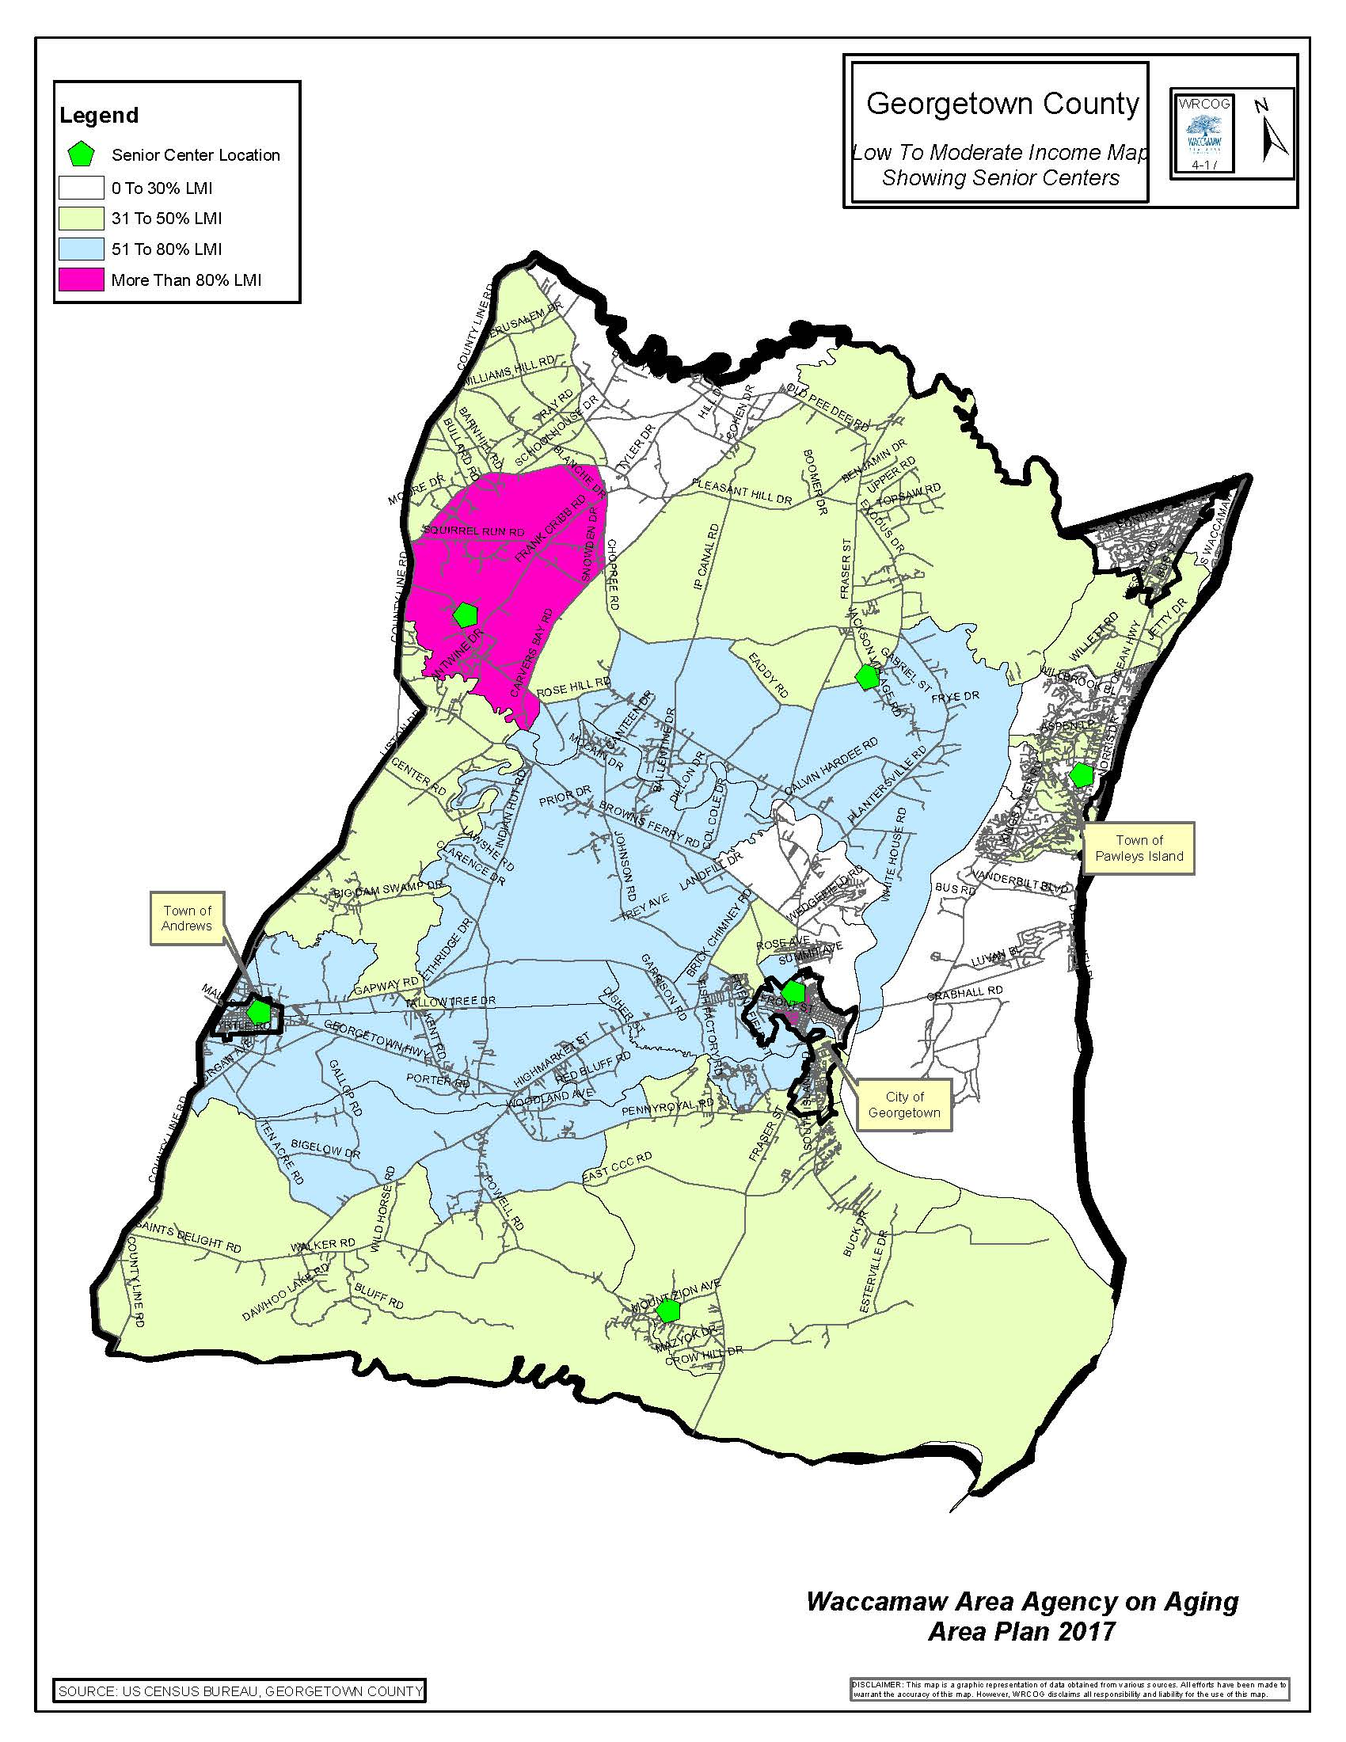

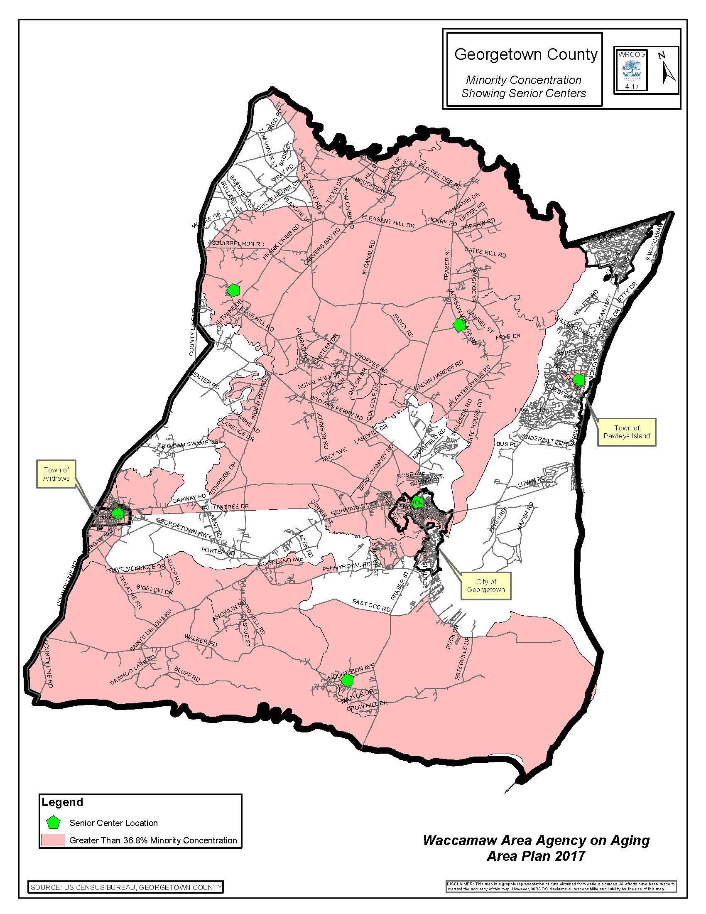
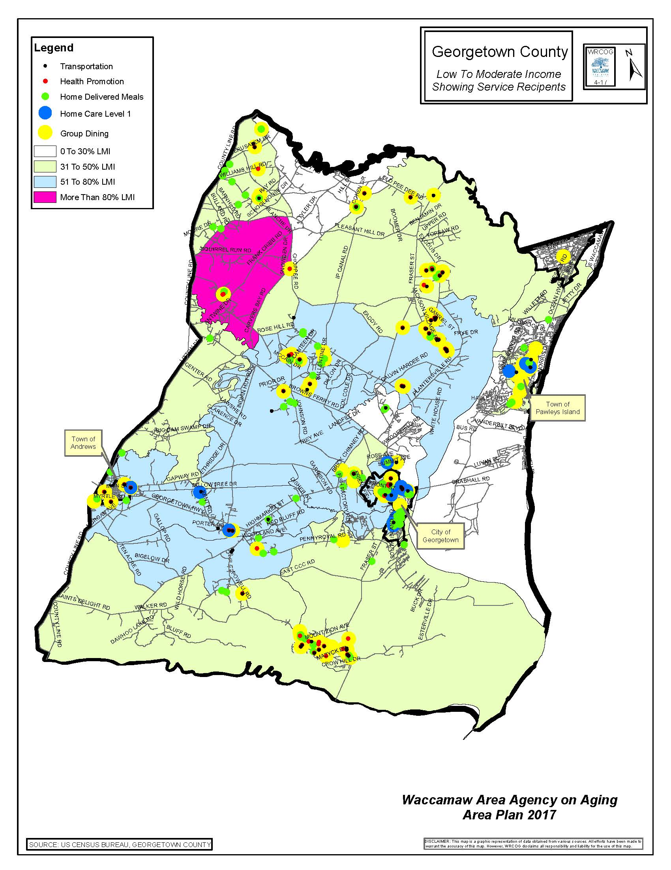

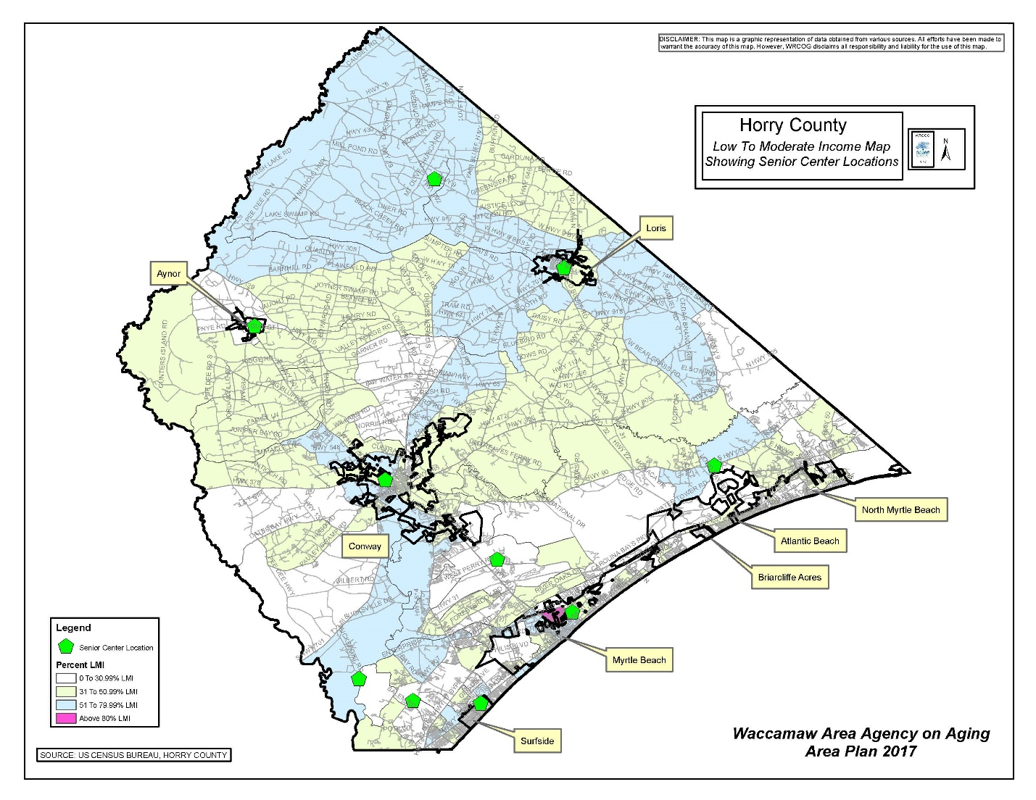

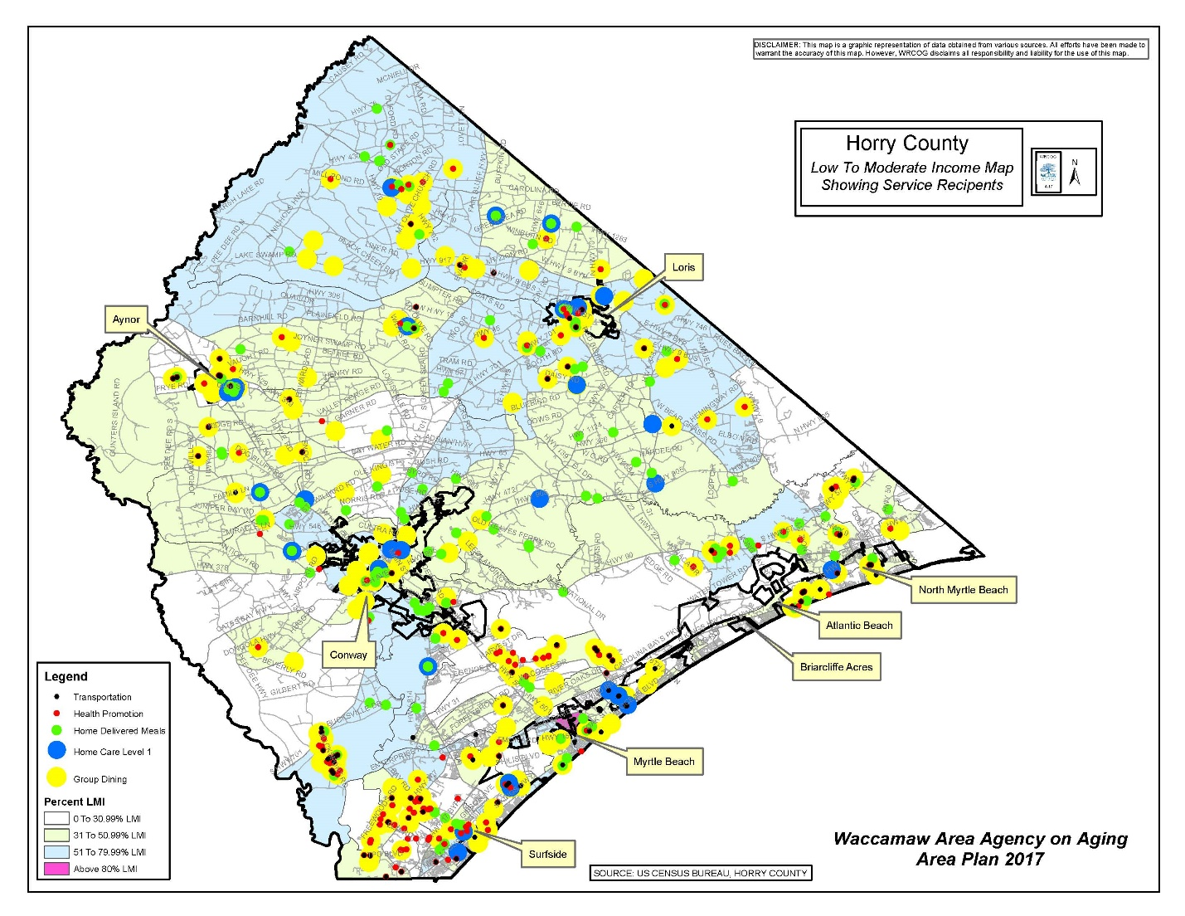

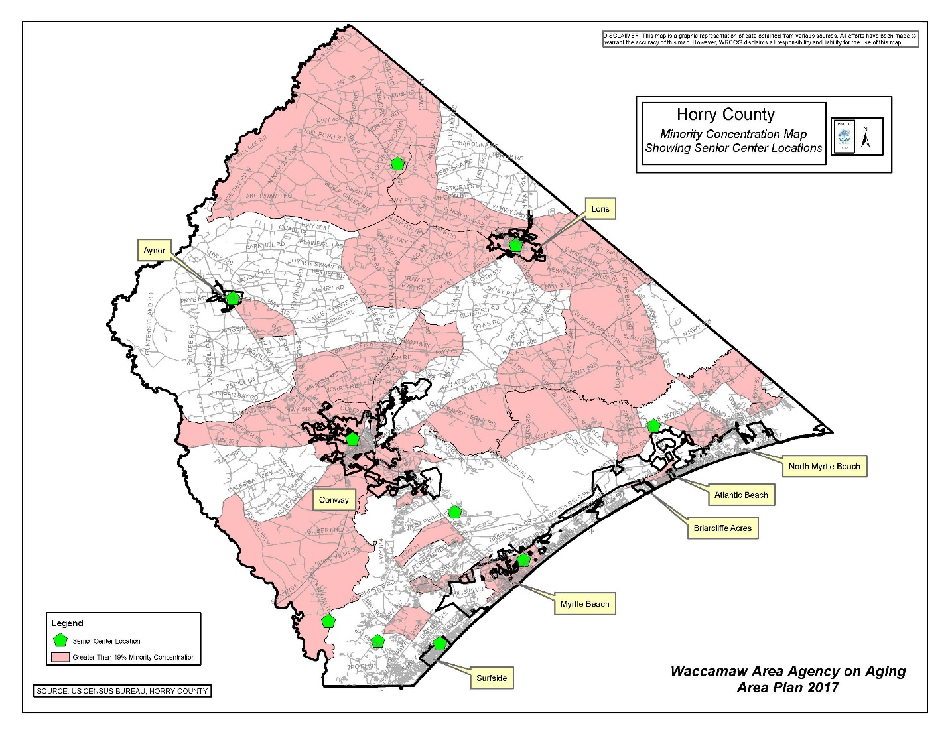

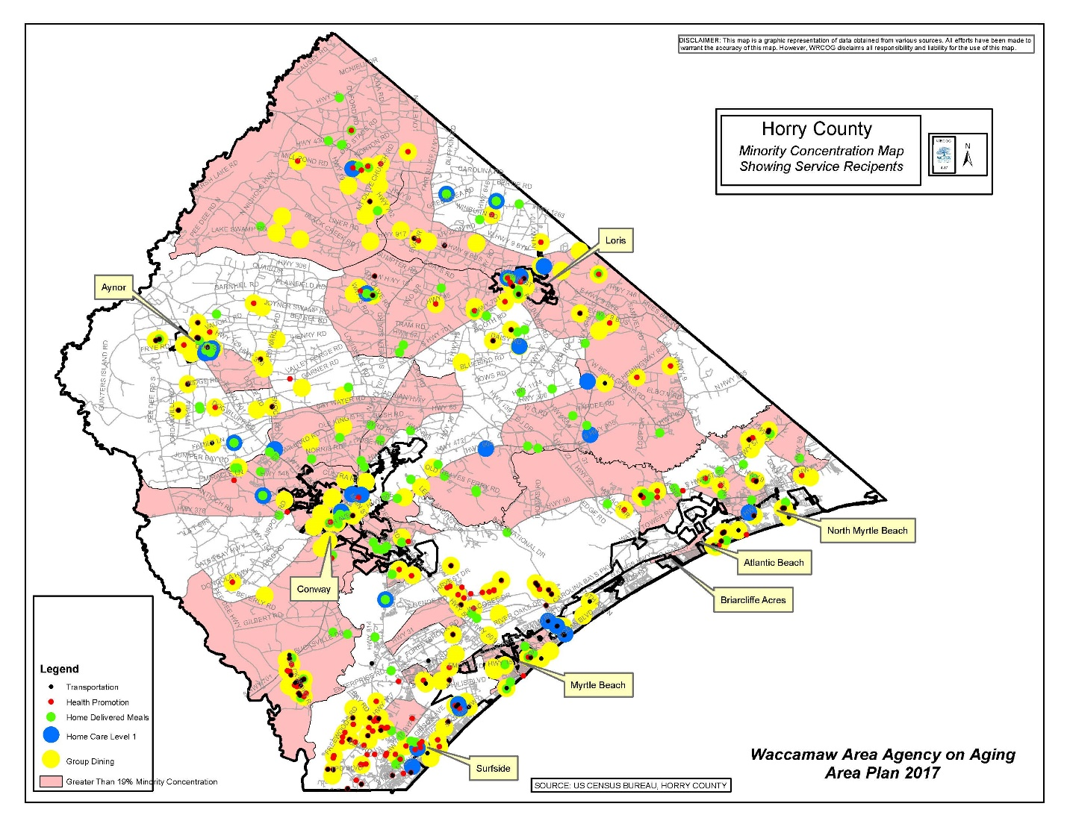

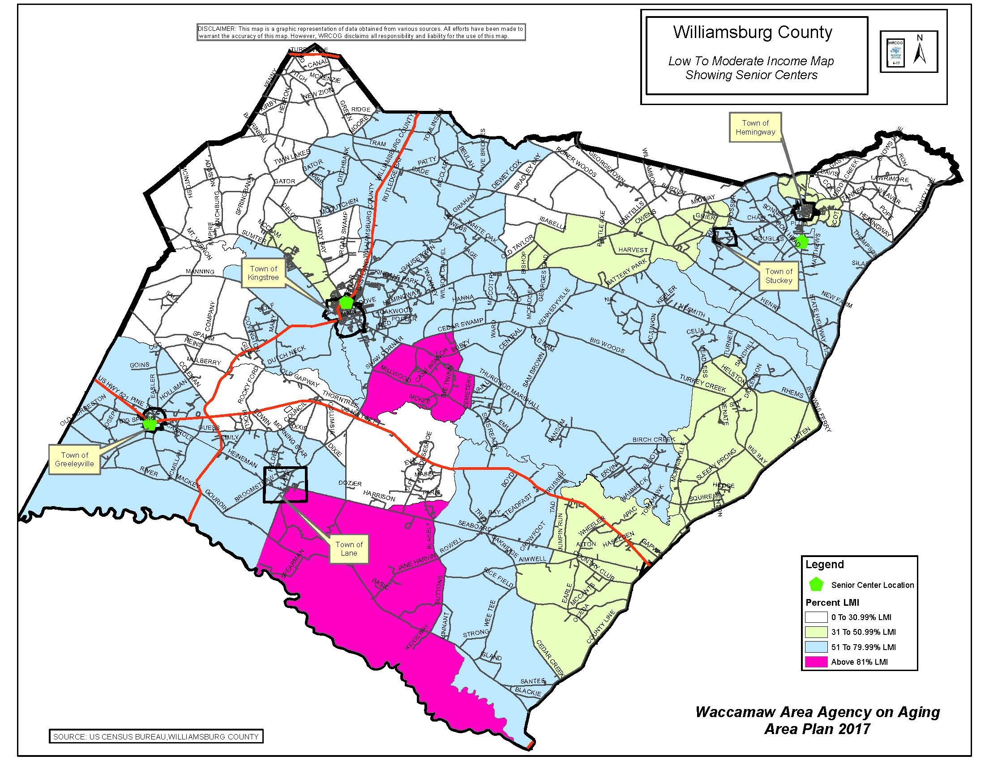

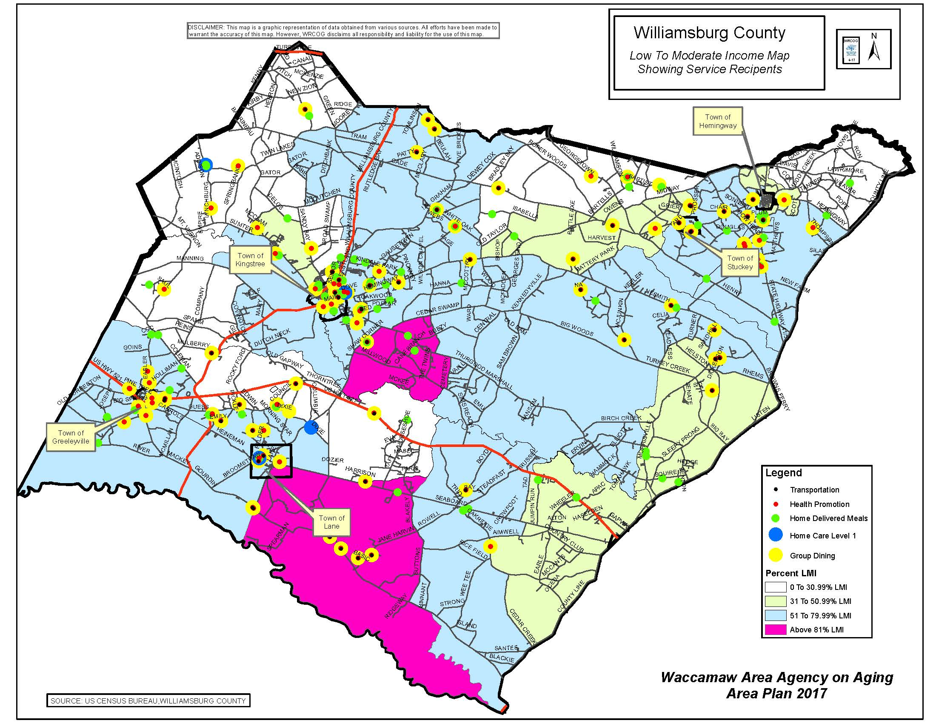

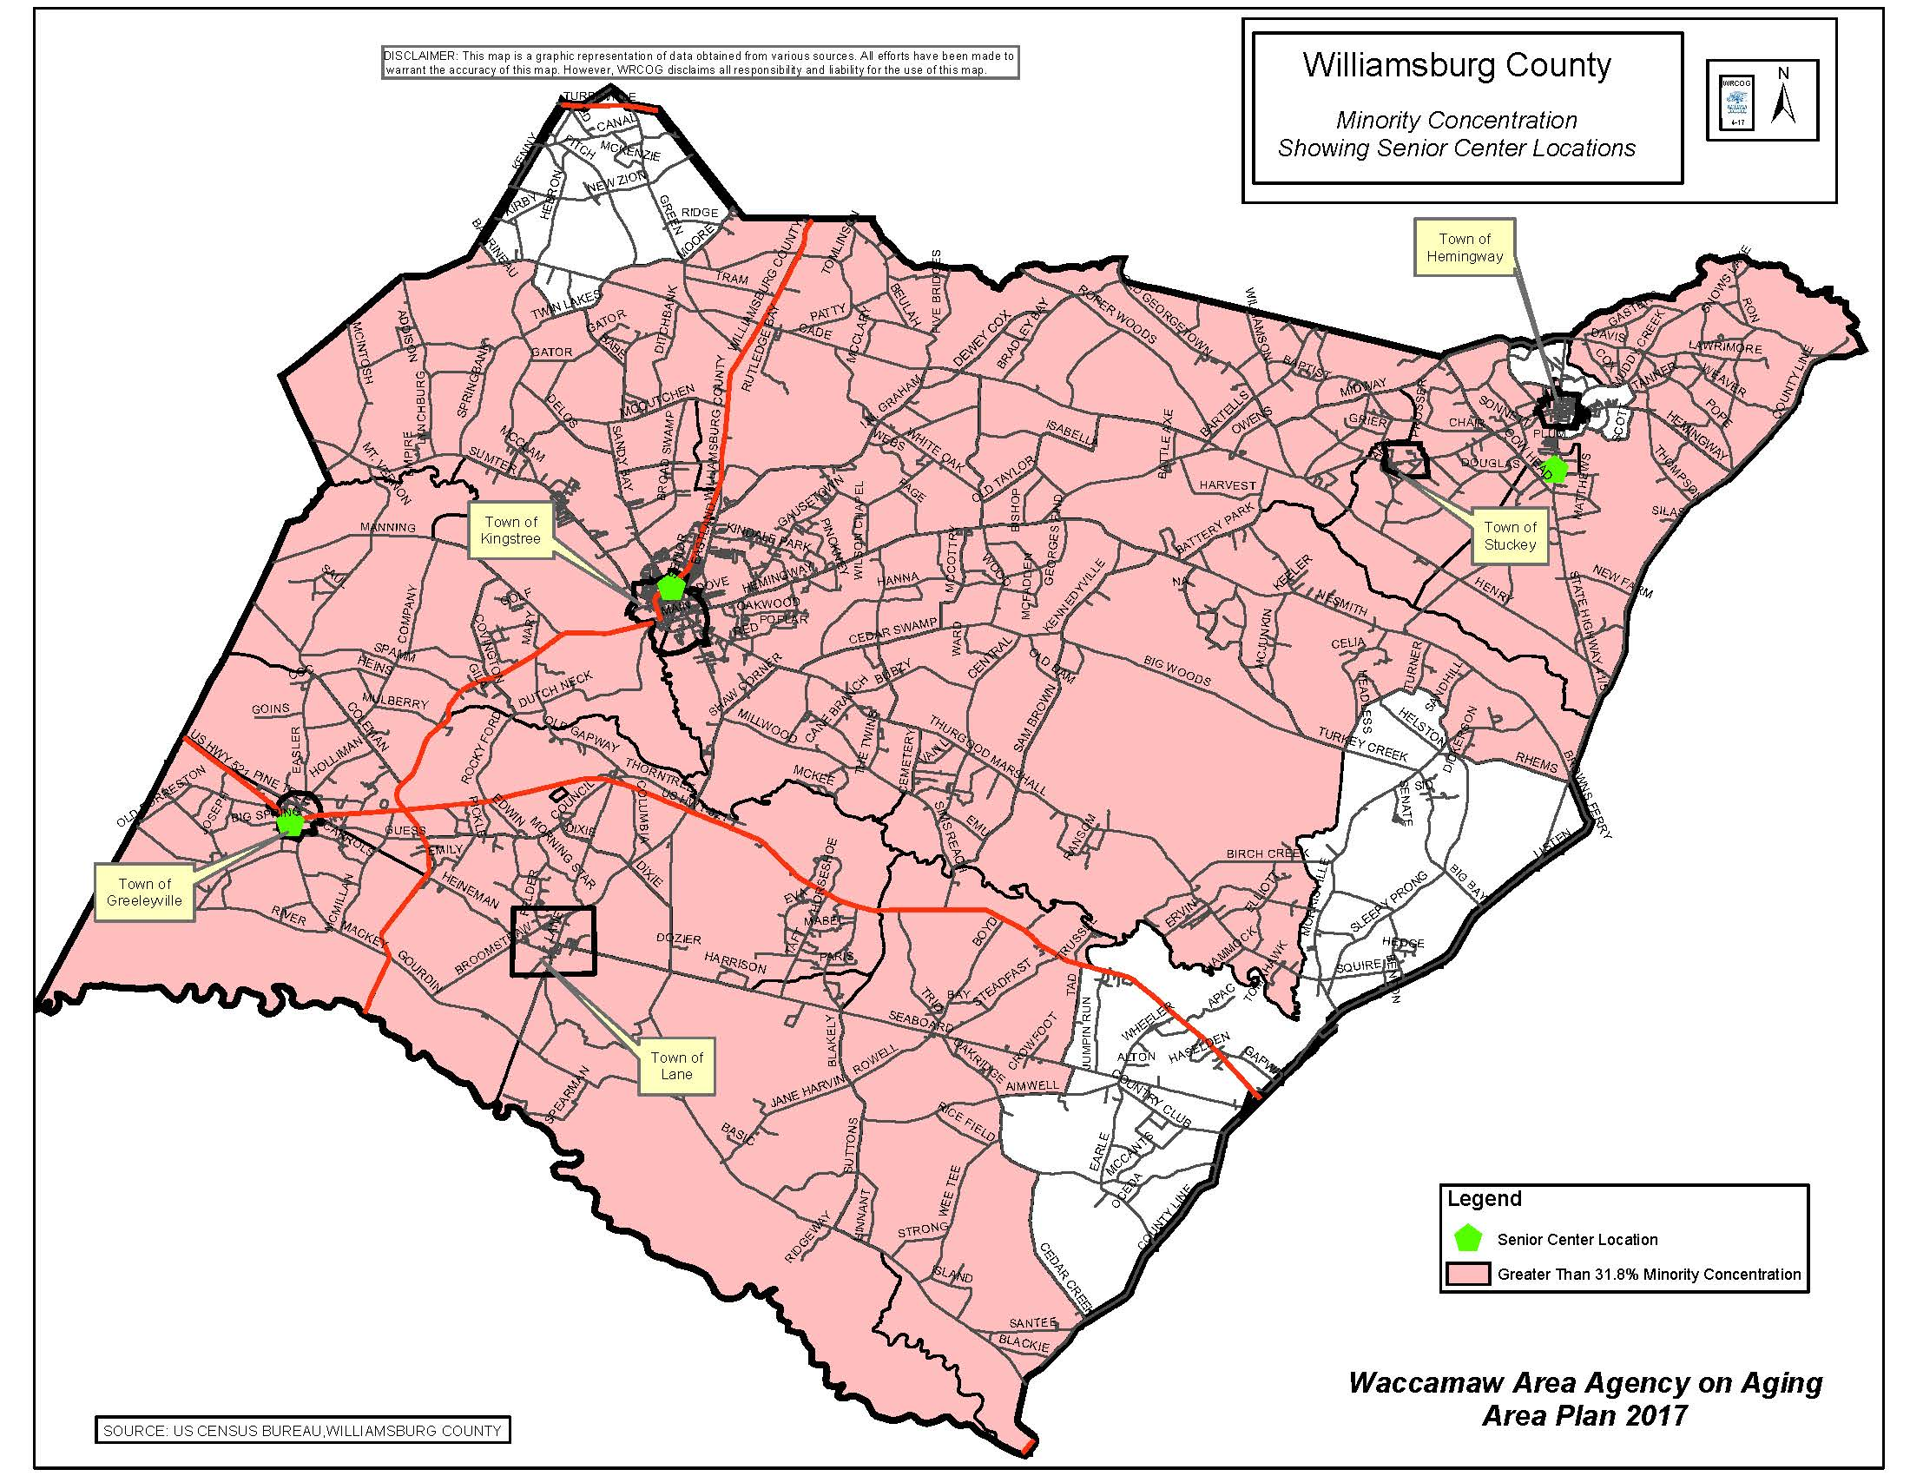

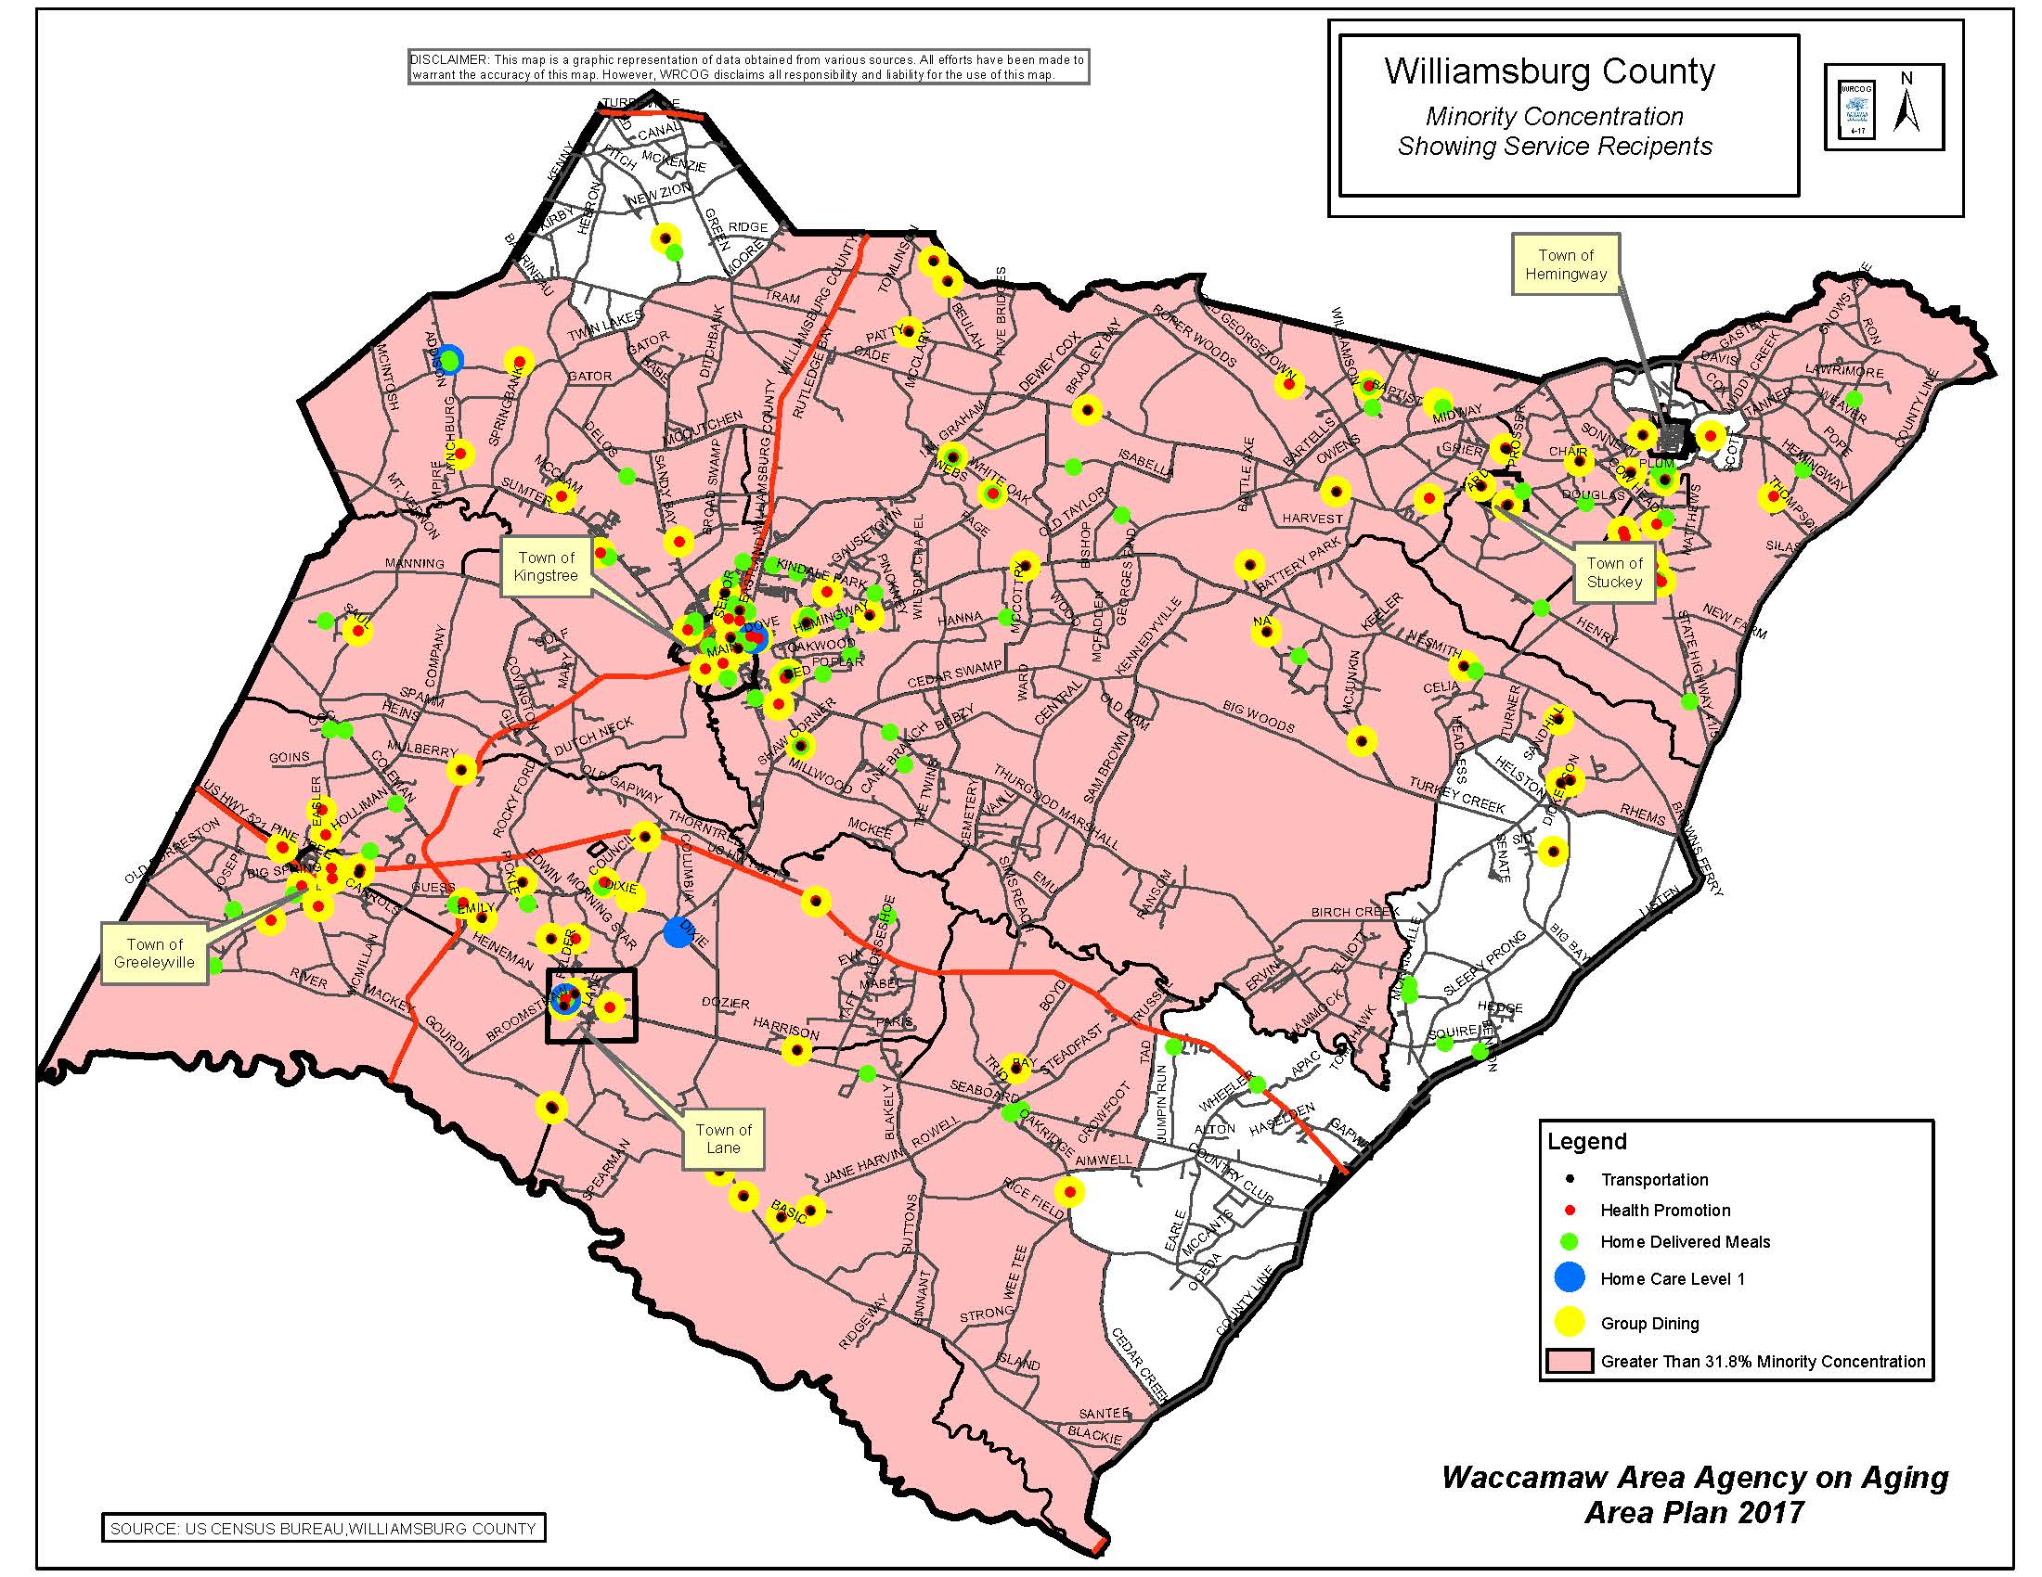

Attachment F: Strategic Planning, Workforce, Process Management and Client/Customer Satisfaction

Strategic Planning
The Waccamaw Area Agency on Aging conducts strategic planning through input from staff, community partners, clientele, potential clientele, Regional Aging Advisory Council and COG Board of Directors.
This process includes assessment of aging services by all stakeholders included above, demographic information concerning aging population in our region as well as South Carolina as a whole. Stakeholders identify opportunities, threats, as well as assess strengths and weaknesses.
Financial and regulatory strategic planning is conducted through the Finance Department as well as the Finance Committee of the COG Board of Directors through audit, meetings, reviews, etc.
Department heads meet monthly to assess program controls and provide updates, individual departments staff meet regular to assess changes, improvements, challenges, etc.
Monthly reporting for each department are provided to the COG Board of Directors at each meeting.
Quarterly reporting for aging services and programs are reported to the Regional Aging Advisory Council during each meeting.

Workforce Focus
The Waccamaw Area Agency on Aging understands the issues regarding our aging network workforce and addresses these issues through internal cross-training, following trends, and continuous promotion of succession planning to upper management.
All staff members are provided opportunities for training both in their areas of expertise as well as those outside of their particular field. Training opportunities include the Southeastern Association of Area Agencies on Aging annual training as well as the National Association of Area Agencies on Aging annual training. State and local training opportunities are also encouraged. Sharing of information and institutional knowledge is paramount in ensuring uninterrupted services and programs. Regular internal meetings and sharing opportunities are one of the tools we use to accomplish these tasks.
Senior leaders in our organization set goals and directions for our overall agency and allow department managers to create strategies to realize these overarching goals. Performance evaluations are conducting yearly to assess performance as well as to set personal goals for professional development.
The Council of Governments assesses its workforce based on needs and funding. Skills and competencies are set by upper management with input from department directors on an as needed basis.

Process Management
The Waccamaw Area Agency on Aging determines its core competencies through on-going internal assessment as well as our communities assessment of our programs and action plans.
Each and every program housed within the Area Agency on Aging has the opportunity to assess itself through client and community interactions. Reporting to and through our Regional Aging Advisory Council, Community Resource Collaborations and our Board of Directors allows opportunity to assess our successes as well as determine improvements needed across programs.
Needs assessment and customer satisfaction surveys help to encourage input and help each department understand changes that need to be made and encouragement and expansion of those areas for which we excel.
Yearly obligations are determined at the beginning of each fiscal year based on funding and in-kind resources. Funding is allocated based on need and funding levels in conjunction with COG fiscal staff and presented to the COG Board of Directors for approval.

Client/Customer Satisfaction
The Area Agency on Aging is able to determine its clientele through data gathered through the AIM system, SCAccess, Ombud, etc. Key requirement are determined through on-going assessment of service successes and client satisfaction or dissatisfaction.
The Area Agency staff are involved in a myriad of community organizations throughout our region. These collaborations and our participation allow us to keep our finger on the pulse of our aging population as well as those who will soon enter this arena. We are always open to hearing both positive and negative input to ensure that we are meeting the community expectations for service and develop those services for which we do not currently provide. Through these collaborations and the surveying of clientele and potential clientele we are able to see the differences in current and future populations. Service delivery options will have to change to accommodate the changing needs and preferences of our population.

Attachment G: Area Plan Public Hearings
Public hearing input will be added after May 2, 2017

