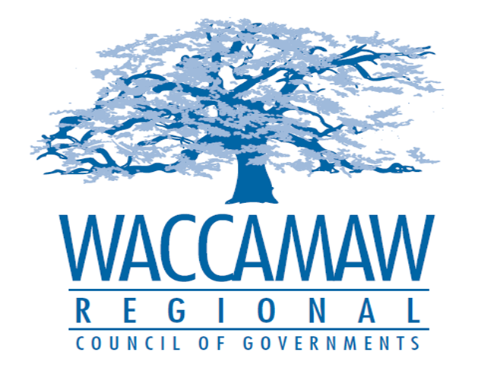
BOARD OF DIRECTORS’ MEETING
Monday, October 9, 2017 - 7:00 PM
1230 Highmarket Street, Georgetown, South Carolina 29440

- Call to Order……………………………………………………………………………....Randal Wallace, Chairman
- Invocation
- Introduction of Guests
- Determination Quorum
- Approval of the August 14, 2017 Minutes

- Finance Report ………………..…………………………………………….………..…Arnold Johnson,
Finance Director

- Section 208 Major Amendment
Grand Strand WSA Longs WWTP Expansion……………………………………........Dan Newquist, Environmental Planner
Board Action Required

- Comprehensive Economic Development
Strategy Resolution……………………………………………………………………...Tomas Langley,
Deputy Director of Workforce and Economic Development
Board Action Required

- NADO Award Projects…………………………………………………………………......Ayla Hemeon,
Workforce and Development Director

- HOME Comprehensive Annual Performance
and Evaluation Report (CAPER)…………………………………………………………...Tom Britton, Planning Director
Board Action Required

- Executive Director’s Report………………………………………….……………………..Sarah Smith,
Executive Director

- Next Meeting: November 13, 2017

- Other Business

