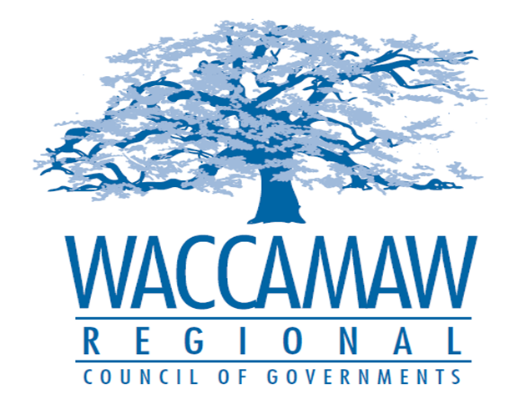

BOARD OF DIRECTORS’ MEETING
Monday, December 11, 2017 - 7:00 PM
1230 Highmarket Street, Georgetown, South Carolina 29440

- Call to Order……………………………………………………………………………....Randal Wallace, Chairman
- Invocation
- Introduction of Guests
- Determination Quorum
- Approval of the November 13, 2017 Minutes

- Finance Report ………………..…………………………………………….………..…Arnold Johnson,
Finance Director

- Rebuilding Our Roads………………………………………………...……………Randall Young, P.E.,
Chief Engineer for Project Delivery

- Executive Director’s Report………………………………………….……………………..Sarah Smith,
Executive Director

- Next Meeting: January 8, 2018

- Other Business

- Adjournment

