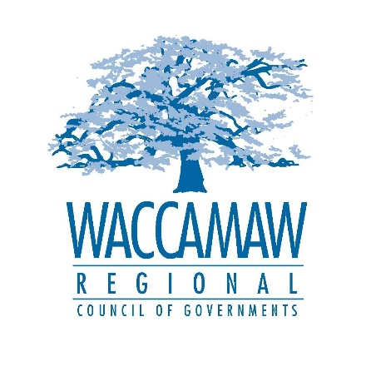

Date of Notice: September 13, 2023

WACCAMAW REGIONAL COUNCIL OF GOVERNMENTS
WACCAMAW HOME CONSORTIUM
HOME INVESTMENT PARTNERSHIPS PROGRAM

PUBLIC COMMENT PERIOD

September 13, 2023- October 13, 2023

The Waccamaw Home Consortium (Consortium), representing Georgetown, Horry and Williamsburg counties, is proposing a substantial amendment to the HOME program’s 2016 Annual Action Plan and 2017 Annual Action Plan.

SUBSTANTIAL AMENDMENT TO GEORGETOWN COUNTY'S 2016 ANNUAL ACTION PLAN.

This amendment is a substantial amendment. This designation was determined due to the activity being a new activity. The amendment will consist of adding a new project, "Horry County TBRA". PY 2016 funds in the amount of $383,065.79, through a subrecipient agreement, will be used by Horry County to carry out the TBRA Rental Program.

The amendment also includes adding a new project "Horry County Owner Occupied Rehab". PY 2016 funds in the amount of $31,803 were utilized in completing owner occupied projects in other funding years.

SUBSTANTIAL AMENDMENT TO GEORGETOWN COUNTY'S 2017 ANNUAL ACTION PLAN.

This amendment is a substantial amendment. This designation was determined due to the activity being a new activity. The amendment will consist of adding a new project, "Horry County TBRA". PY 2017 funds in the amount of $422,811, through a subrecipient agreement, will be used by Horry County to carry out the TBRA Rental Program.

Public Meeting: A public meeting will be held at the Consortium’s office (1230 Highmarket Street, Georgetown, SC 29440) on Thursday, September 28, 2023 at 6:00pm. Persons who need reasonable accommodations for any type of disability to participate in this meeting should contact Waccamaw Regional Council of Governments at 843-546-8502 at least 5 working days before the meeting date.
Draft copies of the amendment will be available for public review from September 13, 2023 to October 13, 2023 at the Consortium’s office (1230 Highmarket Street, Georgetown, SC) and online at WRCOG’s website www.wrcog.org. Written comments may be mailed to the Waccamaw HOME Consortium, c/o Marsha Smith, Waccamaw Regional Council of Governments, Grant Services Department, 1230 Highmarket Street, Georgetown, SC 29440 or by email to msmith@wrcog.org no later than October 13, 2023.

COMMENT PERIOD BEGINS: September 13, 2023
COMMENT PERIOD ENDS: October 13, 2023

