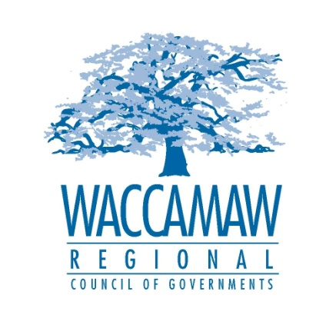
PUBLIC NOTICE

WACCAMAW HOME CONSORTIUM

Notice of Funding Availability

In planning the 2016-2017 program year budget, The Waccamaw Regional Council of Governments HOME Consortium will be seeking applications from non-profits, for-profits, local governments and Community Housing Development Organizations (CHDOs). The U.S. Department of Housing and Urban Development HOME funds (Home Investment Partnership Act of 1992) may be used for approved new construction and renovation of rental housing units, and tenant based rental assistance programs. Grants and low interest loans will be available for eligible projects.

Applications may be obtained on the Waccamaw Regional Council of Government website www.wrcog.org or by contacting Courtney Kain. Applicants may also schedule a technical assistance meeting on February 16, at the Waccamaw Regional Council of Governments, 1230 Highmarket Street, Georgetown, SC 29440.

All applications will be due February 23, 2016 by 5:00pm in the offices of the Waccamaw Regional Council of Governments. Applications received after the due date will not be eligible for funding.

Contact: Courtney Kain, HOME/ Community Development Planner
Waccamaw Regional Council of Governments
(843)436-6126
ckain@wrcog.org

