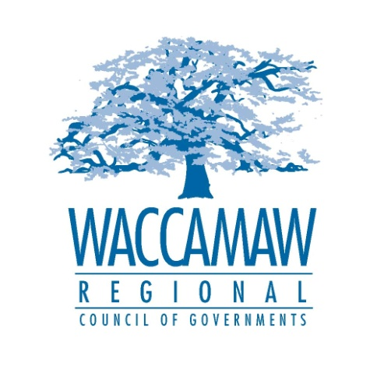
Waccamaw Air Quality Coalition
Thursday July 16 2015- 10:00am
WRCOG Conference Room
1230 Highmarket St.
Georgetown, SC 29440

Local and Regional Bicycle and Pedestrian Projects and Initiatives

- Welcome and Introductions Daniel Newquist, WRCOG

- GSATS Project Updates Mark Hoeweler, WRCOG

- City of Myrtle Beach- Bicycle and Diane Moskow-McKenzie
Pedestrian Committee, Complete Streets Policy. City of Myrtle Beach Planning

- Horry County Bicycle Survey Dr. Sharon Thompson
Coastal Carolina University

V. Bike the Neck Initiative Update Linda Ketron
Bike the Neck Director

VI. Bureau of Air Quality Update Randy Cook, SC DHEC
National Bike Month Challenge

VII. Other Partner Updates and Announcements

VIII. Future Meeting Dates and Topics Daniel Newquist, WRCOG

IX. Adjourn

