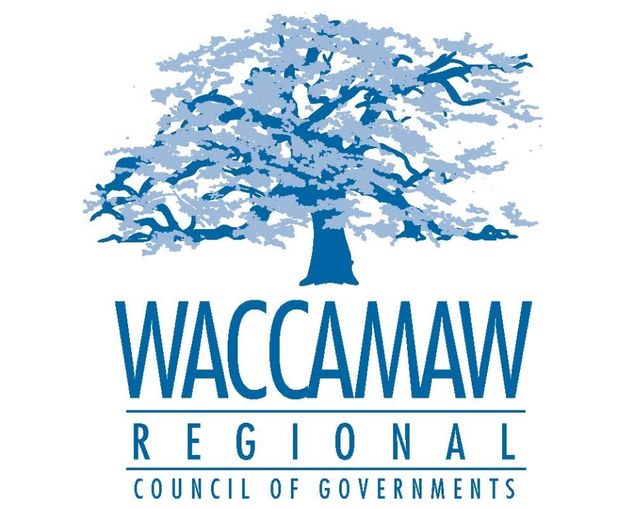

WACCAMAW HOME CONSORTIUM
DRAFT CONSOLIDATED ANNUAL PERFORMANCE
AND EVALUATION REPORT (CAPER)
Program Year 2014-2015
(July 1, 2014-June 30, 2015)
DRAFT FOR PUBLIC COMMENT
Submitted to HUD September 29, 2015

Prepared for:
The U.S. Department of Housing and Urban Development

By:
The Waccamaw HOME Consortium
C/o Waccamaw Regional Council of Governments
Georgetown, South Carolina
INTRODUCTION

HOME funds are used to enhance the region’s effort to provide quality affordable housing to low and very-low income households, to expand the capacity of local nonprofit affordable housing providers and to leverage other funds for local affordable housing efforts. Program Year 2014 was the Waccamaw HOME Consortium’s (WHC) eighth year of funding through the U.S. Department of Housing and Urban Development HOME Investment Partnerships Program (HOME). The data reported in this CAPER is for activities for which the WHC has dispersed funds during the program year beginning July 1, 2014 and ending June 30, 2015.

The WHC Consolidated Plan’s Jurisdiction includes 15 municipalities and 3 counties. Georgetown and Horry counties are situated on the Atlantic coast, while Williamsburg County is inland. Georgetown County is the smallest of the three counties in terms of land area and second in population; it covers 815 square miles. The City of Georgetown is the county seat and the other towns participating in the HOME Consortium are Andrews and Pawleys Island.

Horry County is the largest in area, 1,134 square miles, as well as in population. Its county seat is Conway, and other cities and towns include Atlantic Beach, Aynor, Briarcliffe Acres, Loris, Myrtle Beach, North Myrtle Beach, and Surfside Beach. Of these cities and towns, all are members of the Consortium with the exception of Briarcliffe Acres. Williamsburg County covers 934 square miles and has the smallest population. Its county seat is Kingstree. Other towns include Greeleyville, Hemingway, Lane, and Stuckey; all of which participate in the Consortium.

The HOME Program project activity data in this report includes those projects that have been marked as “Completed” in HUD’s automated Integrated Disbursement and Information System (“IDIS”) for the reporting period as well as ongoing. IDIS protocols allow completed status only for those project activities for which all information has been entered for project closeout.
Consequently, the numerical data reported herein should not be taken as a sole measure of activity in the HOME Program for the period nor should the amounts listed be construed as sole indicators of funds committed and/or disbursed. This report represents the fourth report of the five-year HUD-mandated Consolidated Plan.

ADMINISTRATION
By way of a written agreement with the County of Georgetown, the lead agency of the WHC, the Waccamaw Regional Council of Governments (WRCOG) administers the HOME program funds. This includes conducting an annual planning effort and implementing an annual competitive funding cycle that awards HOME funds for eligible activities.

DISTRIBUTION OF FUNDING
The WHC has not established any specific target areas because the need for affordable housing exists in virtually every part of the region. The WHC works with participating communities and their units of local government to identify and prioritize housing needs. Additional technical assistance is provided to assist in identifying sponsors and developers of activities as well as identifying the additional funding resources needed to make projects viable.
Identified projects are bid competitively through a Request for Proposal process. The process to review proposed activities includes staff review for compliance and eligibility and a Technical Review Committee (TRC), which consists of representatives from all three counties. The TRC makes funding recommendations to the WHC Board. The final, local decision regarding the distribution of HOME funds rests with the WHC Board but is also directly affected by the availability of entities with the capacity and willingness to develop activities eligible for funding.
The WHC is working with community housing development organizations (CHDOs), local units of government, non-profit organizations, for-profit developers, and other stakeholders to develop viable activities to fulfill unmet affordable housing needs. The Consortium provides technical assistance to all partner jurisdictions and assists in identifying viable activities throughout the entire region to ensure adequate distribution of funds.

SUMMARY OF RESOURCES AND
PROGRAMMATIC ACCOMPLISHMENTS

RESOURCES MADE AVAILABLE:

During the twelve month program period the following approximate newly allocated federal HOME funds were made available for affordable housing activities as approved in the 2014 annual action plan.

PROPOSED PROJECT CATAGORIES/GOALS DETAIL FROM 2014 ACTION PLAN

Activity | Description | Proposed Units | Proposed Project Funding
Rental Housing Development | Funds awarded to housing partners for the purpose of producing affordable rental units throughout the service area | 10 | $335,000
Owner Occupied Rehabilitation | Funds for both substantial and moderate rehabilitation of owner-occupied housing units throughout the service area | 14 | $363,732
Homeowner Housing Development | Funds awarded to housing partners for the development of affordable homeownership housing units throughout the service area | 2 | $90,000
Administration |  |  | $87,636
Totals |  | 26 | $876,368

ASSESSMENT OF FIVE YEAR PRIORITIES AND OBJECTIVES:

The Waccamaw HOME Consortium’s 2011-2016 Five Year Consolidated Plan identified six (6) specific housing priorities. Each project/activity for which federal HOME funds were expended during program year 2014 is listed and discussed under the relevant priority.

During this fourth program year, the WHC has continued to work to identify partners and activities to fulfill its Consolidated Plan objectives. Additional administrative efforts were required to develop program compliance standards that aligned with the 2013 New HOME RULE requirements. This included the development of contracts, programmatic and construction standards, and monitoring activities.

A summary table of projects and funding disbursements during the program year 2014 is included in this report.

PRIORITY ONE
Provide HOME funds to support infill rental housing development for low- to moderate-income families.
The WHC Five-Year Consolidated Plan needs assessment identified a growing demand for affordable rental housing. The limited supply of decent, safe and sanitary affordable housing is increasingly making it difficult for low-income households, those earning 80% or less of the area median income, to find adequate housing.
Therefore, the Consortium established a priority to preserve and expand available affordable housing opportunities in cooperation with qualified for-profit and nonprofit developers. This program provides funding for new rental construction and rehabilitation for primarily low and moderate-income housing consisting of five or more housing units, with an emphasis on urban infill.
The rental program provides funding for the new construction, or rehabilitation of structures for affordable rental projects. Rental housing developments must serve, in whole or part, households earning 60% or less of the area median income (AMI) with a priority given to rental developments serving households earning 30% or less of the AMI. Housing developments having a mixture of incomes are encouraged. The Consortium will maintain the affordability for units through the use of deed restrictions and resale/recapture restrictions, as appropriate. The minimum length of the affordability period is based on the amount of Consortium financing per unit and type of development.
The five year goal is 100 units of new or rehabilitated rental housing in developed areas with an emphasis on serving special needs and elderly populations. During 2014, 22% of the five year goal was completed.
Grand Strand Housing Affordable Rental Housing Development
For the 2014 Program Year, $180,000 was awarded to a partner with Grand Strand Housing and Community Development Corporation, for the acquisition and rehabilitation of four existing single-family housing units in Horry County. These units were developed into affordable rentals.
As of June 30, 2014, four of the units were acquired, completely rehabilitated and occupied by income-qualified families. This project was a continuation of PY 2013 and 63,800.75 was disbursed for this project during the program year ending June 30, 2014.

Santee-Lynches Affordable Rental Unit Development
Santee-Lynches Affordable Housing and Community Development Corporation was awarded $180,000, for the acquisition and rehabilitation of four existing single-family housing units in Horry County. This completes the project which commenced in 2013.

Four units were acquired, completely rehabilitated and are occupied by income-eligible families. This was an ongoing project completed during the fiscal year ending June 30, 2014. The 2014 disbursement was $20,611.88 for this project.

Tri-County Rental Development
In April, 2011 funds were awarded to Tri-County Regional Development Corporation (a local CHDO) for the development of affordable rental housing units in the West End Neighborhood of the City of Georgetown. Two multi-unit apartment complexes, known as the Winyah Apartments, at the corner of Duke Street and Lynch Street were acquired in late 2012 with financing from the South Carolina Community Loan Fund. This property is comprised of two rental development projects: Duke Street Apartments consisting of six attached, 3 three bedroom townhouses and Lynch Street Apartments consisting of eight attached, three bedroom townhouses. A well-coordinated effort between Tri-County and the Waccamaw Housing Consortium has yielded revitalization of a cornerstone property in the West End Neighborhood.

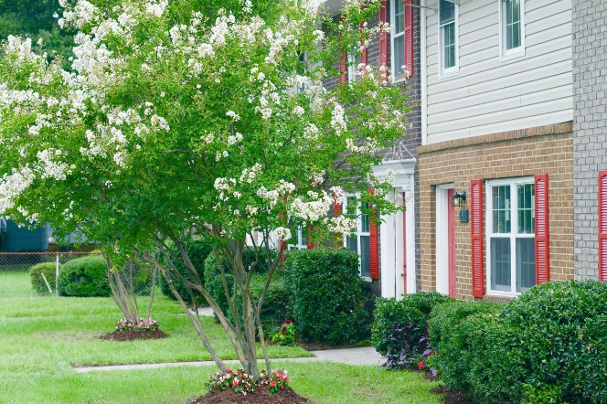
Duke Street Apartments

This 6-unit project is near completion and is occupied. As of June 30, 2014, $128,701.34 has been disbursed for this project. The remaining funds will be allocated to mitigate storm water run-off and other water mitigation projects.

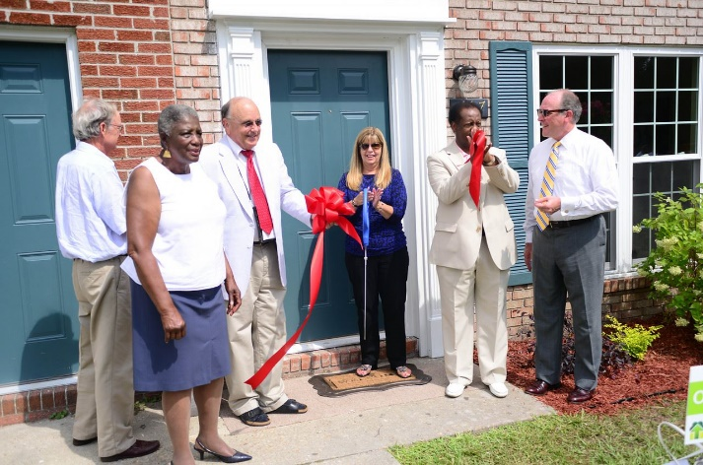

Lynch Street Apartments
This 8-unit project is near completion and is occupied.
As of June 30, 2014, $178,324.67 has been disbursed for this project. The remaining funds will be allocated to mitigate storm water run-off and other water mitigation projects .

PRIORITY TWO
Provide HOME funds for owner occupied rehabilitation of substandard housing in all areas of the region.
The Consolidated plan identifies the cost burden experienced by low and very-low income homeowners as a major impediment to achieving quality, affordable housing. Cost burden makes it difficult for existing homeowners to complete general repairs and maintenance on their homes and threatens the general stability of a neighborhood.
This program provides funding for new construction, rehabilitation of structures for affordable rental, innovative homeownership, and special needs homeowner housing. The Consortium will maintain the affordability for units through the use of deed restrictions and resale/recapture restrictions, as appropriate. The minimum length of the affordability period will be based on the amount of Consortium financing per unit and type of development.
WHC strengthens the area's affordable housing stock by providing grants, deferred loans and/or low-interest loans to low and moderate-income homeowners to substantially rehabilitate their homes. To qualify the person must own and occupy the home and earn 80% or less of median income. The goal is to substantially rehabilitate 50 units in the coming five years with a focus on both rural and urban areas, and inclusive of replacement housing and Elderly Transportable Units. In 2014, WHC completed 14% of the rehabilitations required to meet that goal.

Horry County Owner Occupied Housing Rehabilitation
WHC provided funding for owner-occupied housing rehabilitation to the Horry County. Horry County entered into an agreement with Mary’s Lighthouse to manage the construction and project management for designated HOME projects.

All HOME funded rehabilitation projects bring the entire home up to proper building code standards, with the goal of ensuring descent, safe and sanitary housing. Horry County worked on seven qualified owner-occupied housing units the 2014 program year.

Horry County Community Development has focused on both ADA accommodations as well as safety issues during this program year. The scope of work includes widening doors and bringing bathroom facilities up to code and meeting ADA accessibility for LMI qualified individuals using HOME funds.

Furthermore, where needed, Horry County provided Community Development Block Grant (CDBG) funding to ensure the completion of units that required work beyond the $37,500 per-unit limit set under the HOME program.

PRIORITY THREE
Provide HOME funds to enable low- to moderate-income families to purchase affordable homes
The limited supply of decent, safe and sanitary affordable housing is increasingly making it difficult for low-income households, those earning 80% or less of the area median income, to find adequate housing. Therefore, the Consortium established a priority to preserve and expand available affordable housing opportunities in cooperation with qualified for-profit and nonprofit developers.
For homeownership developments, the target housing development must primarily serve households earning 80% or less of the area median income. Housing developments having a mixture of incomes are encouraged. The Consortium will maintain the affordability for units through the use of deed and recapture restrictions as appropriate. The minimum length of the affordability period will be based on the Consortium’s financing per unit. The five year goal is to create 25 new homebuyer opportunities in infill areas in the coming five years. 2014 saw a completion 3% of that goal. WHC anticipates the completion of an additional seven home in 2015.
Georgetown/Andrews Scattered Site
In 2011, the WHC committed construction funding to Habitat for Humanity of Georgetown County in the amount of $100,000 to construct four single family homes. This project has four scattered sites, three in Georgetown and one in Andrews. All four units have been completed. A total of $10,217.11 was expended for completion of this activity during the 2014 program year. All homes are occupied by low-to moderate-income families.

Habitat for Humanity of Horry County
Habitat for Humanity of Horry County has one unit under construction as a part of the Hopes Crossing project. This project includes the development of four units in Horry County. A total of $20,035.88 was spent in the construction of lot #5 as well as the predevelopment activities on the site.

All homeownership projects require a deferred forgivable mortgage for five to fifteen years depending on how much assistance they receive. Due to the level of assistance for all homeownership projects in this report, they each have ten-year resale provisions in order to maintain affordability.

PRIORITY FOUR
Affirmatively Further Fair Housing in the Waccamaw Region
The WHC affirmatively furthers Fair Housing by creating affordable housing units. All funding provided through the WHC requires that its partners develop an affirmative marketing plan and have policies and procedures in place that affirmatively further Fair Housing. Each project site must also include the Fair Housing logo on signage as well as flyers, brochures and pamphlets regarding the project. These actions are described in greater detail in the section marked “Other Actions taken to Alleviate Fair Housing Barriers“. All plans must be reviewed and approved by the WHC prior to project start. Documentation showing compliance with plans, are reviewed during monitoring.

PRIORITY FIVE
Provide HOME funding to build capacity for Community Housing Development Organizations (CHDO’s)
As a part of the WHC’s Consolidated Plan, the Consortium recognized that there was no single experienced CHDO that serves all three counties in the region. As a result, the Consortium created a CHDO for these purposes in April 2011 and will continue building the capacity of the new CHDO in the coming five years with the assistance of CHDO Operating funds.
The WHC is currently working with six Community Housing Development Organizations (CHDO): Habitat for Humanity of Georgetown County, Grand Strand Housing, Home Alliance, Homes of Hope, Santee-Lynches CDC and Tri-County RDC. Grand Strand Housing, Homes of Hope, Santee-Lynches CDC and Tri-County RDC serve all three counties. Home Alliance serves Horry County and Habitat for Humanity of Georgetown County serves Georgetown County. The WHC staff supports these CHDO’s by assisting them with finding quality projects and providing technical assistance on future projects in the region.

Given all CHDO organizations are beyond their initial three year capacity building period, the WHC now provides operating funds to some CHDOs who have active development projects. The WHC staff continues to provide guidance and technical assistance.
Grand Strand Housing received a total of $1,666.67 in operating funds during the program year in association with its acquisition and renovation of four existing housing for affordable rentals in Horry County. Tri-County Regional Development Corporation received a total of $6,666.68 in operating funds during the program year in association with the development of the ETU program and implemented the construction phase of the Duke Street & Lynch Street Apartment project.

PRIORITY SIX
Reduce lead-based paint through mitigation
Lead-based paint is a concern in the region; more than 35,000 homes in the three-county area are estimated to contain lead paint. The WHC works to reduce the number of housing units with lead-based paint by requiring that each potentially-funded, eligible owner-occupied and rental housing units undergo a standardized lead-based paint assessment. Appropriate mitigation is conducted if necessary and a clearance letter must be filed.

PROJECTS IN PRODUCTION
2014 was the first year that the new HOME RULE came into effect. Planning and policy implementation slowed the development of several projects, due to the reconstruction of processes and agreements. Most impacted was the development of new construction rental units, and homebuyer units. Projects in production include the following:
Grand Strand Housing: Will develop four rental units and 14 homeowner occupied units in 2015.
Habitat for Humanity of Georgetown County: Construction of four new homes will begin during the first reporting quarter of 2015.
Habitat for Humanity of Horry County: Eleven homes located within Horry County to develop “Hopes Crossing”. Construction will commence during the first reporting period of 2015.
Home Alliance – Grey St.: Four new rental units will be under construction during the first reporting period of 2015.
Homes of Hope: This project will be rebid during the first quarter 2015. Four new units will enter into construction during the second reporting quarter of 2015.
Santee Lynches CDC: Four unit Rental Development will be acquired and rehabbed in 2015.
PROGRAM YEAR 2014
PROJECT EXPENDITURE SUMMARY
BY PROJECT TYPE AND COUNTY
Project | HOME Funds Disbursed | HOME  Assisted Units | HOME Funded Units  (pending) | Disposition | Project Type | Location
Habitat for Humanity of Horry County Project Hopes Crossing | $20,035.88 | 5 | 4 | 1 completed unit and 1 under construction | Homeowner New Construction | Horry
Horry County Homeowner Rehabilitation | $106,429.82 | 7 | 5 | outstanding unit will be completed in September 2015 | Homeowner Rehabilitation | Horry
Habitat for Humanity Georgetown County | $10,254.92 | 3 | 0 | 3 completed | Homeowner New Construction | Georgetown
Tri-County Regional Development Duke/ Lynch St. | $307,026.01 | 14 | 0 | 14 completed units. 13 occupied. Water mitigation project will be completed by 12/31/15 | Rental Rehabilitation | Georgetown
Grand Strand Housing Scattered Site | $65,837.19 | 4 | 0 | Completed | Rental Rehabilitation | Horry
Grand Strand Housing Operating Income | $1,666.67 | - | - | Completed | CHDO Operating | -
Tri-County Regional Development Operating Income | $6,666.68 | - | - | Completed | CHDO Operating | -
Santee-Lynches Affordable Housing | $20,611.88 | 4 | 0 | Completed | Rental Rehabilitation | Horry
Homes of Hope Georgetown West End | $1,113.85 | 4 | 4 | Pre-construction activities | Rental New Construction | Georgetown
Home Alliance – Grey St. | $2,194.53 | 4 | 4 | Pre-construction activities | Rental New Construction | Horry
Santee-Lynches Project #2 | $4,084.12 | 4 | 4 | Pre-construction activities | Rental Rehabilitation | Horry
Administration | $105,467.88 | - | - |  | - | -
TOTAL | $651,389.43 | 49 | 25 | Program Year (Completed): Owner-Occupied Rehabs: 2 Affordable Rentals: 22 Single-family Homeownership: 4
Expenditure by Activity Type for 2014 Program Year: July 1, 2014 – June 30, 2015

EVALUATION OF ANNUAL PERFORMANCE (Administration)

The Department of Housing and Urban Development and the Waccamaw HOME Consortium strive to meet the objectives of providing decent housing and creating suitable living environments with the outcomes of availability and accessibility, affordability, and sustainability. During the 2014 CAPER period, WHC sub recipients completed ongoing projects, developed policies and procedures to align with the compliance standards of the 2013 New HOME rules. Moreover, many projects completed predevelopment activities and will start construction during 2015.
The following table reflects the proposed goals and actual outcomes from the 2014-2015 Annual Action Plan.
CONSOLIDATED ANNUAL PERFORMANCE & EVALUATION REPORT
Program Year 2014-2015
General Objective & Activities | OUTCOMES |  |  | Proposed Number | Actual Number
OBJECTIVE #1 – Provide Decent Housing | Availability & Accessibility | Affordability | Sustainability
Activities
Rental Housing – infill | X | X |  | 10 | 22
Preserve & Renovate Substandard Housing |  |  | X | 14 | 4
Owner Housing Development & Purchase |  | X |  | 2 | 4
OBJECTIVE #2 – Create a Suitable Living Environment
Activities
Affirmatively Further Fair Housing | X |  |  | 0 | 0
Reduce Lead paint |  |  |  |  | 0
TOTAL |  |  |  | 26 | 32

BENEFICIARY INCOME DATA/PROJECT TYPE 2014-2015

The table below indicates the level of household income by percentage of area median income for the beneficiary of each of the total number of activity types completed during the program year.

Category | <30% AMI* | 31-50%  AMI | 51-60%  AMI | 61-80% AMI | Total
Homeowner Rehabilitation | 1 | 3 | 0 | 0 | 4
Housing Development | 0 | 0 | 2 | 2 | 4
Rental Development | 7 | 3 | 7 | 2 | 21
Totals | 8 | 9 | 9 | 4 | 32
*AMI = Area Median Income
INDIVIDUAL PROJECT BENEFICIARY INCOME DATA 2014-2015
The table below indicates the level of household income by percentage of area median income for the beneficiary of each of the individual current activities completed during the program year in which case units have been completed and beneficiaries identified.
PROJECT | <30% AMI | 31-50%  AMI | 51-60%  AMI | 61-80% AMI | Total
Georgetown Habitat | 0 | 0 | 1 | 2 | 3
Horry County Habitat | 0 | 0 | 1 | 0 | 1
Grand Strand Housing- Rental Development | 0 | 1 | 3 | 0 | 4
Tri-County Duke & Lynch St. Redevelopment | 7 | 2 | 1 | 2 | 12
Horry County Owner-Occupied Housing Rehabilitation | 1 | 3 | 0 | 0 | 4
Santee-Lynches CDC Rental Development | 0 | 0 | 4 | 0 | 4
Totals | 8 | 9 | 9 | 4 | 32

INDIVIDUAL PROJECT BENEFICIARY RACE/ETHNICITY DATA 2014-2015

The table below indicates the household race by count of the beneficiary of each of the individual activities completed during the program year.
PROJECT | White | Black | Bi-Racial  White/Black | Asian | Am Ind/  Alaskan Native | Hispanic
Habitat Horry County* | 0 | 1 | 0 | 0 | 0 | 0
Georgetown Habitat | 0 | 3 | 0 | 0 | 0 | 0
Grand Strand Housing- Rental Development | 1 | 3 | 0 | 0 | 0 | 0
Tri-County Duke and Lynch St. ** | 0 | 13 | 0 | 0 | 0 | 0
Horry County Owner-Occupied Housing Rehabilitation | 1 | 3 | 0 | 0 | 0 | 0
Santee-Lynches CDC Rental Development | 2 | 2 | 0 | 0 | 0 | 0
Totals | 5 | 27 | 0 | 0 | 0 | 0
*Beneficiary not identified ** vacant units

HOMELESS NEEDS
Representatives of Housing, Social Service and local governments meet regularly to address the needs of the homeless community. The Continuum of Care include discharge planning by local health care providers and jails. The Continuum has already surveyed these agencies regarding their discharge planning and is currently researching best practices on discharge planning to inform local organizations of model protocols. In addition, representatives from the Continuum are coordinating efforts with the State Homeless Council to ensure improved discharge planning from the SC Department of Corrections and the Department of Social Services (foster care). The following table highlights the progress made towards a comprehensive and coordinated discharge planning process.

The Eastern Carolina Homeless Organization (ECHO) is the lead agency of the Continuum of Care (COC) for several counties including the three served by the WHC. Their goals are to decrease the number of homeless through shelter, transitional housing, outreach and prevention programs. The non-profit, Street Reach, based out of Myrtle Beach in Horry County has made strides in building trust among the numerous youth and mentally handicapped homeless in Horry County. They continue to coordinate with law enforcement, social services and housing providers to provide assistance to the unsheltered as well as when they are placed in housing, be it supportive housing or shelter.
Georgetown and Williamsburg counties have much less homeless persons in terms of official identification. There are non-profits in both counties providing transitional housing for battered women and their children as well as some transitional housing for men. During the reporting period WHC staff worked with two non-profits and a re-entry program that are moving to construct additional transitional housing within the next year. Several partners have been engaged to identify needed resources to begin construction. If all plans come to fruition, an additional 16 to 19 individuals, defined as homeless, will be served. There are two non-profits in Georgetown County that provide basic services to homeless persons through counseling and resource identification. Below is a current list of the number of homeless persons being served by county and shelter type.

HOMELESS PREVENTION
Efforts continue to be implemented to assist those at risk of homelessness with programs offering rental and utilities assistance. Many entities from churches to schools have set up food banks and health screenings. ECHO and partner organizations are working to identify the various homeless prevention assistance, services and activities in hopes of maintaining an inventory of these resources as well as encouraging coordination of all efforts where appropriate. During the program year an untold number of renters and homeowners alike were assisted by area entities including the Santee-Lynches Power Company who provided utility bill relief to many during the record-breaking winter months.

Non-Homeless SPECIAL NEEDS

The WHC is a HOME Consortium and does not receive funding to address special needs population other than through its affordable housing projects. Our housing partners provide set-asides of units developed through our partnership in an informal way for those served by the region’s county mental health offices as well as homeless providers. Careteam, an AIDS Service Organization with offices in Horry and Georgetown counties, provides a vast array of services to persons living with HIV/AIDS. Careteam serves Georgetown, Horry and Williamsburg counties through in-office and at-home services including short-term rent, mortgage and utilities assistance (STRMU) to ensure the participant is in a stable, safe and sanitary housing unit. Health through Housing is the driver of Careteams overall activities. They serve nearly 935 households throughout the region. They provide services from support-group interactions and activities to dental care. Most of the funding for their services is derived from the Ryan White Care Act, Housing Opportunities for Persons With HIV/AIDS (HOPWA) and private donations.

Public Housing
The mission of the region’s PHAs is the same as that of the Department of Housing and Urban Development: To promote adequate and affordable housing, economic opportunity and a suitable living environment free from discrimination. The PHAs also share the same goals:
- Increase the availability of decent, safe, and affordable housing.
- Improve community quality of life and economic vitality
- Promote self-sufficiency and asset development of families and individuals
- Ensure Equal Opportunity in Housing for all Americans

Each PHA submits an annual plan that details the specific strategies and objectives adopted by the local PHA. The Myrtle Beach and Georgetown PHAs have been renovating units and continue to succeed in the augmented Family Self Sufficiency Programs.
The following tables summarize public housing data from five authorities in the region.

Waccamaw Region Public Housing Agencies
Agency | Section 8 Vouchers | Section 8 Wait List | Wait List Duration |  | Special Needs Housing Units | Public Housing Units Total Units
Myrtle Beach | 804 | 1000 | 3+ years (closed) |  | -- | -
Georgetown | 163 | 446 | 2+ years (closed) |  | 31 | 293
Conway | 260 | -- | 1 year (open) |  | -- | 368
Kingstree | NA | NA |  |  | 30 | 140
Lake City | 299 | 600 | 4-5 years (closed) |  | -- | 311
Source: Executive Summaries provided by directors of each Housing Authority. April 2014 and HUD Inventory of Section 8 Units. |  |  |  |  |  | 1112

MATCH
Projects awarded 2014 program year funds were required to provide a minimum of 25% match from non-federal sources. As match reported beyond the minimum yearly requirement may be carried over and reported against future match requirements, the WHC has far exceeded the minimum match requirements for total HOME funds expended. The total exceeded match amount allows the WHC to grant waivers to applicants for deserving projects that don’t have readily available sources of match.
The need for decent, safe, and affordable housing within the region is far greater than what the annual HOME allocation can address. An important criterion for project funding is the requirement that applicants provide leveraging as well as non-federal match. This requirement encourages the pursuit of additional funding resources as HOME funds are not meant to be a sole source of funding.
Sources of Match and Leveraging come from the following sources:
  - State HOME funds
  - State CDBG funds
  - State of South Carolina Housing Trust Fund
  - USDA Rural Development Housing Preservation Grant
  - Federal Home Loan Bank of Atlanta
  - Low-income Housing Tax Credits
  - Private foundations
  - Donations of volunteer labor and materials
WHC staff maintains an ongoing match log. The annual match report reflects data from this log. The HOME Match Report is attached.

PROGRAM INCOME
No program income was received during the program year. Program income by policy must be expended before utilizing other HOME funding.

MONITORING
Program monitoring determines whether WHC and its Subrecipients have the proper procedures, files and forms in place to carry out a program in compliance with the regulations and whether it is following those procedures. Program monitoring can help evaluate the overall health of a program’s systems and procedures, but the monitor must differentiate between systemic problems (ones that are present across projects) and problems that might be limited to specific projects. Program monitoring for the WHC involves a self-review for rental and homeownership programs and a Subrecipient review for owner occupied rehabilitation programs.

Program monitoring involves the examination of the following items:

    - Application for HOME Funds. The Recipient’s application documents the basis on which the project was selected for funding. Project activities should conform reasonably to those described in the application.

    - Policies and Procedures. Written policies and procedures should be in place and should be followed in the implementation of activities.

    - Program Files. These include the Recipient’s HOME application, memos, and other written communication documents.

    - Financial Files. These include documentation of disbursements or payments, including supporting documentation such as bank statements, accounting records, copies of checks and other financial documents.

    - Project Files. Project files include the documentation of funding agreement, work write- ups, bids, change orders, and income eligibility and other relevant documents for each beneficiary assisted. These files must be organized in a logical, accountable system.

    - CHDO Files, if applicable. This includes the documentation of CHDO certifications and recertifications, CHDO set-aside projects and financial assistance.

In addition, WHC performs a program self-assessment utilizing monitoring checklists on an annual basis to ensure compliance with uniform administrative requirements, meet the goals of the Consolidated Plan, and build and maintain the capacity of CHDOs and other nonprofit developers, sponsors, or owners.

Administrative and Financial Monitoring

Administrative and financial monitoring ensures that Recipients are administering the program properly (i.e., using funds from authorized sources, tracking funds, using proper methods of record keeping, and managing finances appropriately). Many of these requirements are codified for Recipients through the written agreement with WHC.

Project Monitoring

Project monitoring ensures that each funded project meets all project requirements (i.e., property standards for new construction, cost restrictions, etc.). Project monitoring involves a review of sample files and inspection of units. If a Recipient is involved in the development, sponsorship or ownership of a substantial project, monitoring should determine whether an appropriate level of subsidy has been provided and appropriate payments made. WHC requires progress reports and regularly scheduled meetings to monitor the development while in progress. For rental projects WHC also analyzes the projects for financial stability, management capacity and other long-term viability issues. Finally, project monitoring involves a review of compliance with several other federal regulations including environmental review, the Uniform Relocation Act, the Lead Safe Housing Rule, and others. The chart below highlights some key monitoring areas for the different types of projects.

Homeowner Rehab | Homebuyer | Rental
Owner Income | Owner Income | Tenant Income
Owner Occupancy | Owner Occupancy | Unit Occupancy
Property Ownership | Property Ownership | Affordable Rents
Property Type | Property Type | Property Type
Property Location | Property Location | Property Location
HOME Subsidy  (Type and Amount) | HOME Subsidy | HOME Subsidy
Property Value | Property Value | Cost Allocation
Property Standards | Property Standards | Property Standards
Eligible Activities | Eligible Activities | Eligible Activities
Affordability Period | Affordability Period | Affordability Period

Long Term Monitoring

Long-term monitoring begins when HOME project funds have been expended and a project is completed and primarily concerns rental projects. Long-term monitoring ensures compliance with requirements related to the rents, income of tenants, affirmative marketing and fair housing, the condition of the property, and principal residence and resale/recapture provisions (homebuyer). These are requirements that are imposed for periods of five to 20 years, depending on type of project and amount of HOME funds.

IDIS REPORTS
The following IDIS reports are included with this report:
- PR 25 Status of CHDO Funds
- PR 27 #1 Status of HOME grants
- PR 33 HOME Matching Liability Report
- PR 22 Status of HOME Activities

MBE/WBE (Minority-owned Business Enterprises/Women-owned Business Enterprises)
Most projects reported on in this CAPER were carried out by grantees, subrecipients and CHDOs. WHC strongly encourages its partners to contract with women and minority owned businesses. The following are examples of language taken from WHC written agreements. The Grantee MBE/WBE Report for program year is attached.
“Grantees will take necessary affirmative steps to assure that minority firms and women’s business enterprises are used whenever possible. Procurement regulations at 24 CFR Part 85.36(e) specify that MBE/WBE outreach activities apply to all contracting opportunities facilitated by HOME-funded activities, including contracts related to construction, rental assistance, and HOME program administration. There are no monetary thresholds that trigger MBE/WBE outreach requirements. They apply to all contracts awarded in conjunction with HOME-assisted projects. The HOME Construction Performance Standards Manual provides complete details of requirements that will be followed.”
HOME regulations require that the following minimum affirmative steps are taken to ensure MBE/WBE are afforded every opportunity to participate in HOME generated contracts:
- Placing minorities and women on solicitation lists;
- Assuring that MBE and WBE firms are solicited whenever they are potential sources;
- Dividing the total requirements, when economically feasible, into smaller tasks or quantities to permit maximum participation by small and minority business enterprises, and women business enterprises;
- Where the requirement permits, establishing delivery schedules that encourage participation by small and minority business enterprises, and women business enterprises;
- Using the services and assistance of the Small Business Administration and the Minority Business Development Agency of the Department of Commerce; and
- Requiring the prime contractor, if subcontractors are to be let, to take all the same actions.

CITIZEN PARTICIPATION
The Waccamaw Regional Council of Governments, on behalf of the Consortium, consulted with Consortium members; local public housing authorities; social service agencies; agencies and organizations serving the elderly, persons with disabilities, children, homeless populations, and populations with HIV/AIDS. Consultation is done throughout the year and is on-going through phone calls, e-mail correspondence, and in-person consultations. All of these efforts assist the Consortium in refining the region’s housing needs and priorities.
A public hearing was held at the WRCOG offices on May 20, 2014 at 5:30pm for the 2014-2015 Action Plan. Additional public hearings and needs assessments were conducted in various parts of the region each year to obtain public comment on the needs of the region. Members of the public were given an opportunity to provide comments regarding affordable housing, neighborhood and community revitalization, homelessness, and special needs. Notices for these meetings were published in local newspapers of general circulation. Additionally, notices were sent to local units of government within the region, to state and local social service agencies, and local nonprofits and other organizations that would have a stake in housing and services for low-income and special needs populations.

CAPER COMMENT PERIOD
The CAPER was made available at the county administrative buildings in Horry, Georgetown, and Williamsburg counties and was made available on our website. A Public Hearing on the 2014 CAPER was well published and held at the WRCOG offices at 5:30 on September, 1, 2015. The comment period was from August 26, 2015 to September 10, 2015.

