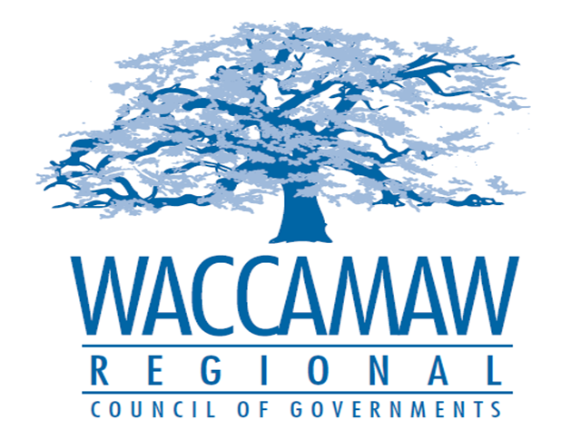

BOARD OF DIRECTORS MEETING
Monday, September 14, 2015 - 7:00 PM
1230 Highmarket Street, Georgetown, South Carolina 29440

- Call to Order…………………………………………………………………………….…....Jimmy Kirby, Chairman
- Invocation
- Introduction of Guests
- Introduction of New Board Member
- Introduction of New Staff Members
- Determination Quorum
- Approval of the July 13, 2015 Minutes

2. Finance Report……………………………………………………………...................Arnold Johnson, Finance Director

- Consolidated Annual Performance and
Evaluation Report (CAPER)………..……………………………………………………Courtney Kain,
Planner/Community Development Specialist
Action Item: YES

4. Watershed Project Presentation…………………………………………………..…Daniel Newquist, 208 Project Director

5. Executive Director’s Report/Departmental Reports………………………………..Sarah P. Smith,
Executive Director

7. Next Meeting: October 12, 2015

8. Other Business

9. Adjournment

