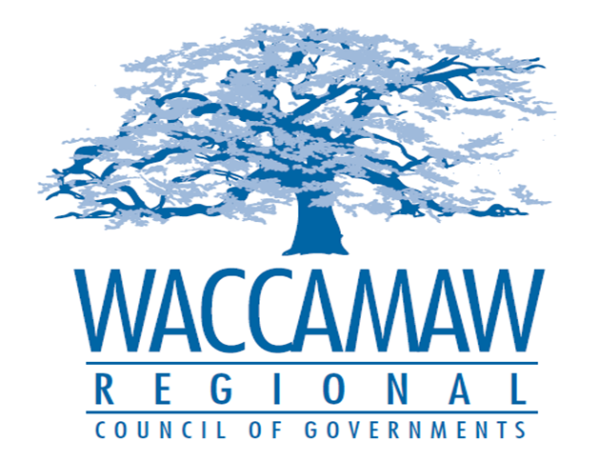
BOARD OF DIRECTORS MEETING
Monday, November 9, 2015 - 7:00 PM
1230 Highmarket Street, Georgetown, South Carolina 29440

- Call to Order………………………………………………………….……………….……...Jimmy Kirby, Chairman
- Invocation
- Introduction of Guests
- Determination Quorum
- Approval of the September 14, 2015 Minutes

- Finance Report……………………………………………………………....................Arnold Johnson,
Finance Director

- Guest Speaker – Brownfield Loan Program…………..…………………….……Harold S. Shapiro,
Former Catawba COG Executive Director

- WIOA Update – Incumbent Worker Training (IWT)……………….…….…………….Ayla Hemeon,
Director of Center Operations & WIOA Programing

- Federal Transportation Administration (FTA) - Resolution ………………….…..Edward Starks,
Transportation Planner
Action Item: YES

7. Executive Director’s Report/Departmental Reports………………………………..Sarah P. Smith,
Executive Director
8. Next Meeting: December 14, 2015

9. Other Business

10. Adjournment

