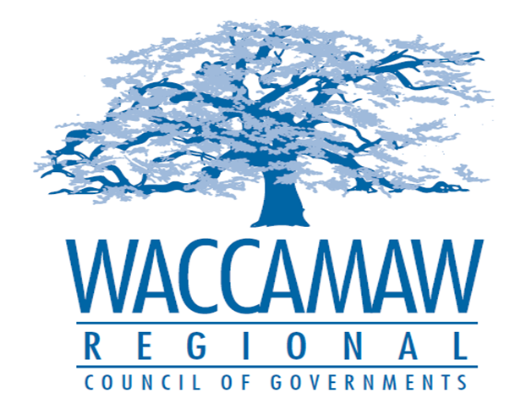
BOARD OF DIRECTORS MEETING
Monday, December 14, 2015 - 7:00 PM
1230 Highmarket Street, Georgetown, South Carolina 29440

- Call to Order………………………………………………………….……………….……...Jimmy Kirby, Chairman
- Invocation
- Introduction of Guests
- Determination Quorum
- Approval of the November 9, 2015 Minutes

- Finance Report……………………………………………………………....................Arnold Johnson,
Finance Director

- Budget Revision…………..…………………….…………………….……………….. Arnold Johnson,
Finance Director
Action Item: YES

4. RLF Committee Recommendation………………….…………………………….…..Tomas Langley,
Deputy Director Workforce & Economic Dev.
Action Item: YES

5. Executive Director’s Report/Departmental Reports………………………………..Sarah P. Smith,
Executive Director
6. Next Meeting: January 11, 2016

7. Other Business

8. Adjournment

