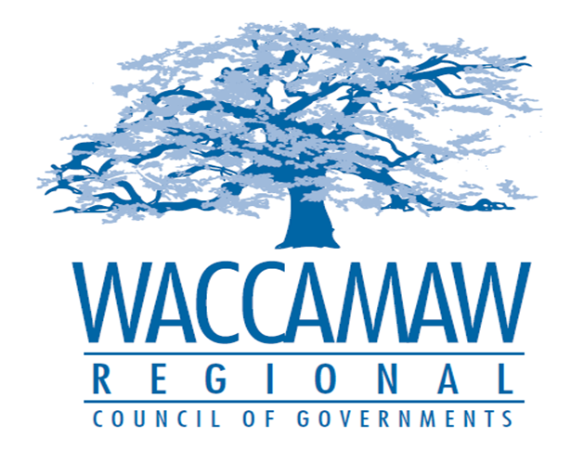
BOARD OF DIRECTORS’ MEETING
Monday, March 14, 2016 - 7:00 PM
1230 Highmarket Street, Georgetown, South Carolina 29440

- Call to Order………………………………………………………………………………Randal Wallace, Chairman
- Invocation
- Introduction of Guests
- Introduction of New Board Members
- Determination Quorum
- Approval of the February 8, 2016 Minutes
- Rural Officials Survey – SCDOT

- Finance Report…………………………………………………………………..…...…Arnold Johnson,
Finance Director

3. Section 5310 Rural Transit Project Funding…….…………….………………….....Edward Starks,
Transportation Planner
Action Item

- 2016 HOME Action Plan Budget……………………………….…Tom Britton and Courtney Kain,
Planning Director and Community Development Planner
Action Item

- Tri-County CHDO Board Appointments………..………………………....................Courtney Kain,
Community Development Planner
Action Item

- Tri-County Board – Amendments to By Laws………………………………………..Courtney Kain,
Community Development Planner
Action Item

- Executive Director’s Report…………………………………..……….…………….....Sarah P. Smith,
Executive Director
8. Next Meeting: April 11, 2016

9. Other Business

10. Adjournment

