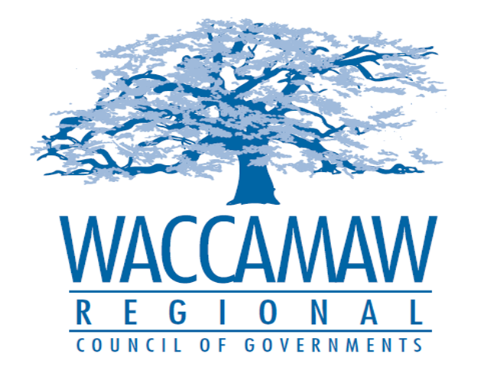
BOARD OF DIRECTORS’ MEETING
Monday, May 9, 2016 - 7:00 PM
1230 Highmarket Street, Georgetown, South Carolina 29440

- Call to Order……………………………………………………………………………....Randal Wallace, Chairman
- Invocation
- Introduction of Guests
- Determination Quorum
- Approval of the March 14, 2016 Minutes
- Recognition of Employee Service 10+ years
- Waccamaw Sports Classic Slideshow

- Finance Report/Budget Amendment…………………………………………………………………..………..…Arnold Johnson,
Finance Director
Board Action Required: Yes

- 2016-2020 HOME Five Year Consolidated Plan/
2016 HOME Annual Action Plan…………………….……………..Tom Britton and Courtney Kain,
Planning Director and Community Development Planner
Board Action Required: Yes

- Tri-County CHDO Board Appointments………..………………………....................Courtney Kain,
Community Development Planner

- Rural Long Range Transportation Plan (LRTP)………………………….….………………………………..………..…………..…Edward Starks,
Transportation Planner

- Executive Director’s Report…………………………………..……….…………….....Sarah P. Smith,
Executive Director
7. Next Meeting: June 13, 2016

8. Other Business.

10. Adjournment.

