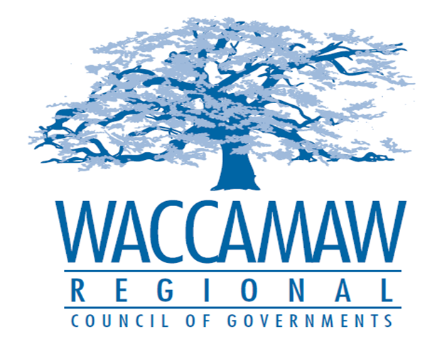
BOARD OF DIRECTORS’ MEETING
Monday, July 11, 2016 - 7:00 PM
1230 Highmarket Street, Georgetown, South Carolina 29440

- Call to Order……………………………………………………………………………....Randal Wallace, Chairman
- Invocation
- Introduction of Guests
- Determination Quorum
- Introduction of New Staff Member(s)
- Approval of the June 13, 2016 Minutes

- Finance Report ………………..…………………………………………….………..…Arnold Johnson,
Finance Director

- *SC DOT Presentation Regarding Potential
Andrews Bypass Phase II Guideshare Proposal…………………………………....…..……SC DOT

*Board Action Required: Yes

- GSATS Metropolitan Transportation Plan (MTP) Land
Use and Population Projections.…………………………..………………….……………..…....Mark Hoeweler,
Assistant Executive Director

- Executive Director’s Report…………………………………..……….…………….….....Sarah Smith,
Executive Director

6. Next Meeting: September 12, 2016

7. Other Business

8. Adjournment

