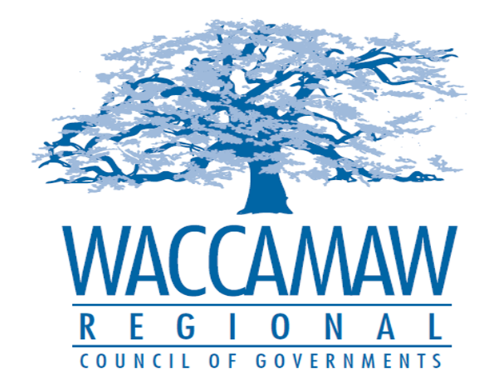

BOARD OF DIRECTORS’ MEETING
Monday, April 10, 2017 - 7:00 PM
1230 Highmarket Street, Georgetown, South Carolina 29440

- Call to Order……………………………………………………………………………....Randal Wallace, Chairman
- Invocation
- Introduction of Guests
- Determination Quorum
- Approval of the February 13, 2017 Minutes

- Finance Report ………………..…………………………………………….………..…Arnold Johnson,
Finance Director

- Audit Committee RFP Recommendation……………………………………………..Murray Vernon,
Chairman Audit Committee
Board Action Required

- 5310 Rural Grant Applications….………………………………………………………Edward Starks, Transportation Planner
Board Action Required

- HOME Program Update……..…………...……………………….……………...………….Tom Britton, Planning Director

- WIOA Monitoring Report………………………………………………………………... Ayla Hemeon,
Workforce and Development Director

- Executive Director’s Report………………………………………………………………..Sarah Smith,
Executive Director

- Next Meeting: May 8, 2017

- Other Business:

- Adjournment

