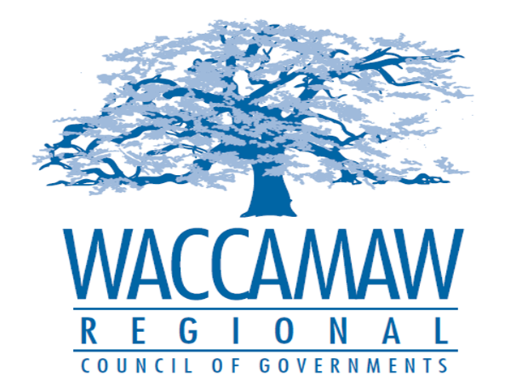

BOARD OF DIRECTORS’ MEETING
Monday, August 14, 2017 - 7:00 PM
1230 Highmarket Street, Georgetown, South Carolina 29440

- Call to Order……………………………………………………………………………....Randal Wallace, Chairman
- Invocation
- Introduction of Guests
- Determination Quorum
- Approval of the June 12, 2017 Minutes

- Finance Report ………………..…………………………………………….………..…Arnold Johnson,
Finance Director

- Section 208 Plan Amendment Proposal
Grand Strand WSA Longs WWTP Expansion………………………………………...Dan Newquist,
Environmental Planner

- CHDO Board Appointments…………………………………………………….…………Tom Britton, Planning Director

- Executive Director’s Report………………………………………………………………..Sarah Smith,
Executive Director
6. Next Meeting: September 11, 2017

7. Other Business

