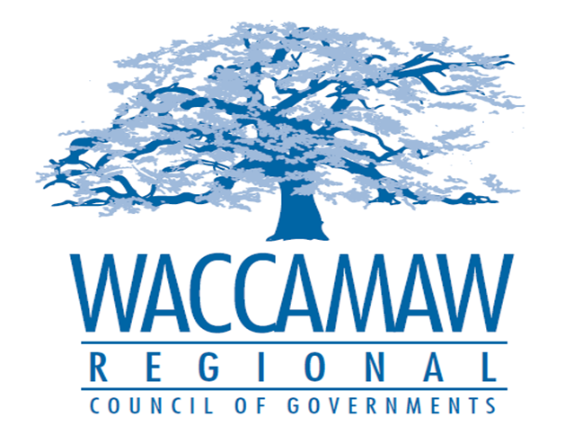
BOARD OF DIRECTORS’ MEETING
Monday, November 13, 2017 - 7:00 PM
1230 Highmarket Street, Georgetown, South Carolina 29440

- Call to Order……………………………………………………………………………....Randal Wallace, Chairman
- Invocation
- Introduction of Guests
- Determination Quorum
- Approval of the October 9, 2017 Minutes

- Finance Report ………………..…………………………………………….………..…Arnold Johnson,
Finance Director

- Metropolitan Transportation Plan Update…………………………………………….Mark Hoeweler,
Assistant Executive Director

- Rural Intersection Program Update…..…………..Mark Hoeweler, Assistant Executive Director
Rebecca Breeland, Program Manager SCDOT

- Budget Amendment…………………………………………………………………….Arnold Johnson,
Finance Director
Board Action Required

- Executive Director’s Report………………………………………….……………………..Sarah Smith,
Executive Director

- Next Meeting: December 11, 2017

- Other Business

