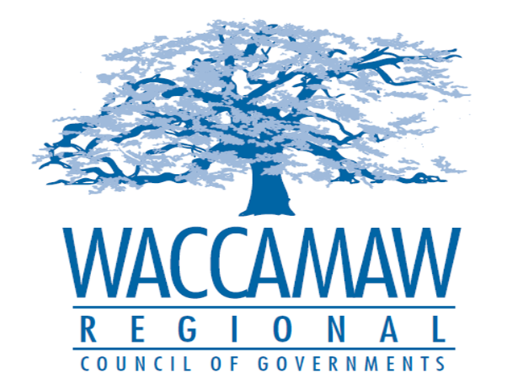

BOARD OF DIRECTORS’ MEETING
Monday, February 12, 2018 - 7:00 PM
1230 Highmarket Street, Georgetown, South Carolina 29440

- Call to Order……………………………………………………………………………....Randal Wallace, Chairman
- Invocation
- Introduction of Guests
- Determination Quorum
- Approval of the December 11, 2017 Minutes

- Finance Report ………………..…………………………………………….………..…Arnold Johnson,
Finance Director

- Audit Commitee Report…..…………...………………………….…………………..…Murray Vernon,
Minor Amendment Policy Finance Committee Chairman

Board Action Required
- Audit Presentation……………………………………………………………..Harper, Poston & Moree
Board Action Required

- Planning Department Update……………………………………………………..………..Tom Britton,
Planning Director

- Executive Director’s Report………………………………………………………………..Sarah Smith,
Executive Director

7. Next Meeting: March 12, 2018

8. Other Business

