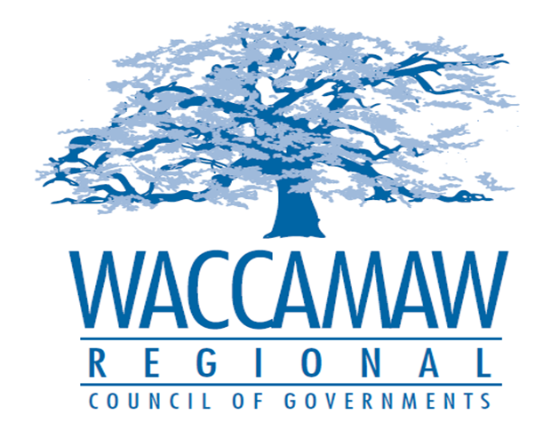

BOARD OF DIRECTORS’ MEETING
Monday, April 9, 2018 - 7:00 PM
1230 Highmarket Street, Georgetown, South Carolina 29440

- Call to Order……………………………………………………………………………....Randal Wallace, Chairman
- Moment of Silence in Memory of Murray Vernon, Vice Chairman
- Invocation
- Introduction of Guests
- Determination Quorum
- Approval of the March 12, 2018 Minutes

- Finance Report ………………..…………………………………………….………..…Arnold Johnson,
Finance Director

- Budget Amendment……….……………………………………………………….......Arnold Johnson,
Finance Director
Board Action Required

- Safety Policy……………………………………..……………………………………..…..Kelly Stuckey,
Assistant Finance Director
Board Action Required

- GSATS Update- Third Round Intersection Projects.…….……..……………….....Mark Hoeweler,
Assistant Executive Director

- Executive Director’s Report………………………………………………………………..Sarah Smith,
Executive Director

7. Next Meeting: May 14, 2018

8. Adjournment

