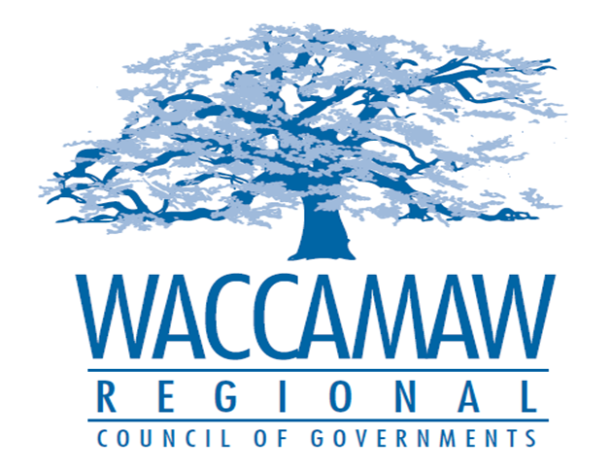

BOARD OF DIRECTORS’ MEETING
Monday, May 14, 2018 - 7:00 PM
1230 Highmarket Street, Georgetown, South Carolina 29440

- Call to Order……………………………………………………………………………....Randal Wallace, Chairman
- Invocation
- Introduction of Guests
- Determination Quorum
- Approval of the April 9, 2018 Minutes

- Finance Report ………………..…………………………………………….………..…Arnold Johnson,
Finance Director

- Planning Services Update……………………………………………………....................Tom Britton,
Planning Director

- Revolving Loan Fund Transfer……………….……..…………….Tomas Langley, Deputy Director
Randy Imler, Catawba COG Director
Board Action Required

- Resolution to Sign SCDOT Certifications............................................................Elizabeth Tucker,
Planner
Board Action Required

- Executive Director’s Report………………………………………………………………..Sarah Smith,
Executive Director

7. Next Meeting: June 11, 2018

8. Adjournment

