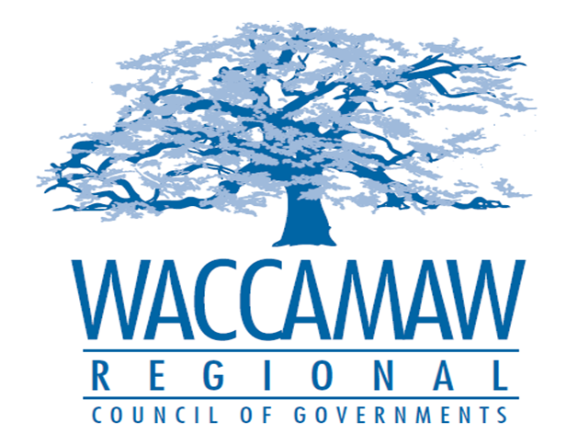

BOARD OF DIRECTORS’ MEETING
SPECIAL CALLED MEETING
Monday, June 18, 2018 - 12:00 PM
1230 Highmarket Street, Georgetown, South Carolina 29440

- Call to Order……………………………………………………………………………....Randal Wallace, Chairman
- Invocation
- Introduction of Guests
- Determination Quorum

- Nominating Committee Member Nomination………………………..…………...….Randal Wallace,
Chairman
Board Action Required

- 2018-2019 Annual Budget……………….……..…………………………………..….Arnold Johnson,
Finance Director
Board Action Required

- CHDO Board Appointment...........................................................................................Sarah Smith,
Executive Director
Board Action Required

5. Next Meeting: August 13, 2018

6. Adjournment

