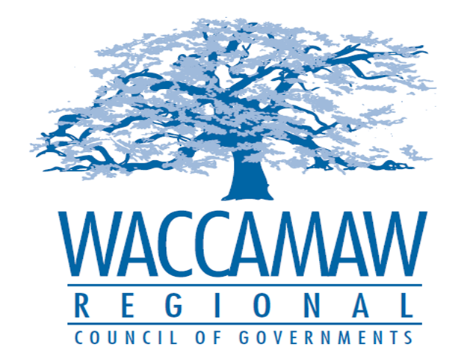

BOARD OF DIRECTORS’ MEETING
Monday, June 11, 2018 - 7:00 PM
1230 Highmarket Street, Georgetown, South Carolina 29440

- Call to Order……………………………………………………………………………....Randal Wallace, Chairman
- Invocation
- Introduction of Guests
- Determination Quorum
- Approval of the May 14, 2018 Minutes

- Nominating Committee Recommendations………………………………...….Sen. Yancey McGill,
Personnel/Nominating Committee Chairman
Board Action Required

- Finance Report…………………………………………………………………………..Arnold Johnson,
Finance Director

- 2017-2018 Minor Budgetary Amendment….........................................................Arnold Johnson,
Finance Director
Board Action Required

- 2018-2019 Annual Budget……………….……....Arnold Johnson/Finance Committee Chairman,
Finance Director/Finance Committee
Board Action Required

- CHDO Board Appointment............................................................................................Tom Britton,
Planning Director
Board Action Required

- Incumbent Working Training Update…………………………...….…………………....Ayla Hemeon,
Workforce Development Director

- Executive Director’s Report……………………………………………………………...…Sarah Smith,
Executive Director

9. Next Meeting: August 13, 2018

10. Adjournment

